

A2 Coursework

WRITE-UP

Simpson’s Department Store

James Bothwell

Contents

Introduction 3

General problems 4

Selected area and problems faced 5

Development methodologies 6

Waterfall 6

RAD 6

Scrum 7

DSDM 8

XP 9

My Methodology of Choice: Waterfall 10

ER Diagram 12

Normalisation 13

0NF 13

1NF 13

2NF 14

3NF 15

User Requirements 16

Project Plan 19

Data Dictionary 21

Input Specification 21

Processes 25

Output Specification 27

Wireframes 30

Testing 50

Black Box Testing 50

White Box Testing 50

Unit Testing 51

Integration Testing 52

System Testing 52

Acceptance Testing 53

Test Plan 54

Test Evidence 116

Evaluation of Time Management/Project Plan 140

Evaluation of User Requirements 141

Solution Evaluation 163

Strengths 163

Weaknesses 163

Improvements 163

Evaluation of Selected Approach 164

Evaluation of Test Procedures 165

Evaluation of My Performance 166

# Introduction

After a struggle to maintain a suitable profit margin in the recent years, George Simpson, owner of Simpson’s Department Store, and the management team have been made to consider and plan for the future of the store. This is due to customers becoming more cautious with their spending because of problems facing the economy, such as rising inflation. As well, a growth in e-commerce and internet shopping has reduced the number of people visiting high street businesses in person. After an extensive information gathering process, Simpson’s management team identified a need for an improved reporting system. An old-fashioned management style of the store has resulted in the employment of staff who are unsuitable for the job. Henry Wilson, the general manager of the store, is only accountable to George Simpson and acts autonomy. He has appointed staff without consulting the section heads, who are appointed to each section of the store. Section heads are responsible for duties such as stock control which includes orders, sales recording, finance, staff hours issue, layout and organisation, and marketing strategies utilised. This approached has been found to be ineffective as it results in problems such as overstocking. As well, deliveries are rarely checked, and invoices are passed on to the finance manager automatically who has a limited means to uphold their accuracy. Due to this, Simpson’s is left with out of fashion products which are unlikely to sell and are overstaffed with unsuitable employees.

As a result of the investigation, the management team at Simpson’s have decided that a new computer system must be in place that allows for the stock by any section to be ordered through one central system that can record and provide tracking for the product from the point of order through to sale and finally delivery. Simpson’s hopes to provide many goods and services, while also having to close many other sections. Separate developments of this new system are to be built and then combined to produce a fully integrated system. This will require a detailed project plan, as well as a highly detailed User Requirements Specification. A new style of management will also be put into place which will result in the creation of teams within each area of the store. Staff will be able to move between teams, and as well these teams will have appointed team leaders, who will meet with staff regularly. A new overall senior manager will be appointed, who will meet with team leaders to help increase their control. New procedures and policies will be put in place to help control these to keep them as consistent as possible. As a result of the new management style and the new system, Simpsons hopes that it will be able to save the future of the store and try increase its profits.

As a developer part of the engineering of this new system, I will have to evaluate and consider the best development methodology for thus new software and provide justification for my choice. I will have to plan and design the solution, and as well I will be responsible for testing the design. This design will be made with strong emphasis and consideration of the user requirements which I will also write. Using Visual Studio. I will development the solution and implement it so that the required database is linked to the GUI. After development, I will be responsible for the creation of a test plan, where I will document test outcomes and provide an evaluation of the tests. If a test is failed, corrective action will be in place to fix this, and it will also be documented. When all this is done, I will provide an evaluation of my solution to the problem. My solution will be for one of the subsystems, particularly the household goods, which includes bedding, China, cutlery, and appliances. The solution I build must resolve the issues that are in this department. The management requires the recording of accurate stock and sales figures every week in this section. This is to be summarised for monthly reports, and this will help the management to keep a tight control of this section.

# General problems

There are a wide range of general problems faced by Simpsons. In the large scheme, there is a decrease in customer spending due to customers becoming more cautious with their spending because of problems facing the economy, such as the cost-of-living crisis and the rise of inflation. As well, a growth in shopping via the internet and e-commerce has allowed for customers to be able to purchase items from the comfort of their own home, which has caused a decrease in the amount of people coming to the physical high street stores to make their purchases.

Simpsons continues to run with an old-fashioned management system. This has however created the problem of the recruitment of unsuitable employees and staff. Henry Wilson has been known to appoint these new staff without the consolation of the section heads who are then responsible to deal with the new, unsuitable employees such as people who are not suitable for sales positions. As well, there is also overstaffing of these unsuitable employees in some sections of the store.

Section heads being responsible for their own sections has also led to a catastrophe. Different sections will have their own ways of identifying order items which has led to overstocking. In all clothes sections the stock rooms are overfilled and bursting with items. Many of these items are now well out of fashion which makes them very hard to be sold.

It has been discovered that deliveries are rarely checked and reconciled against delivery dockets. As a result, invoices are just automatically passed onto the finance manager by the section heads who has a limited ability to check the and confirm their accuracy.

During the investigation, the management team discovered a range of problems that are general to the department store. With no fixed procedure for the section heads to follow for the daily reconciliation of cash and totals, the management team has found that control and monitoring are not in place. As well, due to the large size of the premises of the store, there is a large price for the upkeep and maintenance. To try and utilise this space the management team has decided to convert the top floor into office space that is available to rent. This will also help them earn extra income that they need, helping to pay for the upkeep.

As well as this, the management team has discovered that people would rather have current clothes repaired instead of paying money for new ones. This is a problem for Simpsons as they sell a lot of clothing items. The management team have therefore decided to stop selling any clothes that are not wedding apparel, due to the problem of the online completion that they face and that they are currently unable to keep up with. The facilities and skilled staff that the department store have has allowed for Simpson’s to shift their focus on providing a top class tailoring and dressmaking service, as well as alterations.

Furthermore, Simpsons lacks a considerable interest from the public. To try and garner more interest, Simpsons already have a well-appointed wedding salon with trained staff and exclusive stock which is now going to be further developed into a wedding hire service.

Due to the problem of the competition faced by online stores, the team has decided to abandon areas that do not make them adequate profit and instead focus on services that cannot be provided online.

# Selected area and problems faced

My selected area is the household goods. This section has a strong set of requirements demanded by the management team at Simpson’s. For example, the stock has to be ordered through a central system in order for it to be required and to allow for the tracking of the stock. Management has also stated a need for identifying of the speed of different products and have decided to have sales staff create reports on this in an effort to clear slow moving stock by allowing them to push their promotion.

Accuracy in the reports for stock and sales is of the upmost importance for this area of the store and Simpson’s are very strong on their need for these reports to be made weekly. They also state that they want a monthly summary of these reports. Reports on the wedding list should be also made in a similar way. By doing this, Simpsons will be able to keep a very tight control and management of this section which is now an important part of their policies and procedures.

Furthermore, when items are purchased from the wedding list these items must be recorded in the same way for any other item, but in addition they must be recorded separately so that the total sales for the wedding list can be calculated.

When a client places a wedding list at the store, the household goods must be booked to view by appointment. This appointment is made by the bridal salon. As a result, the appointment requires for a member of the sales staff for household goods, normally the new team leader, to be present to accompany them for when they first view the stock. A member of staff will then be required to record the items the couple decide on. A list will be provided to the couple for verification, and the completed list will be available to be printed as well as being made to view online. This online version will allow customers the opportunity to see which items are still available as the list is updated and gives them the opportunity to view all the available information about the product they plan to purchase.

As the developer of this subsystem, I will be responsible for controlling how all information is collected and for how the reports will be made. I will use databases to store information, reading and writing to them through the use of SQL queries. Some items may be stored in more than one database, such as items purchased from the wedding list. Reports will be made from summaries of tables within the database. Ensuring the system works to a high accuracy as required is especially crucial in this section as this section is to be tightly controlled because the sustainably of the sales of these goods are to be regular reviewed.

# Development methodologies

## Waterfall

The Waterfall methodology, also known as the traditional approach, was a methodology that evolved from the construction industry and transferred to apply to software development. The software development lifecycle is followed in a sequential pattern which is top to bottom just like a waterfall. A phase is not allowed to begin until the previous phase is completed. Certain roles are only required for certain activates. There are different versions of the waterfall model and different ones may have different names for different phases. While the waterfall model doesn’t accommodate changes in the requirements, it does have a simple and easy to understand approach. It is also easier for Project Managers as they have a higher level of control. The customer is only involved in the early stages to define requirements so therefore there is a low customer involvement.

However, Waterfall is not without its flaws. The low customer involvement increases the risk of the customer’s needs not being met when the product is finished. Waterfall also does not accommodate for changes in the requirements making it unsuitable for projects where there is a risk of the requirements changing or for projects where there is a long project timescale. Project management is also very authoritarian in its style which does not let the developers express their creativity. Testing is performed at the end which means that bugs written early will often only be discovered now, and iteration is then preformed in a big bang at the end which means that design problems uncovered late may be costly.

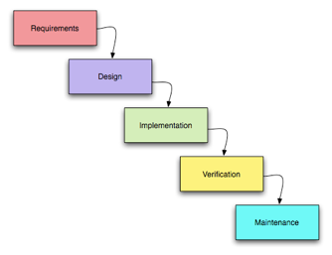

## RAD

RAD compresses several steps of the waterfall process into an iterative process using prototyping with high user precipitation. The stages of RAD are Analysis and Quick Design, an iterative cycle of Develop, Demonstrate and Refine, testing and finally Deployment. Instead of throwaway prototyping where the prototype is discarded after use, RAD uses evolutionary prototyping which means the model is developed into the final system. A development team will deliver a series of fully functional prototype to the users who evaluate the prototype and request further refinement and changes. RAD is centred around four key points which help to prioritise the work to be completed in the project. It uses MoSCow for prioritisation. These key points are discussed with the customer, and they are:

**Musts** – The essential requirements of the program.

**Shoulds** – Functionally which the program should have but are not absolutely essential.

**Coulds** – Functionality which the customer would like to have if the resources and time are available.

**Wont Haves** – Unacceptable to have in the program.

RAD has the advantages of less up-front planning. This is achieved through prototyping. RAD also speeds up the design and implementation. Tools such as Computer Aided Software Engineering (CASE), Joint Application Design (JAD) and fourth generation/visual programming languages. Furthermore, RAD helps to facilitate the customer’s requirements determination because the customer can visually see part of the working system. Construction of the system can be broken down into several compartments which all can have several prototypes developed in parallel. RAD also accommodates changes in the user requirements and allows for rapid deployment to the customer. This is useful in business environments which are so rapidly changing that it ensures the product is not out of date before it reaches the customer. There is no big bang iteration at the end which means the design can still be changed when the cost of change is low.

However, managing a large project will be much harder as there is a lack of control due to the lack of planning. RAD is also very demanding on user interaction, and the businesspeople who are key to the project success may not be available to support this demand. There is also a large cost for CASE tools. RAD also has a need for the workers involved to be highly skilled for the rapid response to changing requirements and to create new prototypes. There is no time for training courses. A high focus on visual prototyping may lead to a poor architectural design of the system, and due to the small-medium sized project teams that RAD is suited for, there is a lack of scalability associated with the methodology.

## Scrum

Scrum is a modern Agile methodology which is used in many companies such as Microsoft. Scrum uses iteration to split development of the software like RAD and DSDM do. Scrum places an emphasis on team working by focusing on collaboration and communication throughout a project. Scrum is more flexible as it doesn’t require for the requirements to be set in stone from the outset in the likely event that the requirements change. Scrum has three roles, the Product Owner, the Development Team and the Scrum Master. Scrum can be simply slotted into DSDM, being wrapped in its extra project level activities if desired. An iteration in scrum is known as a sprint. Each sprint comes in the following sections:

**Sprint Planning –** At the start of a sprint, the team comes together to decide which pieces of functionally are to be completed in the sprint time frame. The work is separated and designated to team members with a time estimate. Once finished, the requirements cannot change until the sprint is finished.

**Daily Scrum** – The daily scrum is a quick meeting that takes place during the development in each sprint. This helps to keep every team member involved and as well it helps to showcase if the sprint is going well and if the time estimates are accurate. Each team member is expected three questions: What did I do yesterday? What did I do today? What obstacles are in my way?

**Sprint Review** – At the end of the sprint the team comes together to review the work and compare it to what was planned for the sprint in the sprint in planning. The completed functionality is then showcases for the customer to provide feedback.

**Sprint Retrospective –** The team will discuss what went right and what went wrong in the sprint. The team will continue with the positives and plan against the negatives when planning their next sprint.

The advantage of Scrum is that there is highly visible progress through continual product releases and a high involvement of stakeholders. As well, Scrum facilitates change and therefore good for innovative and novel projects where user requirements are uncertain. Daily Scum meetings mean issues raised at early stage, high level of communication between stakeholders, as well as team member’s productivity is made apparent. There is also minimal documentation.

The disadvantages of Scrum are that it requires a big commitment from the designated users. There is also an intense lifecycle with frequent product releases and change which is demanding on team members. Resources are also required for the daily scrum meetings and frequent reviews. It is also difficult to plan and structure at the beginning as lacks definition – difficult to produce business plan with costs and estimates.

## DSDM

DSDM is based on RAD and is intended to be an improvement of RAD by adding discipline and structure. It is an iterative methodology, and it allows users to provide feedback at the end of an iteration. Like RAD, it also uses the four MoSCoW points for prioritisation. DSDM projects have 5 phases:

**Feasibility** **Study** – An investigation to see whether the project is feasible and if DSDM is the right process to use for the project.

**Foundations/Business** **Study** – This phase looks at the process the business currently uses, and the requirements are made in this phase.

**Exploration/Function** **Model** **Iteration** – Iterations are used to create prototypes. Iteration occurs in time boxes.

**Engineering/Evolutionary Development/Design** **and** **Build** **Iteration** – During this phase the software is finished throughout successive iterations which occur in agreed time boxes.

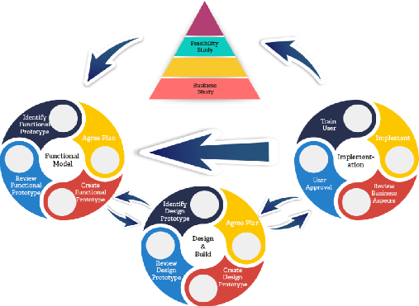**Deployment/Implementation** – Users are trained to use the finished software and the software is handed over to the customer.

DSDM makes use of iterations which are performed in time boxes. Within each iteration entire features are developed, and analysis, coding and testing are all preformed.

DSDM uses MoSCoW rather than ‘done’ which may give DSDM the advantage over Scrum if there is a strict budget and time budget. In DSDM, there are twelve roles from project management, business and technical backgrounds, such as Team Leaders, Project Managers, Solution Developers, Solution Testers and Business Sponsors.

The advantages of DSDM are that it is provides a high level of customer satisfaction due to the fast time to product release and the high quality of the solution. As well, due to its more disciplined structure, DSDM has a more predictable schedule and cost for the project. It may also be easier to use due to its similarity to other methodologies such as RAD.

The disadvantages of DSDM are that it needs a highly disciplined management or else the project will fail. DSDM may also have a very tight time scale – about five months to the first working model from the brief and it also requires a high level of customer involvement, such as providing feedback to the developers. Unlike Scrum, the documentation required is extensive. DSDM is also more suited towards large development teams.

## XP

XP stands for Extreme Programming, which uses all points of the Agile manifesto, therefore it is a pure Agile methodology. It provides a focus on short iterations and relaxed requirements which means allows for demonstrable functionally to be provided quickly. The requirements can change at any time as long as a piece of work has not been started. There is a strict order of prioritisation for pieces of functionality, and these are defined by the customer’s priorities. Teams using XP will also sometimes have an on-site customer who would be responsible for writing user stories and preforming acceptance tests. They set the priorities and must always be available to answer questions. These teams may also have a Coach, who makes sure the project stays on track and trains team members, or a Tracker, who monitors programmers taking action if anything goes off track. A typical XP development team will have 2-10 people working in it. XP has five core values - Communication, Simplicity, Feedback, Courage and Respect. XP makes use of engineering processes such as:

Pair Programming – This is where two developers work together to find a solution to a problem. This is based on the idea “Two programmers are better than one”.

Code Review – Code finished by a developer is reviewed by another developer, usually a senior developer. This tries to prevent bugs and highlight pitfalls of the code.

Unit Testing – A test written to test each unit of code. This takes the form of test-driven development (TDD) which is where the tests for functionality are written before writing the functionality itself. The developer will continue to write code until they pass the test.

The advantages of XP are that there is constant feedback from the customer which allows for the software to be improved to fit the customer’s needs. As well, simplicity is one of the values of XP and this means that the developers can create the software with simple code that can be improved at any moment. The methodology is cost efficient and is able to have a fast output of the working functionality due to the shortened iteration times compared to DSDM or Scrum. The engineering processes in XP also help to improve the quality of the software.

The disadvantages of XP are that it requires a very high level of customer involvement, even to go as far as advocating for an on-site customer. Some businesses may not be able to meet this demand. As well, it is not suitable for teams that are working over a large geographical area. Furthermore, the teams required for XP must be highly skilled to be able to cope with the engineering processes and automated tools. Paired programming may also take longer and cause the project to have a longer time scale than necessary. Due to the short iterations and fast paced lifecycle, it can be demanding on workers and may be stressful.

# My Methodology of Choice: Waterfall

My methodology of choice is the Waterfall methodology. Waterfall is a suitable methodology because the developers and customers do not work together for a large amount of the project apart from in analysis and testing, and this is a good option as the customer is not able to provide a high level of involvement in the project. Waterfall is also suitable as it is suitable for individual developers and since I am not working in a team this is crucial to consider when choosing a methodology. As well, due to the simple structure of the waterfall methodology, it will ensure each section is completed to a high level. This also works in my favour as I am inexperienced working with agile methodologies that are more difficult to understand. Since you must complete an entire phase before moving onto the next one, roadblocks to completion are brought to light right away and can be dealt with in an effective manner. Unlike Scrum, Waterfall will not require for me to have specific training as the process is intuitive. Waterfall also helps to keep the end goal always in focus, unlike Scrum where the end goal is divided into sprints. Furthermore, I can use the waterfall methodology as the requirements are unambiguous, clear, and unchanging and Simpsons have described them in detail in the early stages of development.

RAD would not be suitable because it is also very demanding on user interaction, and the businesspeople who are key to the project success may not be available to support this demand. As well the cost of CASE tools is quite high. The focus on visual prototypes may lead to poor architectural design. There is a lack of scalability so RAD is suited better for small-medium sized projects. RAD is also suitable for projects where the requirements are uncertain or unknown, or rapidly changing. However, Simpsons have clearly defined their requirements for the software, so this methodology does not make sense in retrospect of this. RAD also requires highly skilled team members and developers that can keep up with its fast-paced development lifecycle, which I am not.

Scrum would not be suitable due to the high level of involvement with the customer. For example, the sprint reviews, which requires for the completed functionality to be showcased for the customer to provide feedback, would not be possible. As well, the end goal for the solution is divided into smaller individual sprints, which are not suitable as they may result in extra work that reduces the time taken to reach the end goal and you may get caught up in the details. Simpson’s have set a due date for the system to be delivered and it is crucial that I meet this.

DSDM is not suitable for this project as it requires for Simpson’s to provide feedback at the end of iterations, which they are unable to provide. As well, DSDM requires a large team which is not possible for this project either. In addition, DSDM is more suited to large projects and as a result the workload is broken up into different iterations known as time boxes. Since I am working on a relatively small-scale project, there is not enough work for it to be required to be broken up into time boxes and as well the project time scale is too short for the use of time boxes to make any sense. DSDM also makes major use of pre-existing class libraries (APIs). I however do not have access to any and I am also not skilled enough to make use of them.

XP would not be suitable due to the engineering processes that are a key part for the methodology. For example, since I am working as a lone developer, the Pair Programming and Code Review would not be possible as they both require the involvement of a second developer. As well as this, in XP there is a lot of software engineering practices and automated tools needed for testing, so a highly experienced and stable team is needed, so again proving XP to be unsuitable for my project. Furthermore, in XP it is advocated that there is an on-site customer. Since they must be permanently on site, XP is highly unsuitable for the project as this is a massive commitment that Simpsons are unable to provide.

# Graphical user interface Description automatically generated with low confidenceER Diagram

# Normalisation

## 0NF

UNNORMALISED DATA

(OrderNo, DateOfOrder, ReferenceName, CompletedYN, StockNo, StockDesc, StockCategory, StockPrice, StockSellingPrice, StockQty, StockImage, QtyOrdered, CustNo, CustName, CustAddress1, CustAddress2, CustPostcode, CustPhone, CustEmail, BookingNo, DateOfBooking, Slot, StaffNo, StaffName, StaffJob, QtyRequired, QtyOrdered, OrderNo, DateOfOrder, Delivery, DateOfDelivery, DeliveryYN, QtyOrdered)

NOTE – There are two different OrderNo fields because there is one OrderNo for weddings lists, and another OrderNo for customer order stock. These will be distinguished in the normalisation as they will be highlighted differently.

OrderNo – the OrderNo for wedding lists

OrderNo – the OrderNo for customer order stock

As well, there are three QtyOrdered fields because there is one for wedding list stock, one for wedding list stock, and the last one is for customer order stock. However, these will not be highlighted as they are easily distinguishable from one another.

## 1NF

WEDDINGLIST

(OrderNo, DateOfOrder, ReferenceName, CompletedYN)

WEDDINGLISTSTOCK

(OrderNo*, StockNo, StockDesc, StockCategory, StockPrice, StockSellingPrice, StockQty, StockImage, QtyOrdered, CustNo*)

WEDDINGLISTPURCHASE

(OrderNo*, StockNo*, CustNo, CustName, CustAddress1, CustAddress2, CustPostcode, CustPhone, CustEmail, BookingNo, DateOfBooking, Slot, StaffNo, StaffName, StaffJob, QtyRequired, QtyOrdered)

CUSTOMERORDERSTOCK

(StockNo*, OrderNo, DateOfOrder, Delivery, DateOfDelivery, DeliveryYN, QtyOrdered, CustNo*)

## 2NF

WEDDINGLIST

(OrderNo, DateOfOrder, ReferenceName, CompletedYN)

WEDDINGLISTSTOCK

(OrderNo*, StockNo*, QtyOrdered, CustNo*)

STOCK

(StockNo, StockDesc, StockCategory, StockPrice, StockSellingPrice, StockQty, StockImage)

WEDDINGLISTPURCHASE

(OrderNo*, StockNo*, CustNo*, QtyRequired, QtyOrdered)

CUSTOMER

(CustNo, CustName, CustAddress1, CustAddress2, CustPostcode, CustPhone, CustEmail, BookingNo, DateOfBooking, Slot, StaffNo, StaffName, StaffJob)

CUSTOMERORDERSTOCK

(StockNo*, OrderNo*, QtyOrdered)

CUSTOMERORDER

(OrderNo, DateOfOrder, Delivery, DateOfDelivery, DeliveryYN, CustNo*)

## 3NF

WEDDINGLIST

(OrderNo, DateOfOrder, ReferenceName, CompletedYN)

WEDDINGLISTSTOCK

(OrderNo*, StockNo*, QtyOrdered, CustNo*)

STOCK

(StockNo, StockDesc, StockCategory, StockPrice, StockSellingPrice, StockQty, StockImage)

WEDDINGLISTPURCHASE

(OrderNo*, StockNo*, CustNo*, QtyRequired, QtyOrdered)

CUSTOMER

(CustNo, CustName, CustAddress1, CustAddress2, CustPostcode, CustPhone, CustEmail)

BOOKING

(BookingNo, DateOfBooking, Slot, StaffNo*, CustNo*)

STAFF

(StaffNo, StaffName, StaffJob)

CUSTOMERORDERSTOCK

(StockNo*, OrderNo*, QtyOrdered)

CUSTOMERORDER

(OrderNo, DateOfOrder, Delivery, DateOfDelivery, DeliveryYN, CustNo*)

# User Requirements

**General User Requirements**

1. All forms should have return buttons to their previous forms
2. All forms should have a title
3. Invalid data should be handled in a way that prevents the program from producing errors
4. All forms must have an icon of the Simpson’s logo and follow the same set colour scheme for Simpson’s – blue, black and white

**Menu**

1. All strands of Simpson’s should be accessible from this form
2. Strands that have not yet been implemented are to display a “currently under construction” message when clicked on
3. The user should be able to access the Welcome form in this menu

**Welcome Menu**

1. All parts of the Household Goods department should be accessible from this screen
2. The user should be able to return to the Menu form

**Customers**

1. The application should attempt to establish a successful connection to the Customer table in the database upon opening of the Customer form
2. In the event that a database connection cannot be established, the application should direct the user back to the Welcome form
3. The user should be prevented from entering invalid customer details into the database
4. The user should be able to use either a combo box or a data grid view to create a new customer or view the details of existing customers
5. The user should be able to create a new customer with valid details
6. The user should be able to update an existing customer with new details
7. The user should be able to search for existing customers using customer details such as name, address, and email
8. The user should be able to create a booking for the currently selected customer
9. The user should be able to create a new customer order allowing them to purchase stock for the currently selected customer
10. The user should be able to return to the Welcome form

**Stock**

1. The application should attempt to establish a successful connection to the Stock table in the database upon opening of the Stock form
2. In the event that a database connection cannot be established, the application should direct the user back to the Welcome form
3. The user should be prevented from entering invalid stock details into the database
4. The user should be warned when an item is out of stock
5. The user should be able to supply an image for the new item of stock
6. The user should be able to use either a combo box or a data grid view to create a new item of stock or view the details of existing stock
7. The user should be able to create a new item of stock with valid details
8. The user should be able to update existing items of stock with new details
9. The user should be able to search for existing items of stock using stock details such as description, price, and quantity
10. The user should be able to return to the Welcome form

**Bookings**

1. The application should attempt to establish a successful connection to the Staff table in the database upon opening of the Bookings form
2. In the event that a database connection cannot be established, the application should direct the user back to the Customer form
3. The name of the customer who is making the booking should be displayed to avoid confusion and ensure that the user is making a booking for the correct customer
4. The user should be able to choose a date from a list of dates, with a minimum date of one day after the current date
5. The user should be able to choose a time slot for their chosen date
6. When the user selects a time slot for their chosen date a Sales Representatives team member will be automatically assigned to assist for that time slot
7. When a time slot has been booked it is removed from the available time slots for that day to prevent double bookings
8. The user should only be able to make a booking when all details are correct
9. When a booking is made, booking details are recorded in the Booking table and the user is no longer able to make a booking for that customer
10. The user should be able to return to the Customer form once they have made a booking, or if they decide to cancel making a booking

**Purchase Stock**

1. The application should attempt to establish a successful connection to the Stock table in the database upon opening of the Purchase Stock form
2. In the event that a database connection cannot be established, the application should direct the user back to the Customer form
3. The name of the customer who is purchasing stock should be displayed to avoid confusion and ensure that the user is making a customer order for the correct customer
4. The customer order details of the customer who is purchasing stock should be passed into the form as well
5. The user should be able to select stock, enter a valid quantity and add the stock to their cart for purchase
6. The maximum quantity of stock a user can buy cannot be greater than the quantity that is currently in stock
7. The total price for the order is to be displayed and updated as the user adds more stock to their cart
8. The user should be able to complete their purchase after selecting stock and have their order recorded in the CustomerOrderStock table in the database, with stock quantities available being adjusted accordingly
9. The user should be able to search for existing items of stock using stock details such as description, price, and quantity
10. The user should be able to return to the Customer form

**View Bookings**

1. The application should attempt to establish a successful connection to the Customer table in the database upon opening of the View Bookings form
2. In the event that a database connection cannot be established, the application should direct the user back to the Welcome form
3. The user should be able to select a date from a date-time picker and view the details of any customers who have made a booking for that selected date
4. The user should only be able to create a wedding list if the date is today and at least one customer has made a booking for today and is selected
5. The user should not be allowed to update a wedding list once that wedding list has been marked as complete
6. The user should be able to return to the Welcome form

**Wedding List Stock**

1. The application should attempt to establish a successful connection to the Stock table in the database upon opening of the Wedding List Stock form
2. In the event that a database connection cannot be established, the application should direct the user back to the View Bookings form
3. The name of the customer who is making a wedding list should be displayed to avoid confusion and ensure that the user is making a wedding list for the correct customer
4. The wedding list details of the customer who is making a wedding list should be passed into the form as well
5. The user should be able to select stock, enter a valid quantity and add the stock to their cart for purchase
6. The maximum quantity of stock a user can buy cannot be greater than the quantity that is currently in stock
7. The total price of the items to be bought off the wedding list is to be displayed and updated as the user adds more stock to their cart
8. The user should be able to complete their purchase after selecting stock and have their items recorded in the WeddingListStock table in the database, with stock quantities available being adjusted accordingly
9. The user should be able to search for existing items of stock using stock details such as description, price, and quantity
10. When a customer is satisfied that their wedding list is complete, the user should be able to mark the wedding list as complete
11. The user should be able to return to the View Bookings form

**Wedding List Purchase**

1. The application should attempt to establish a successful connection to the WeddingList, WeddingListStock and Customer tables in the database upon opening of the Wedding List Purchase form
2. In the event that a database connection cannot be established, the application should direct the user back to the Welcome form
3. Any items added more then once to the same wedding list will only be displayed as one item with an overall quantity
4. The user should be able to select the customer they are buying for, and the customer they are buying as
5. The user should be able to select stock, enter a valid quantity and add the stock to their cart for purchase
6. The maximum quantity of stock a user can buy cannot be greater than the quantity that is currently in stock
7. The total price of the items to be bought off the wedding list is to be displayed and updated as the user adds more stock to their cart
8. The user should be able to complete their purchase after selecting stock and have their order recorded in the WeddingListPurchase table in the database, with stock quantities available in that wedding list being adjusted accordingly
9. The user should be able to search for existing items of stock within that wedding list only using stock details such as description, price, and quantity
10. The user should be able to view the currently selected wedding list online
11. The user should be able to view the customers who have purchased from the currently selected wedding list
12. The user should be able to return to the Welcome form

**Wedding List Customers**

1. The user should be able to see all the customers who have bought from the wedding list that they selected in Wedding List Purchase form
2. The user should be able to close this pop-up form

# Project Plan

Given that I had adopted a waterfall approach, it was important to ensure that tasks were completed in a specific sequence without any overlap. However, in the real world, it's not always possible to avoid some degree of overlap between tasks, despite the rigid structure of the waterfall model.

As a result, I found that a lot of the smaller tasks at the start of the project experience a high level of overlapping. During the start of the actual software design, a few tasks such as creating the initial forms such as the Customer form took longer than expected. However, the forms did not take as long after this as this customer form was able to act as a blueprint for future forms. The Wedding List Purchase form did take longer than expected and overlapped with the creation of the Customer Order form due to this form being quite complex to make. As well, at the later stages of the project, such as testing the system, there was a large degree of overlapping. This was due to the magnitude of tests required to be completed to ensure the software operates as it would be expected to.

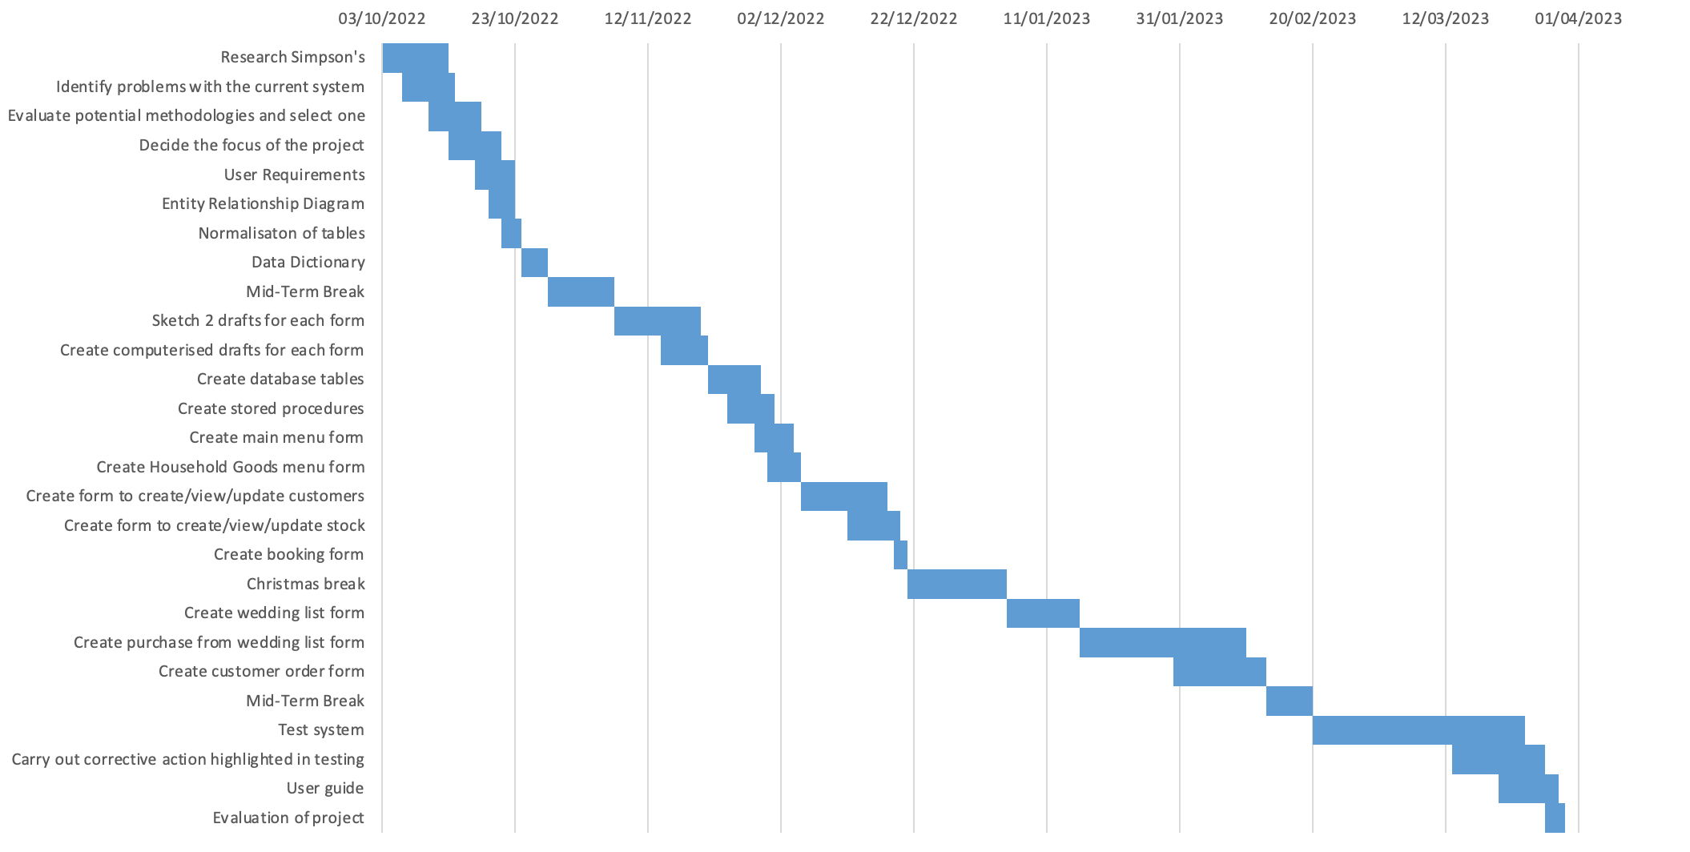

# Data Dictionary

## Input Specification

I need to input multiple values into the database so a new customer can be made:

* *Customer details*: Name, Address Line 1, Address Line 2, Postcode, Phone Number and Email Address

I need to input multiple values into the database so a new item of stock order can be made:

* *Stock details*: Description, Category, Price, Selling price, Quantity in Stock

I need to input a customer number into the database so a customer order can be made:

* *Customer No (from Customer details)*

I need to input multiple values into the database so a customer can purchase stock:

* *Order No (from Customer Order details)*
* *Stock No (from Stock details)*
* *Customer Order Stock details:* Quantity Ordered

I also need to input a reference name into the database so a wedding list can be made:

* *Wedding List details:* Reference Name, Completed Y/N

I also need to input multiple values into the database so stock can be added to a wedding list:

* *Order No (from Wedding List details)*
* *Customer No (from Customer details)*
* *Stock No (from Stock details)*
* *Wedding List Stock details:* Quantity Ordered

I also need to input multiple values into the database so a wedding list can be purchased from:

* *Order No (from Wedding List details)*
* *Cust No (from Customer details)*
* *Stock No (from Stock details)*
* *Wedding List Purchase details:* Quantity Required, Quantity Ordered

I also need to input multiple values into the database so a booking can be made:

* *Customer No (from Customer details)*
* *Staff No (from Staff details)*
* *Booking details:* Date of Booking, Time Slot

|  |  |  |  |  |  |
| --- | --- | --- | --- | --- | --- |
| **Entity** | Customer | | | | |
| **Attribute** | **Data Type** | **Size/Bytes** | **Validation** | **Purpose** | **Comments** |
| CustNo | Int | 4 | Must not be null | Primary Key | Identity, increments from 1 |
| CustName | Varchar(255) | 255 | Must be shorter than 30 characters  Must be longer than 2 characters  Must not contain numbers or symbols  Must not be null |  |  |
| CustAddress1 | Varchar(255) | 255 | Must be shorter than 50 characters  Must be longer than 2 characters  Must not be null |  |  |
| CustAddress2 | Varchar(255) | 255 | Must be shorter than 50 characters  Must be longer than 2 characters  Must not be null |  |  |
| CustPostcode | Varchar(8) | 8 | Must be 7 characters long  Must not be null |  |  |
| CustPhone | Varchar(11) | 11 | Must be 11 characters long  Must not contain letters or symbols  Must not be null |  |  |
| CustEmail | Varchar(255) | 255 | Must be shorter than 30 characters  Must be longer than 6 characters  Must contain an “@” symbol  Must not be null |  |  |

|  |  |  |  |  |  |
| --- | --- | --- | --- | --- | --- |
| **Entity** | Stock | | | | |
| **Attribute** | **Data Type** | **Size/Bytes** | **Validation** | **Purpose** | **Comments** |
| StockNo | Int | 4 | Must not be null | Primary Key | Identity, increments from 1 |
| StockDesc | Varchar(255) | 255 | Must be shorter than 50 characters  Must be longer than 2 characters  Must not be null |  |  |
| StockCategory | Varchar(255) | 255 | Must be shorter than 50 characters  Must be longer than 2 characters  Must not contain numbers or symbols  Must not be null |  |  |
| StockPrice | Decimal | 6 | Must not be 0  Must not be negative  Must not contain letters or symbols  Must not be null |  |  |
| StockSellingPrice | Decimal | 6 | Must not be 0  Must not be negative  Must not contain letters  Must not be null |  |  |
| StockQty | Int | 4 | Must not be negative  Must not contain letters  Must not be null |  |  |
| StockImage | Varchar(255) | 255 | Must not be null |  |  |

|  |  |  |  |  |  |
| --- | --- | --- | --- | --- | --- |
| **Entity** | CustomerOrder | | | | |
| **Attribute** | **Data Type** | **Size/Bytes** | **Validation** | **Purpose** | **Comments** |
| OrderNo | Int | 4 | Must not be null | Primary Key | Identity, increments from 1 |
| DateOfOrder | DateTime | 8 | Must not be null |  | Default of current DateTime |
| Delivery | Varchar(1) | 1 | Must not be null |  | Default ‘N’ |
| DateOfDelivery | Varchar(255) | 255 |  |  | Default null |
| DeliveryYN | Varchar(1) | 1 |  |  | Default null |
| CustNo | Int | 4 | Must not be null | Foreign Key | Refrences CustNo in Customer |

|  |  |  |  |  |  |
| --- | --- | --- | --- | --- | --- |
| **Entity** | CustomerOrderStock | | | | |
| **Attribute** | **Data Type** | **Size/Bytes** | **Validation** | **Purpose** | **Comments** |
| OrderNo | Int | 4 | Must not be null | Part of composite Primary Key & Foreign Key | Refrences OrderNo in CustomerOrder |
| StockNo | Int | 4 | Must not be null | Part of composite Primary Key & Foreign Key | Refrences StockNo in Stock |
| QtyOrdered | Int | 4 | Must not be null  Must be less than or equal to quantity of stock available |  |  |

|  |  |  |  |  |  |
| --- | --- | --- | --- | --- | --- |
| **Entity** | WeddingList | | | | |
| **Attribute** | **Data Type** | **Size/Bytes** | **Validation** | **Purpose** | **Comments** |
| OrderNo | Int | 4 | Must not be null | Primary Key | Identity, increments from 1 |
| DateOfOrder | DateTime | 8 | Must not be null |  | Default of current DateTime |
| ReferenceName | Varchar(255) | 255 | Must not be null |  |  |
| CompletedYN | Varchar(1) | 1 | Must not be null |  |  |

|  |  |  |  |  |  |
| --- | --- | --- | --- | --- | --- |
| **Entity** | WeddingListStock | | | | |
| **Attribute** | **Data Type** | **Size/Bytes** | **Validation** | **Purpose** | **Comments** |
| OrderNo | Int | 4 | Must not be null | Part of composite Primary Key & Foreign Key | Refrences OrderNo in WeddingList |
| CustNo | Int | 4 | Must not be null | Part of composite Primary Key & Foreign Key | Refrences CustNo in Customer |
| StockNo | Int | 4 | Must not be null | Part of composite Primary Key & Foreign Key | Refrences StockNo in Stock |
| QtyOrdered | Int | 4 | Must not be negative  Must not be null |  |  |

|  |  |  |  |  |  |
| --- | --- | --- | --- | --- | --- |
| **Entity** | WeddingListPurchase | | | | |
| **Attribute** | **Data Type** | **Size/Bytes** | **Validation** | **Purpose** | **Comments** |
| OrderNo | Int | 4 | Must not be null | Part of composite Primary Key & Foreign Key | Refrences OrderNo in WeddingList |
| CustNo | Int | 4 | Must not be null | Part of composite Primary Key & Foreign Key | Refrences CustNo in Customer |
| StockNo | Int | 4 | Must not be null | Part of composite Primary Key & Foreign Key | Refrences StockNo in Stock |
| QtyRequired | Int | 4 | Must not be negative  Must not be null |  |  |
| QtyOrdered | Int | 4 | Must not be negative  Must not be null |  |  |

|  |  |  |  |  |  |
| --- | --- | --- | --- | --- | --- |
| **Entity** | Staff | | | | |
| **Attribute** | **Data Type** | **Size/Bytes** | **Validation** | **Purpose** | **Comments** |
| StaffNo | Int | 4 | Must not be null | Primary Key | Identity, increments from 1 |
| StaffName | Varchar(255) | 255 | Must not be null |  |  |
| StaffJob | Varchar(255) | 255 | Must not be null |  |  |

|  |  |  |  |  |  |
| --- | --- | --- | --- | --- | --- |
| **Entity** | Booking | | | | |
| **Attribute** | **Data Type** | **Size/Bytes** | **Validation** | **Purpose** | **Comments** |
| BookingNo | Int | 4 | Must not be null | Primary Key | Identity, increments from 1 |
| DateOfBooking | DateTime | 8 | Must not be null |  |  |
| Slot | Varchar(255) | 255 | Must not be null |  |  |
| CustNo | Int | 4 | Must not be null | Foreign Key | Refrences CustNo in Customer |
| StaffNo | Int | 4 | Must not be null | Foreign Key | Refrences StaffNo in Staff |

## Processes

***Updating***

In the **Customer** form, the details of a customer can be updated by selecting an existing customer from either **cbxCustomer** or **dgvCustomers**, editing the customer details in the textboxes, and then clicking **btnCreateUpdate.** A method of the name **UpdateCustomer()** is called, which passes through the updated customer details to the stored procedure **Update_Customer**. This will update the details of the selected customer in the **Customer** table in the database.

In the **Stock** form, the details for a selected item of stock from **cbxStock** or **dgvStock** can also be updated as well by editing the details in the textbox and then clicking on **btnCreateUpdate.** A method of the name **UpdateStock()** is called, which passes through the updated item of stock to the stored procedure **Update_Stock**. This will update the details of the selected item of stock in the **Stock** table in the database.

As well as this, when a customer buys stock in the **Purchase Stock** form, the new quantities available for each item of stock in the **Stock** table in the database will be updated using the **UpdateStock()** method. This method passes through the updated item of stock with its new quantity to the stored procedure **Update_Stock**. This will update the details of any items of stock that have been purchased in the **Stock** table in the database. If the maximum quantity for an item of stock has been purchased, the quantity for that item of stock in the **Stock** table in the database will be updated to 0 using the **UpdateStock()** method as well.

In the **Wedding List** **Stock** form, the same processes for updating stock used in the **Purchase Stock** form are used to update the quantities of stock available in the **Stock** table whenever that item of stock has been added to a wedding list. As well as this, however, when a user marks a wedding list as complete, a method of the name **UpdateWeddingList()** is called, which passes through the updated wedding list with a new **MarkedYN** value of “Y” to the stored procedure **Update_WeddingList**. This will update the details of the current wedding list in the **WeddingList** table in the database.

In the **Wedding List Purchase** from, when items of stock is purchased from a wedding list, the new quantities available for each item of stock in the **WeddingListStock** table in the database will be updated using the **UpdateWeddingListStock()** method. This method passes through the updated item of stock with its new quantity to the stored procedure **Update_WeddingListStock**. This will update the details of the current item of stock in the **WeddingListStock** table in the database. Similar to how **Purchase Stock** form works, whenever a customer buys the maximum quantity of an item from a wedding list, the quantities for the item of stock in the **WeddingListStock** table in the database will be updated to 0 using the **UpdateWeddingListStock()** method. This method passes through the updated item of stock with its new quantity to the stored procedure **Update_WeddingListStock**. This item of stock will then be hidden from **dgvStock** whenever that wedding list is selected.

***Deleting***

In the **Wedding List Purchase** form, a method **DeleteWeddingListStock()** is used to help sort the wedding list and combine items of stock added at different times to the list so that it they can be displayed as one item of stock with an overall quantity. This method passes through the current item of stock to the stored procedure **Delete_WeddingListStock** which will then delete the items from the **WeddingListStock** table in the database.

Furthermore, in this form items of stock are also deleted from when the maximum quantity of them is bought from the wedding list. Using a method called **DeleteWeddingListStock()**, any items of stock with a quantity of 0 will be deleted from the **WeddingListStock** table in the database. The items to be deleted are passed to the stored procedure **Delete_WeddingListStock** which will then delete the items from the **WeddingListStock** table in the database.

***Searching***

Users can search for customers in the **Customer** form using **tbxSearch.** When a user types in **tbxSearch**, input is passed to the stored procedure **Search_Customers** using the method **GetCustomersFromSearch()**. This stored procedure will select the details of all customers from the **Customer** table in the database which have details like the input. The results are stored within a list of customers, and then the details of each customer in this list are added to **dgvCustomers**.

Users can also search for stock in the **Stock** form using **tbxSearch.** When a user types in **tbxSearch**, the input is passed to the stored procedure **Search_Stock** using the method **GetStockFromSearch()**. This stored procedure will select the details of all stock from the **Stock** table in the database which have details like the input. The results are stored within a list of stock items, and then the details of each item of stock in this list are added to **dgvStock**.

Users can also search for stock in both the **Purchase Stock** form and the **Wedding List Stock** using **tbxSearch.** When a user types in **tbxSearch**, the input is processed in the same way as it is in the Stock form, making use of the method **GetStockFromSearch()** which will pass the input to the stored procedure **Search_Stock.** This stored procedure will select the details of all stock from the **Stock** table in the database which have details like the input. The results are stored within a list of stock items, and then the details of each item of stock in this list are added to **dgvStock**.

When a user searches for stock in the **Wedding List Purchase** form, only stock from the wedding list that they have selected will be displayed in **dgvStock.** When a user types in **tbxSearch,** the input is passed to the stored procedure **Search_Stock** using the method **GetStockFromSearch()**. This stored procedure will select the details of all stock from the **Stock** table in the database which have details like the input. The results are stored within a list of stock items. These results are checked to see if any of these items appear in the current wedding list, and then the details of each valid item of stock in this list are added to **dgvStock** with their respective quantities from the **WeddingListStock** table in the database.

***Calculations***

In the **Purchase Stock** form, a total for **dgvCart** is calculated by multiplying the price of each item in the cart by the quantity to be bought, and then adding this to the current running total. This total price will be displayed by **lblTotal.**

This same calculation is also carried out for **dgvCart** in both the **Wedding List Stock** form and the **Wedding List Purchase** form.

In all three of these forms as well, the new quantities of stock are calculated when an item of stock is added to the cart.

## Output Specification

**Customer**

* The “dgvCustomers” data grid-view will display the details of all customers stored in the database
* The “cbxCustomer” combo box will display the names of all customers stored in the database
* The “tbxName” textbox will display the name of the currently selected customer
* The “tbxAddress1” textbox will display the address line 1 of the currently selected customer
* The “tbxAddress1” textbox will display the address line 2 of the currently selected customer
* The “tbxPostcode” textbox will display the postcode of the currently selected customer
* The “tbxPhone” textbox will display the phone number of the currently selected customer
* The “tbxEmail” textbox will display the email of the currently selected customer

**Stock**

* The “dgvStock” data grid-view will display the details of all stock stored in the database
* The “cbxStock” combo box will display the names of all stock stored in the database
* The “tbxDescription” textbox will display the description of the currently selected item of stock
* The “tbxCategory” textbox will display the category of the currently selected item of stock
* The “tbxPrice” textbox will display the price of the currently selected item of stock
* The “tbxSellingPrice” textbox will display the selling price of the currently selected item of stock
* The “tbxQuantity” textbox will display the quantity of the currently selected item of stock
* The “pbxPreview” picture box will display the image for the currently selected item of stock

**Booking**

* The “tbxCustomer” textbox will display the name of the customer passed in to make a booking for
* The “dtpDate” date-time picker will display the dates available for booking, starting from the day after the current day
* The “cbxTime” combo box will display the available slots for that day
* The “lblStaffMember” label will display the name of the staff member assigned to assist on the day of the booking

**Wedding List Stock**

* The “tbxCustomer” textbox will display the name of the customer passed in to make a wedding list for
* The “dgvStock” data grid-view will display the details of all stock stored in the database
* The “tbxItemSelected” textbox will display the description of the currently selected item of stock
* The “pbxPreview” picture box will display the image for the currently selected item of stock
* The “dgvCart” data grid-view will display the details of all stock added to the cart
* The “lblTotal” label will display the total price of all items in the cart added up

**Wedding List Purchase**

* The “cbxBuyingFor” combo box will display the names of all customers who have made a completed wedding list to buy from
* The “cbxBuyingAs” combo box will display the names of all customers in the database, apart from the name of the customer who is currently selected in “cbxBuyingFor”
* The “dgvStock” data grid-view will display the details of all stock in the current wedding list only
* The “tbxItemSelected” textbox will display the description of the currently selected item of stock
* The “pbxPreview” picture box will display the image for the currently selected item of stock
* The “dgvCart” data grid-view will display the details of all stock added to the cart
* The “lblTotal” label will display the total price of all items in the cart added up

**Purchase Stock**

* The “tbxCustomer” textbox will display the name of the customer passed in to make a customer order for
* The “dgvStock” data grid-view will display the details of all stock stored in the database
* The “tbxItemSelected” textbox will display the description of the currently selected item of stock
* The “pbxPreview” picture box will display the image for the currently selected item of stock
* The “dgvCart” data grid-view will display the details of all stock added to the cart
* The “lblTotal” label will display the total price of all items in the cart added up

**View Bookings**

* The “tbxCustomer” textbox will display the name of the currently selected customer
* The “dtpDate” date-time picker will display all dates, starting from the current day
* The “dgvCustomers” data grid-view will display the details of all customers who have made a booking for the currently selected day

# Diagram, engineering drawing Description automatically generatedWireframes

**frmMenu**

After showcasing the initial design to the client, the following improvements were suggested:

* Remove the second logo, **pbxLogo**, on the right
* Move **lblMenu** to the left, placing it beside the logo on the left
* Add a ”Please select a category below to begin:” message at the top, similar to the one in **frmWelcome**

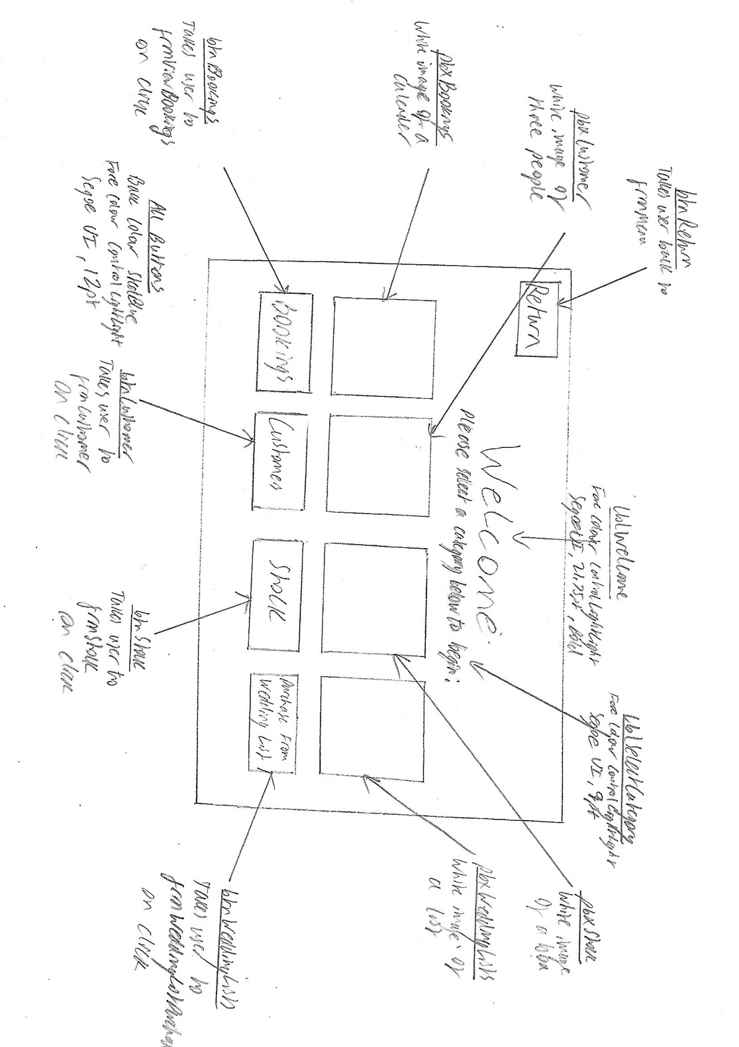**frmWelcome**



After showcasing the initial design to the client, the following improvement were suggested:

* Change the order of the picture boxes and buttons, so that it goes in the order: Customers, Stock, View Bookings, Purchase from Wedding List



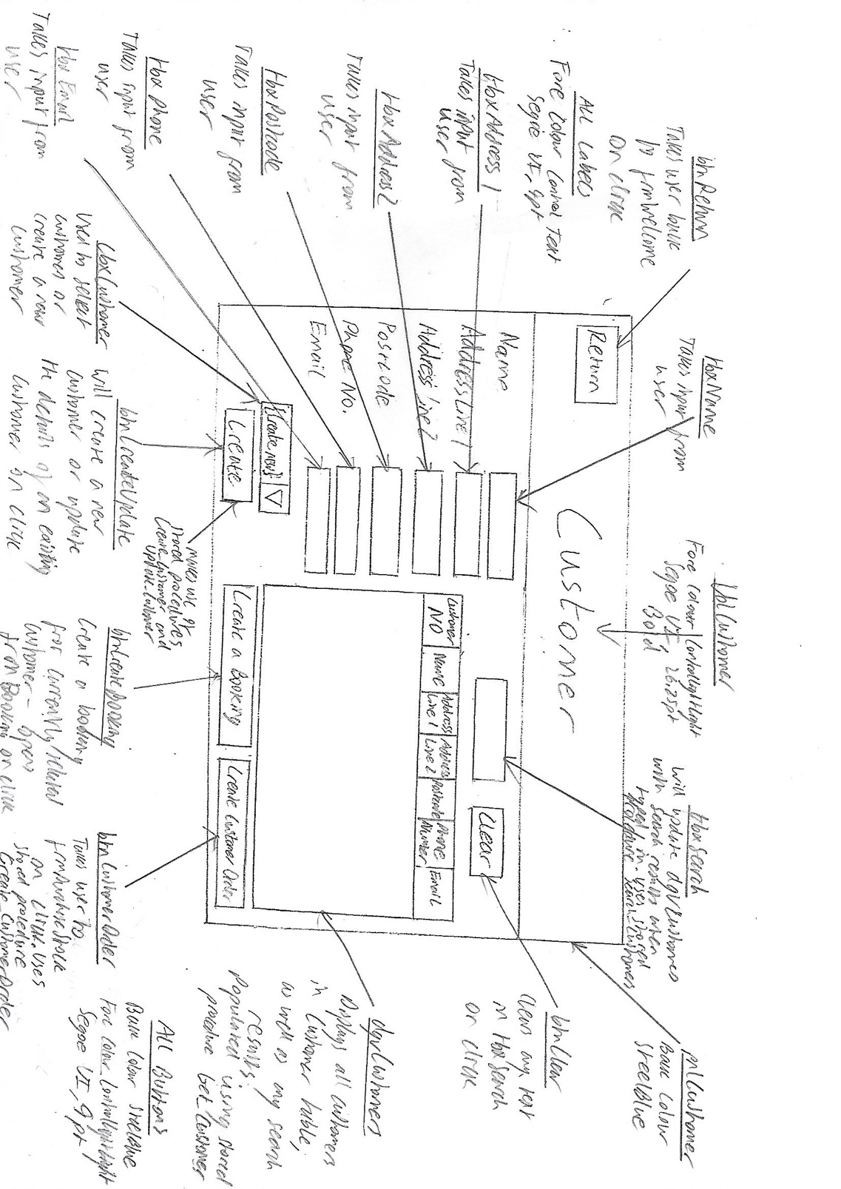**frmCustomer**



After showcasing the initial design to the client, the following improvement were suggested:

* Move **btnCreateBooking** to the left, beside **btnCreateUpdate**

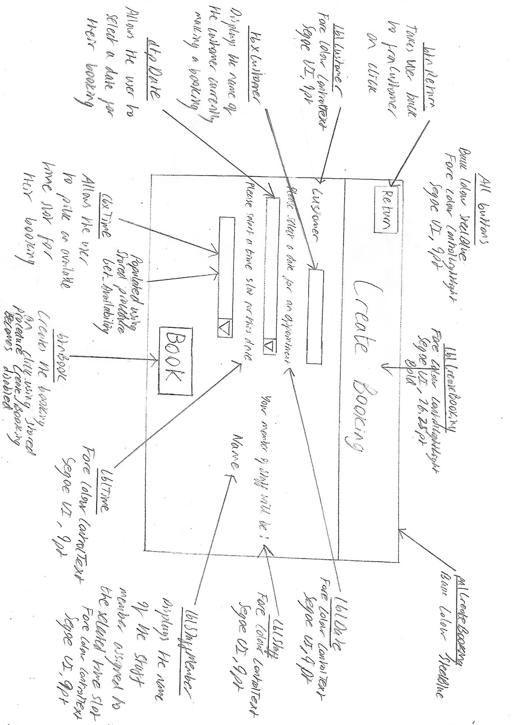**frmBooking**



After showcasing the initial design to the client, the following improvements were suggested:

* Move **lblTime** and **cbxTime** so that they are on the right-hand side of the form, above **lblStaff** and **lblStaffMember**
* Increase the font size of btnBook from 9 pt to 12 pt



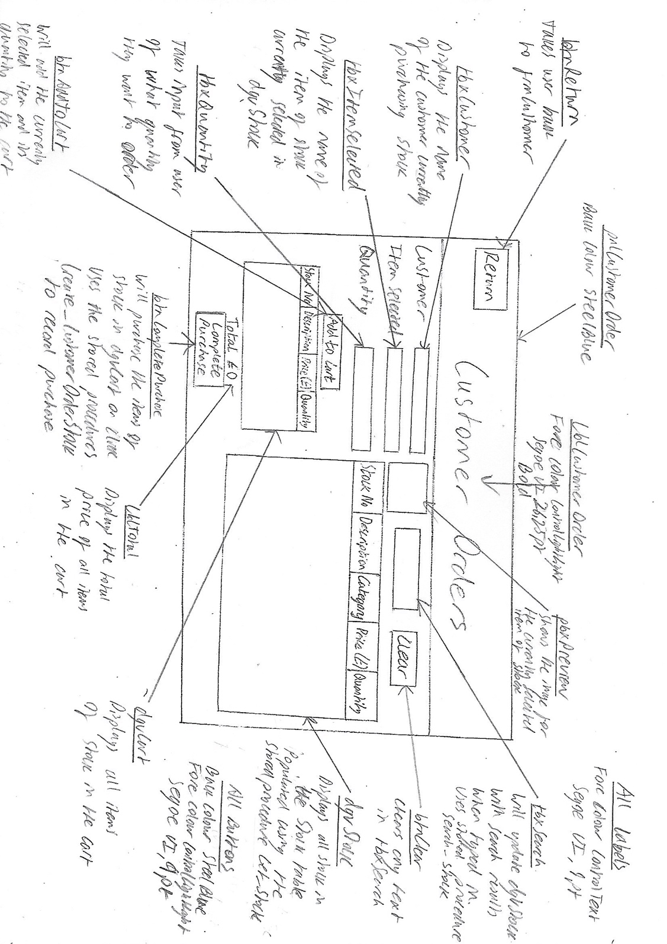**frmPurchaseStock**



After showcasing the initial design to the client, the following improvements were suggested:

* Move **pbxPreview** so it is to the right of **btnClear**
* Change the text of **lblCustomerOrder** at the top of the form so that it says “Purchase Stock” instead of “Customer Orders”



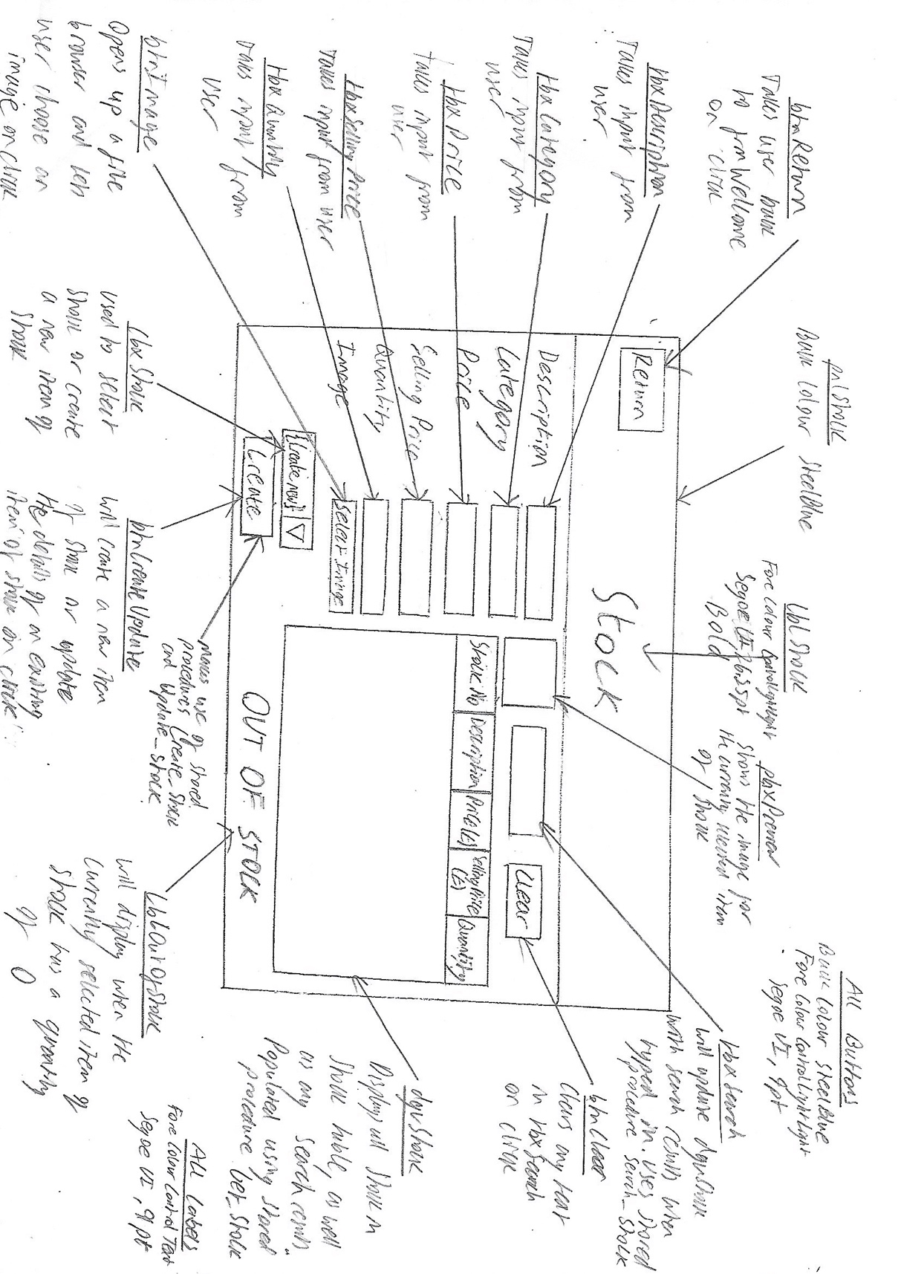**frmStock**

After showcasing the initial design to the client, the following improvements were suggested:

* As already mentioned, move **pbxPreview** so it is to the right of **btnClear**
* Move **lblOutOfStock** so it is above all the input fields on the left-hand side



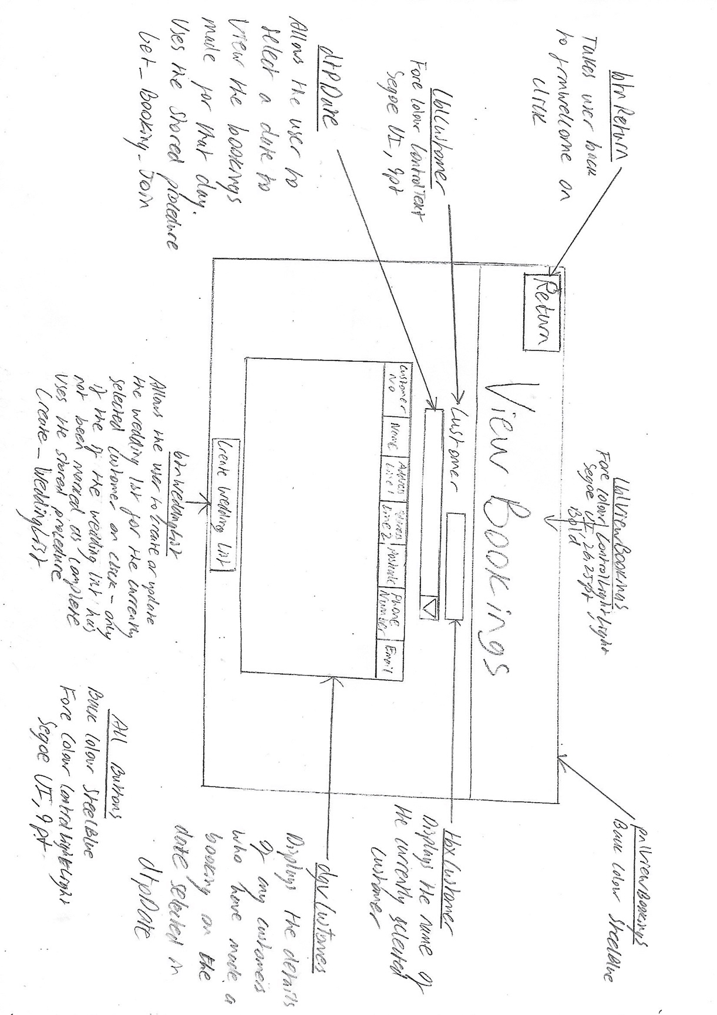**frmViewBookings**



After showcasing the initial design to the client, the following improvement was suggested:

* Move **dtpDate** so it is above **lblCustomer** and **tbxCustomer**



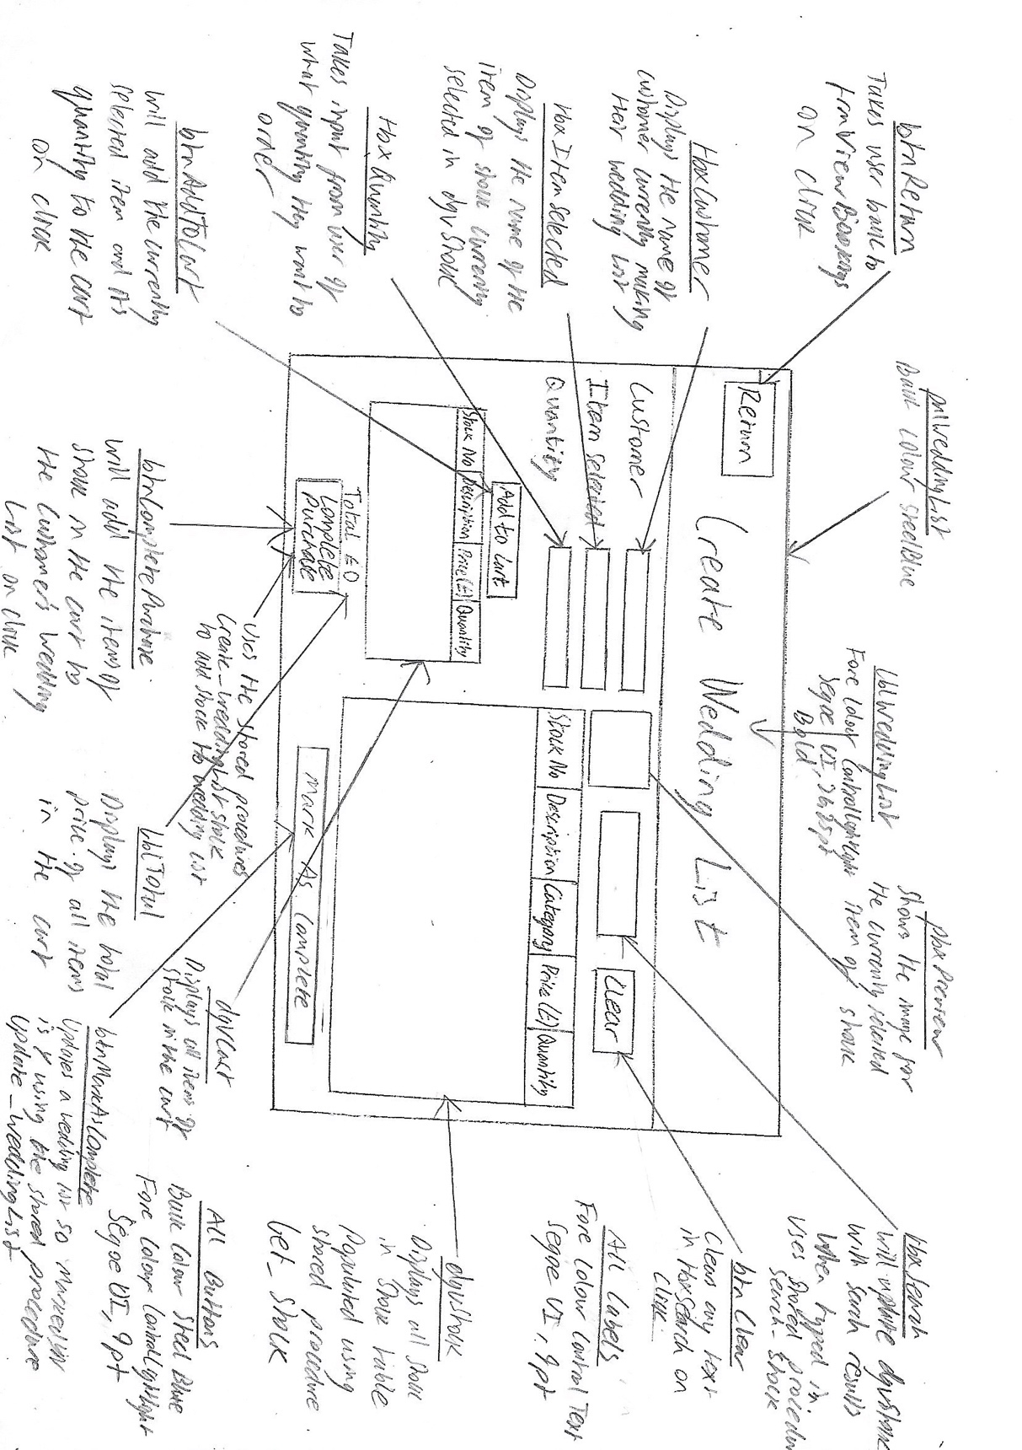**frmWeddingListStock**

After showcasing the initial design to the client, the following improvements were suggested:

* As already mentioned, move **pbxPreview** so it is to the right of **btnClear**
* Change the text of **btnCompletePurchase** so it says “Add To Wedding List” instead of “Complete Purchase”

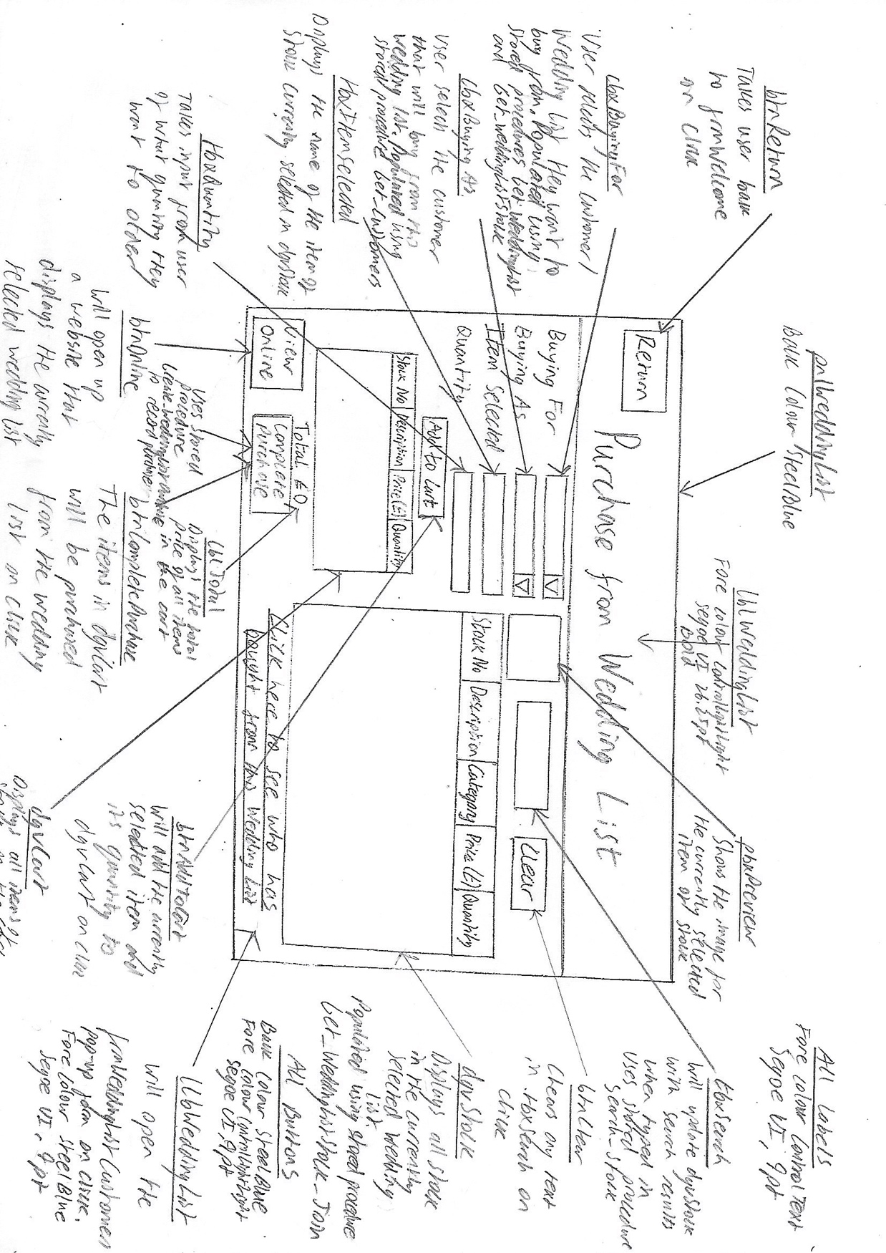**frmWeddingListPurchase**



After showcasing the initial design to the client, the following improvements were suggested:

* As already mentioned, move **pbxPreview** so it is to the right of **btnClear**
* Move **btnOnline** so that it is above the hyperlink **llbWeddingList**
* Make the hyperlink **llbWeddingList** smaller so that the text is all able to fit on one line



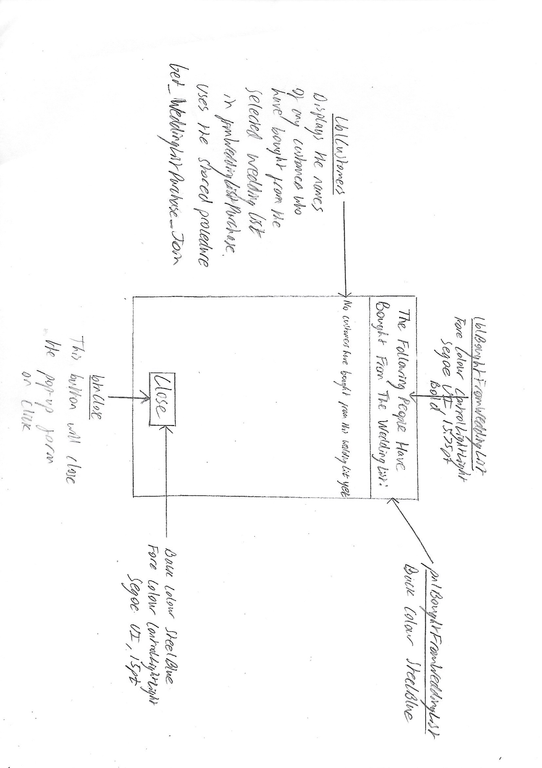**frmWeddingListCustomers**

The client suggested no improvements for this form

**frmMenu**

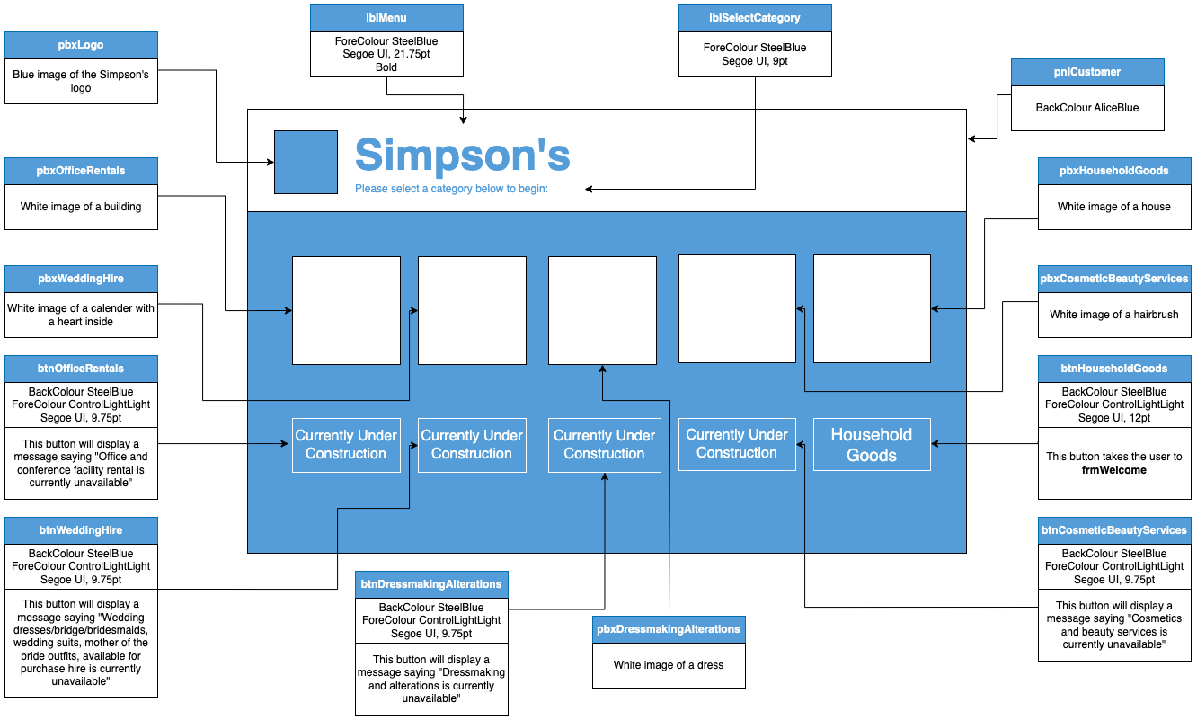

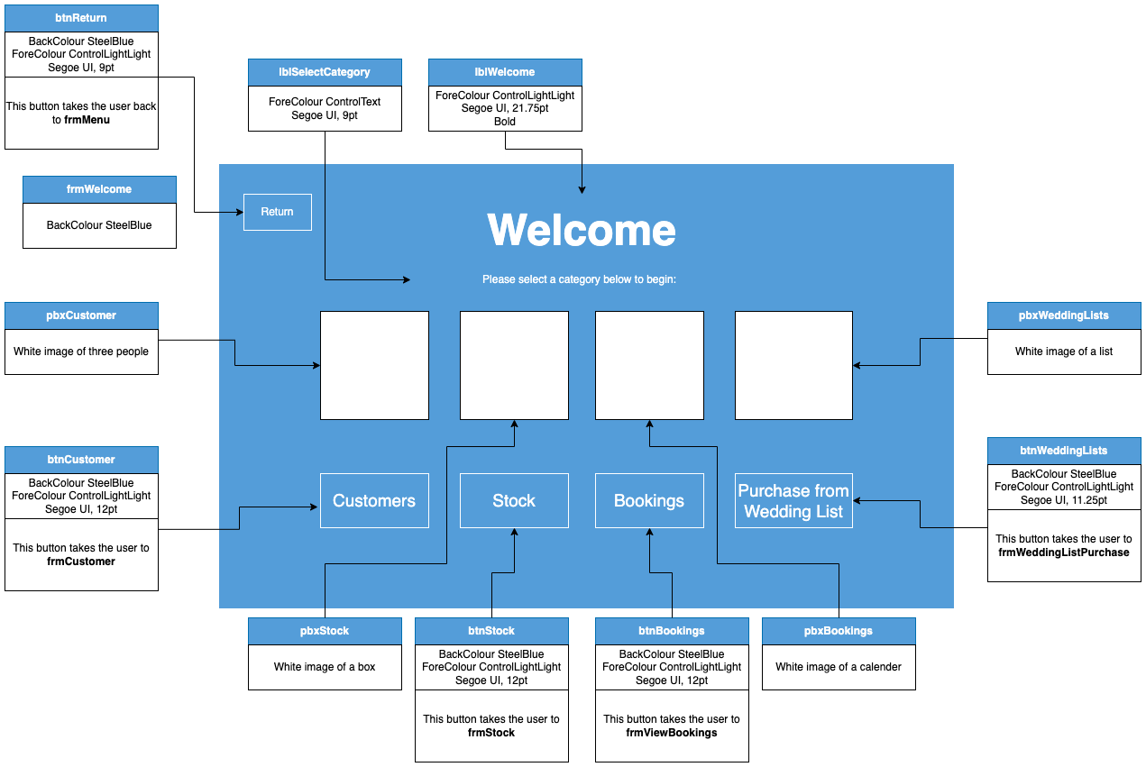**frmWelcome**

**frmCustomer**

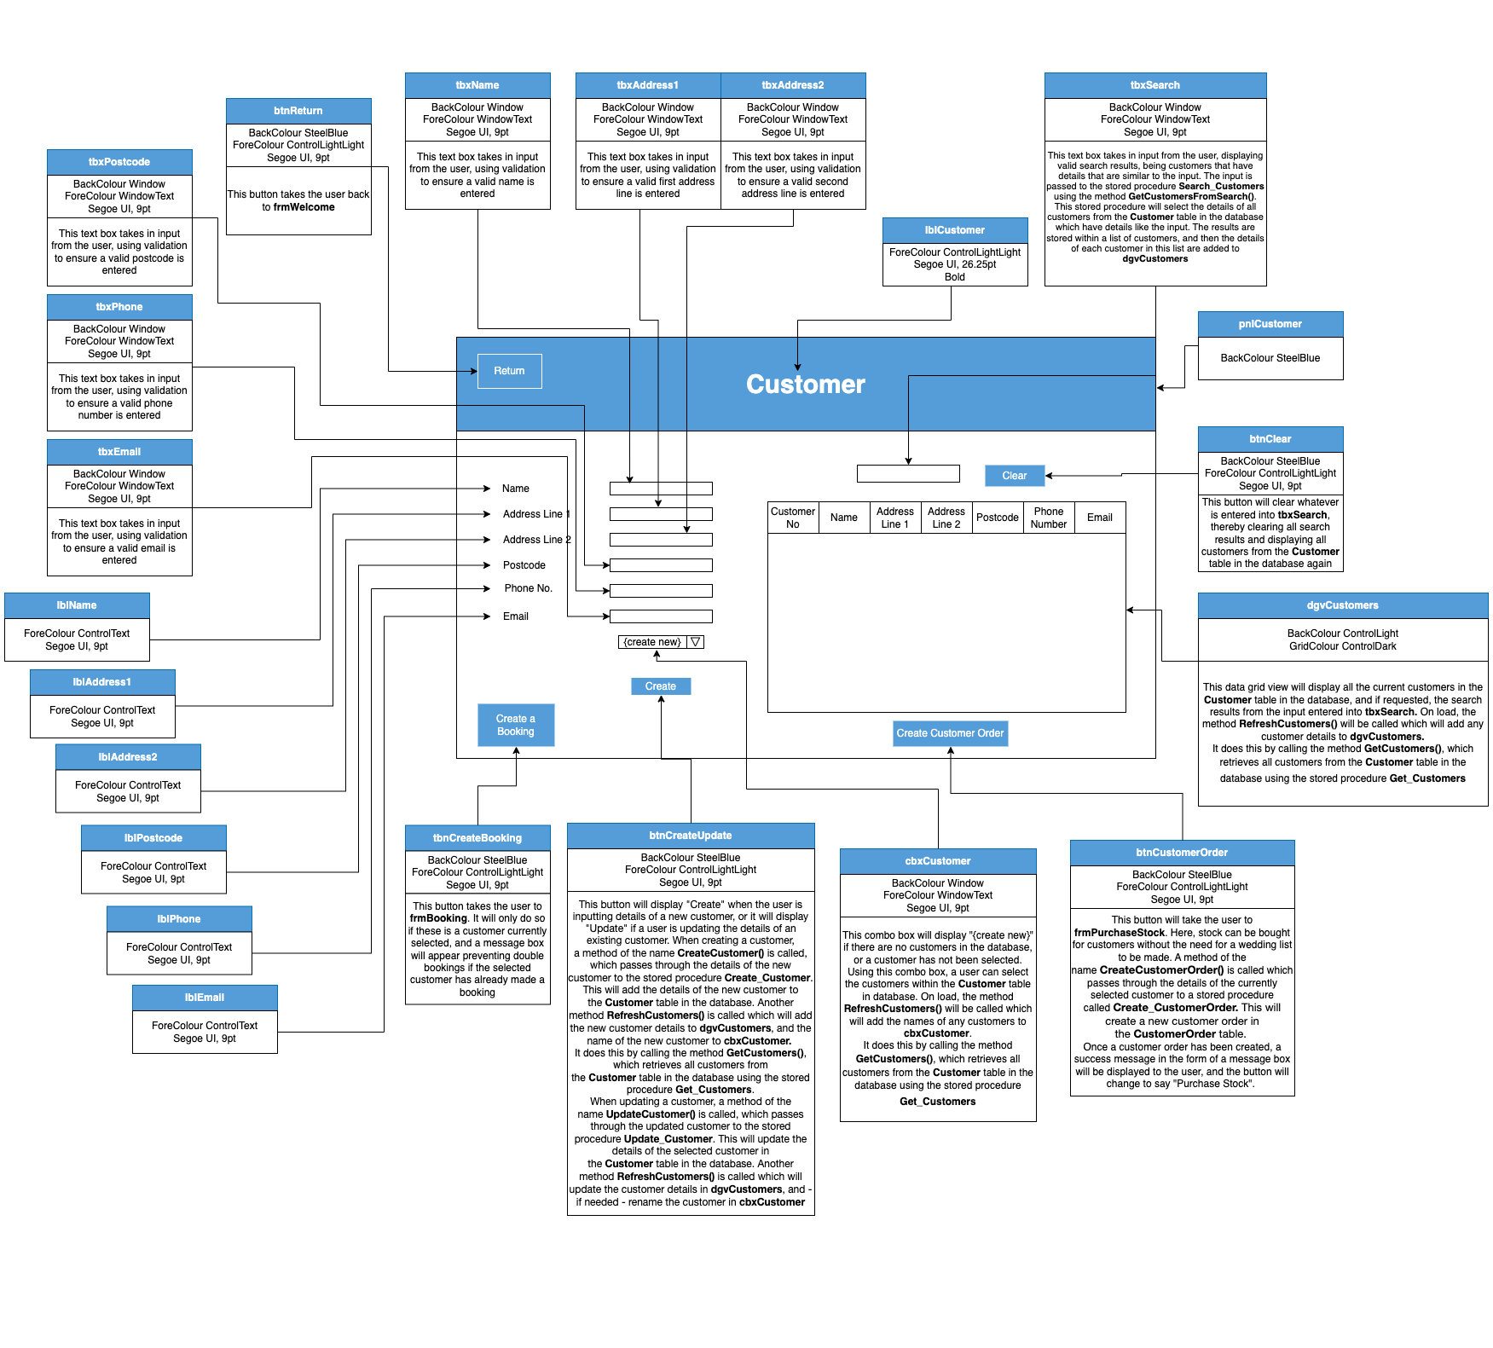

**frmBooking**

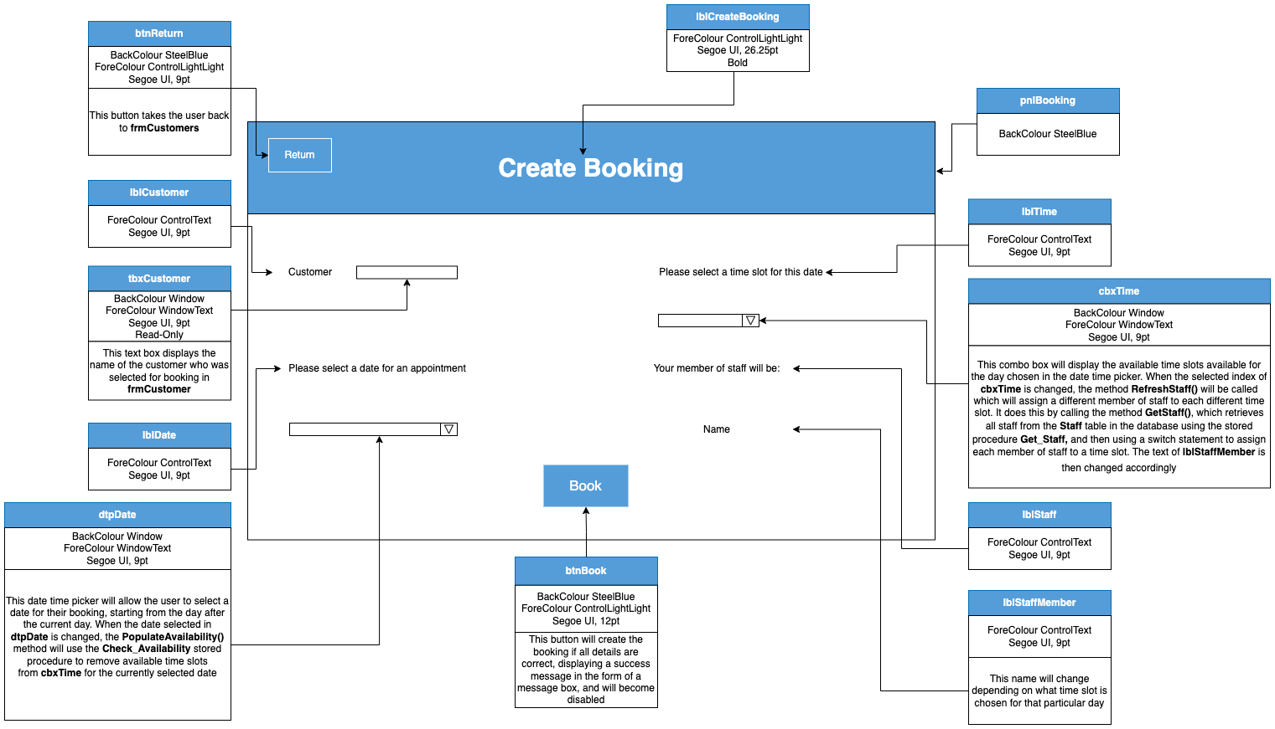

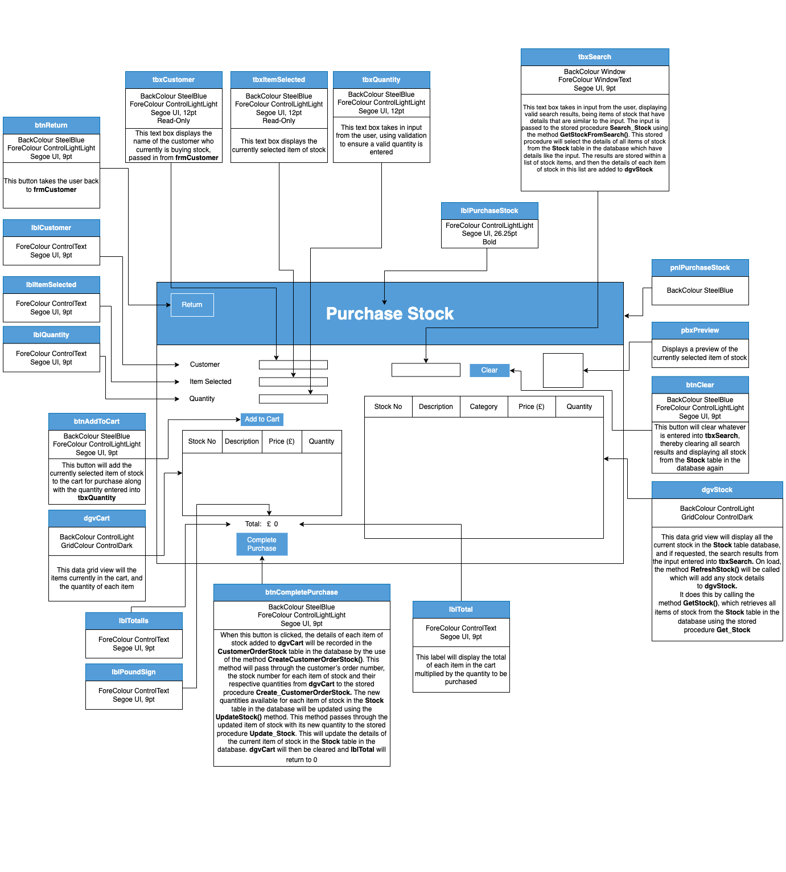**frmPurchaseStock**

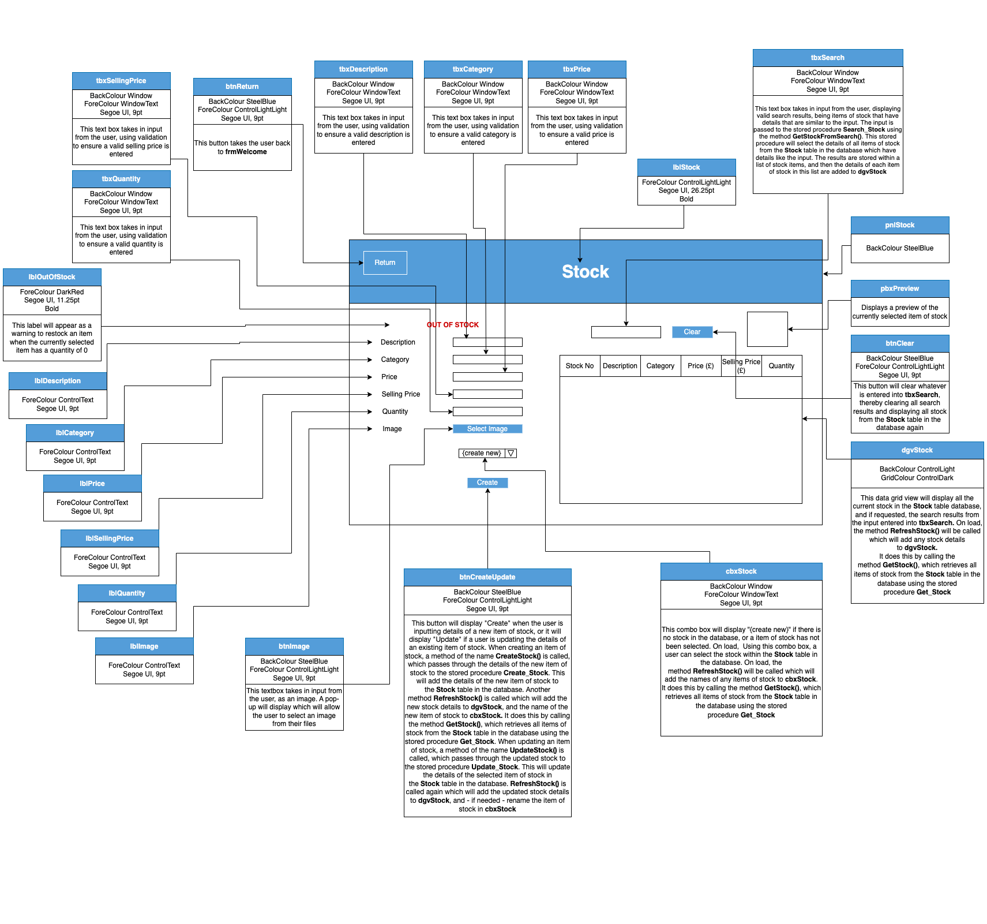**frmStock**

**frmViewBookings**

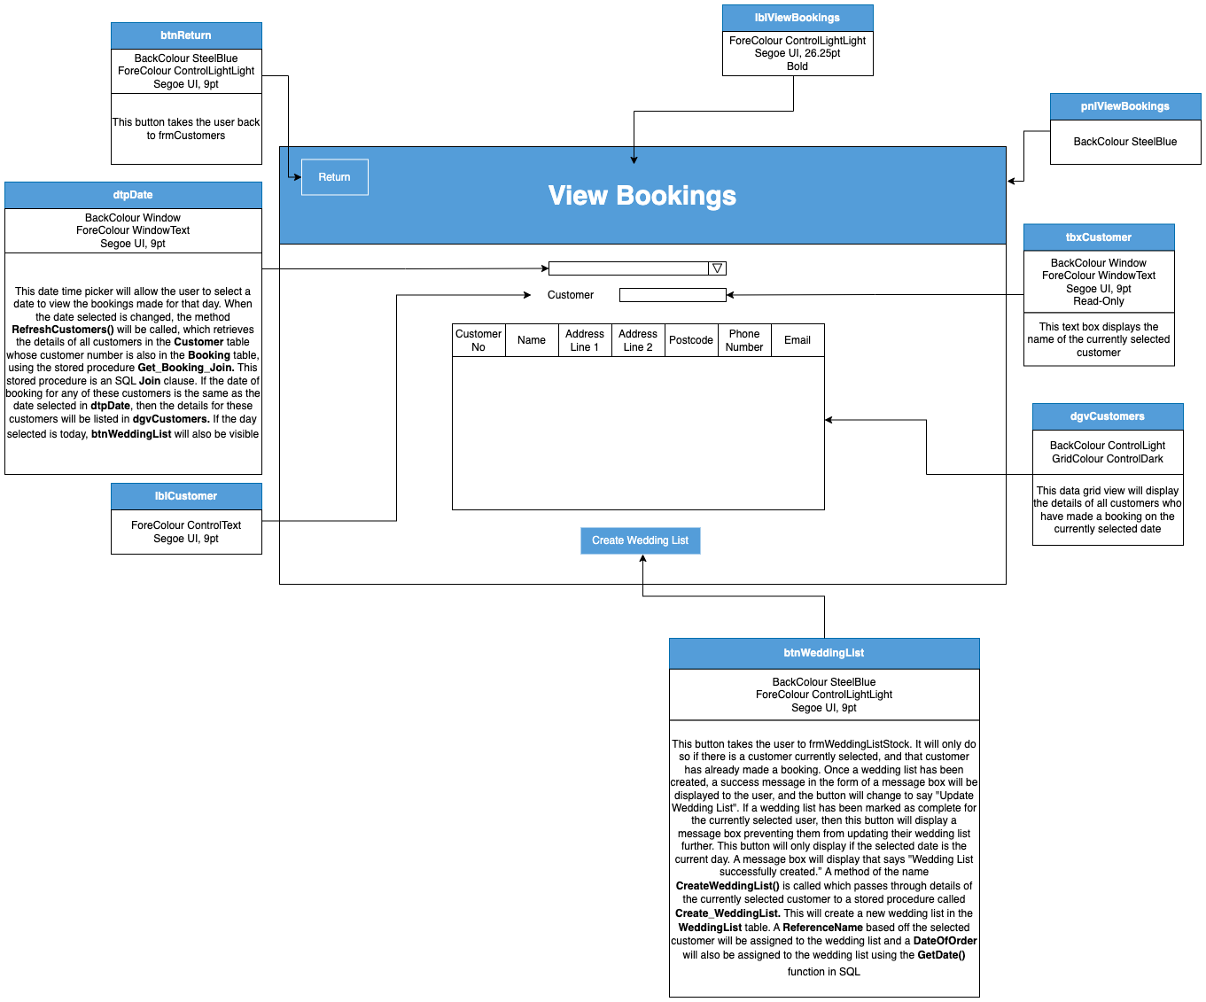

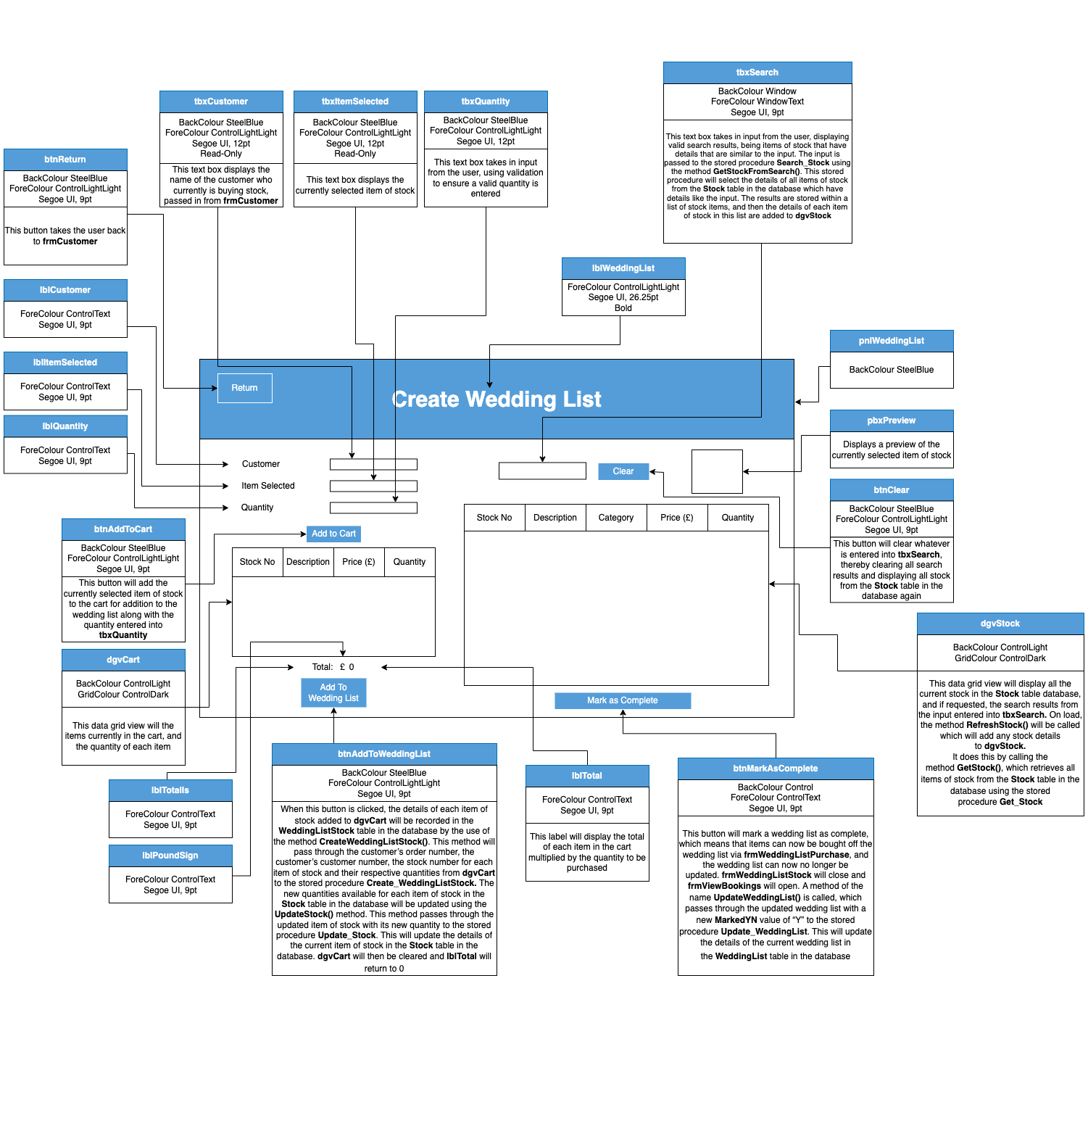**frmWeddingListStock**

**frmWeddingListPurchase**

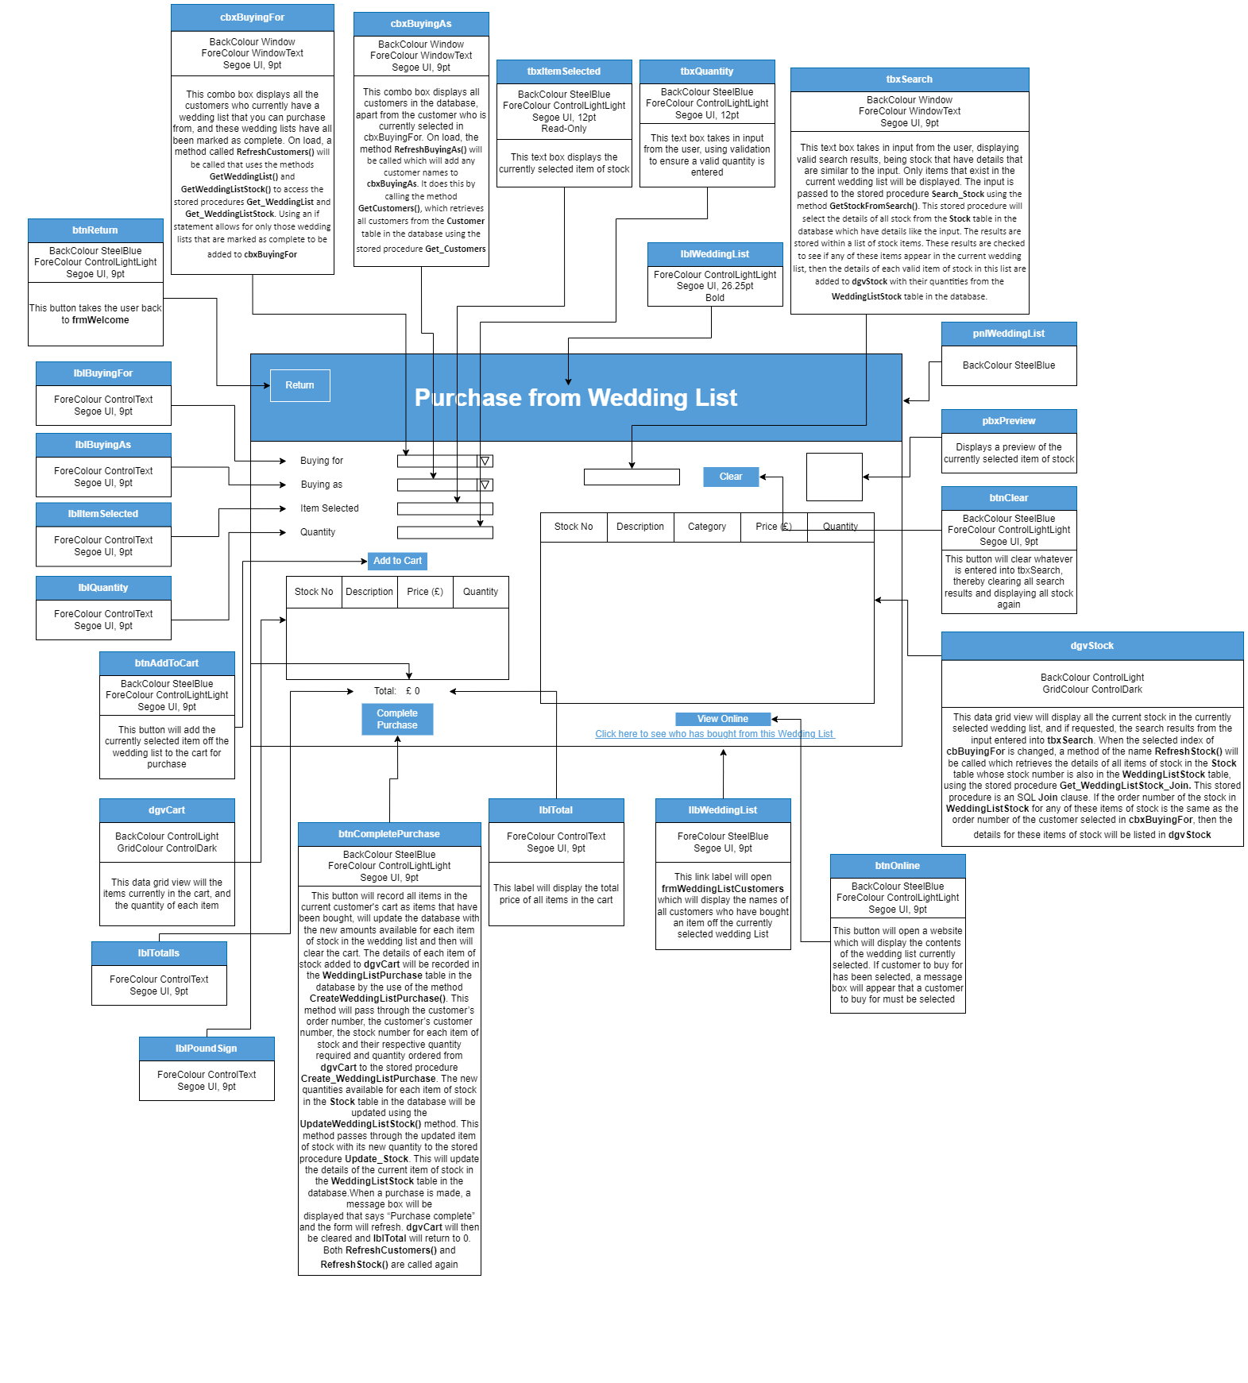

**frmWeddingListCustomers**

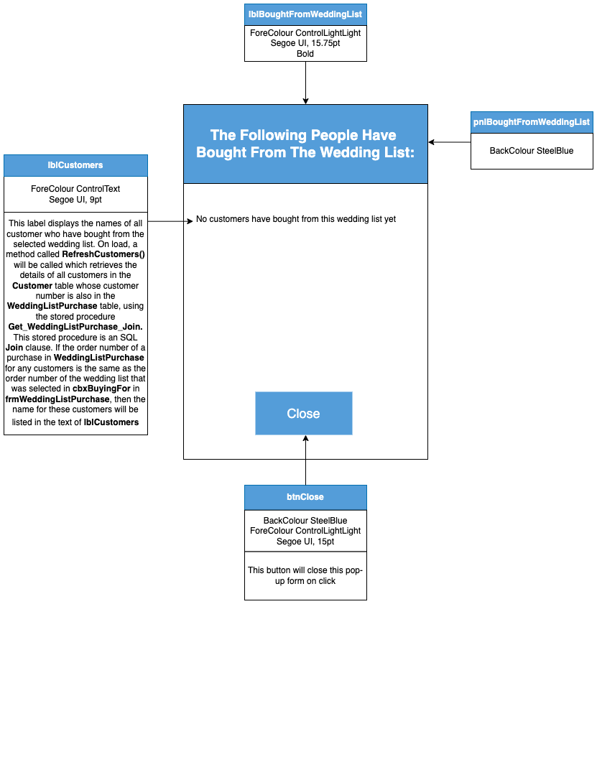

# Testing

## Black Box Testing

Black box testing is a method used in the testing of software to examine the input and output behaviour of an application without looking into its internal structures or workings. It is performed at many levels, as the black box can represent the whole system at the acceptance and system testing levels, a subsystem at the integration testing level or just a single unit at the unit testing level. At the acceptance test level it is the responsibility of the user, however, at the unit test level it is the responsibility of the developer and at the system test level it is the responsibility of the analyst. The functional requirements of the application are required for base tests, use cases are required at the system test level, and at unit test level, the detailed design specification is required.

During testing, the tester will provide input and the output produced is inspected. Inputs that result in both success and failure are required to be tested, and the results of an failed tests can be examined to see if appropriate error messages are produced. It would be impractical to test all the possible inputs (called exhaustive testing), so selected inputs are used instead. A common method to select these inputs to be tested is called Equivalence Partitioning, where the input data of a software unit is divided into partitions of equivalent data from which test cases can be derived.

Black box testing offers the advantage of allowing testers with no programming knowledge to test the system and the testing therefore can be performed by independent testers. Since the behaviour of the system is tested, any functionality that is missing can be highlighted. Black box test cases can also be designed as soon as the functional specifications are complete.

However, there are some disadvantages to black box testing. For example, there is such a wide range of possible inputs that it becomes impractical to do exhaustive testing for every possible input. As well, it’s impossible to know whether every line of code is being executed as expected as the underlying functionality of the application is not visible. If code has not been executed it has not been tested.

In the testing of this system, I will be using black box testing to ensure that the system's user interface, data input and output, and overall usability meet the highest standard. For example, one area in which I will be using black box testing will be in the Purchase Stock form, where I will be testing that system accurately records and processes customer orders, and that if there are any errors that the necessary alerts and error messages are displayed.

## White Box Testing

White box testing is a method used in the testing of software to test the internal structure or workings of an application, as opposed to its functionality. It serves the purpose of analysing the internal workings, algorithms, and logic of the application. It is mainly carried out at the unit testing level, using programmers who know and understand the internal logic. It is the responsibility of the programmer/developer. With white box testing, access to the actual code and algorithms is required in order for testing to be carried out.

Test cases should be written to test all possible execution paths of the code so that all the statements are covered in the tests. White box testing should ensure that loops are skipped altogether, executed at least once, and more than one, and that are paths/statements are executed at least once and that each possible branch of a conditional statement is executed.

White box testing has the advantages of providing a thorough test – each line of code has been checked. It helps to tidy up and optimise code for better performance, and while testing it is easy to know which input values the application should be tested with. It gives the developer an idea of how to fix or debug the code.

However, with white box testing, the tester must be a knowledgeable in programming and therefore the tester’s time is more costly. As well, it may be difficult to test every line of code in a large system.

In the testing of this system, I will be using white box testing to ensure that the system's internal workings, such as its code and stored procedures will be working as expected. For example, one area in which I will be using white box testing will be in the Wedding List Purchase form, where I will be testing that the method SortWeddingListStock() works as expected. I will add breakpoints to the code to ensure that all the methods such as DeleteWeddingListStock() and CreateWeddingListStock() are called, and that these pass the correct wedding list stock details to their respective stored procedures Delete_WeddingListStock and Create_WeddingListStock.

## Unit Testing

A unit test looks at a small part of an application, such as a class or a web page, and ensures that it works as expected. The unit is tested in isolation from the rest of the system so that the tester is able to easily identify where any problems are occurring and how they should approach the fix for them. The internal behaviour of a single unit is the focus, rather than its interaction with other units. To help facilitate the testing, code may be added by the tester to the unit act as a “test harness”, helping to stand in for any missing parts of the system. This test harness may receive any results or pass data to objects. For unit testing, both black box and white box testing are used. Programmers often perform these unit tests as they write the code, and while it is preferable for someone other than the programmer, such as an independent person who is impartial and objective, to perform the tests, this usually does not happen. In XP, the developers will design the unit tests before any code for the unit is wrote, and they use the design specification as a guide. This practice is known as TDD, or Test-Driven Development. XP offers the advantage of paired programming, so programmers can check each other’s code during unit testing.

In the testing of this system, I will be using unit testing to ensure that the different classes in the system work on their own as expected. For example, one area in which I will be using unit testing will be in the Customer form, where I will be testing that system accurately creates a new customer when the “Click” button is created. This will test many different areas of this class, such as the properties for a new Customer object to ensure that validation works. It will then test that the CreateCustomer() method is successfully called, and that it passes through the details of the new customer to the stored procedure Create_Customer.

## Integration Testing

Integration testing is when several associated, independent, modules or classes are tested together in a group or subsystem. It is carried out to check that different units of code work together as intended without errors. It is used to verify and check that the code matches the architectural model or the high-level design specification, and there is a focus on the flow of data, messages, and information from one class or module to another. Just like in unit testing, code may have to be created to stand in for missing parts of the system. The testing at this stage is mainly black box because the focus is on the interaction between the different modules and the data passed between subsystems rather than the internal code. Integration test cases can be made as soon as the design specification has been created. The person chose to carry out integration testing is dependent on what level of integration is involved. At a high level, called system integration or integration in the large, is when several subsystems are interconnected, and for this the analyst who designed the system will usually be responsible for test design as they know and understand how the modules link together. Integration testing could also be classes as a low-level process, which is where a small number of classes are tested together. If it is this level of integration testing, then usually a programmer will design and run the tests. It is important in Object Orientated Programming, and it is usually hard to test a single object without linking it to another object. It is a good practice to carry out integration tests throughout the development of an application rather than leaving the integration of all classes till the end. This idea is promoted in Agile methodologies.

In the testing of this system, I will be using integration testing to ensure that the different classes in the system work together as expected. For example, one area in which I will be using integration testing will be in the Wedding List Purchase form, where I will be testing that system accurately returns search results of stock that are only in the currently selected wedding list. The input will be passed to the stored procedure Search_Stock using the method GetStockFromSearch(), which is in the Stock class. Then, a list of all Wedding List Stock items will be made using the method GetWeddingListStock(), which is in the WeddingListStock class. A “For” loop will be used to ensure that the details of each item of stock in the search results are added to the data grid viewwith their respective quantities from theWeddingListStocktable in the database, only if these items of stock are also in the currently selected wedding list.

## System Testing

System testing is when all subsystems are integrated together to make a complete software system that is tested. The focus is to make sure that the software meets all of the functional and non-functional requirements. The functional requirements can be expressed as a set of use cases with their various scenarios. There is also a focus on whether the system was developed correctly. The whole system is tested as one black box, where the underlying code is not analysed. Functional tests are used to test the input and output behaviour, and non-functional tests are used to test areas such as reliability, performance, usability and security. These tests should be carried out on a system that is likely to be used in the real working environment of the business of the customer. No code is required to replace missing parts as the entire system has been made. System test cases will be made as soon as the requirements specification is ready. These tests will be carried out by members of the team who did not write any of the code, which in most cases is the analyst, or a separate team of independent testers. System testing is carried out after integration testing for all subsystems has been carried out. After system testing is complete, acceptance testing is carried out.

In the testing of this system, I will be using system testing to ensure that the whole system works as expected, and that all of its components work seamlessly together. I will be using system testing when I carry out a full test of the system, to ensure that it all works as expected and that there is not any hidden errors. This is a crucial part of testing, as the customer will carry out a full test of the system in the acceptance testing, to ensure that the system meets their requirements, so it is crucial to ensure that the system works as expected.

## Acceptance Testing

Acceptance testing is carried out on the complete whole system, with a focus on the customer’s judgement. It is done to ensure that that the correct software has been made and that it meets the customer’s requirements, and it is also done to check that the system is complete and approved for use. It makes sure the system is ready for operational use and that it is accepted by the users. It also has a focus on if the system has met the criteria laid out in the Terms of Reference contract. The tests are very similar to system tests; however, these tests will be carried out by the end user/the customer instead of the team who developed the software. They will be usually carried out in the customer’s place of work, but they can also be carried out in the software company which will simulate the customer’s working environment. These tests are black box tests as the user will not be able to view the code. The user is expected to test the system in unusual ways by entering both valid and invalid data and they are also expected to test the entire system. There are two kinds of acceptance testing:

Alpha – This is conducted by a selected user group or test engineers at the developer’s work site in a controlled environment. Alpha testing is carried out with the company’s software and hardware and the developers may also provide test data to be used.

Beta – This is conducted in a real-world uncontrolled environment (the site of the user), with the software and hardware of the user, using any test data that the user chooses. Users are not typically chosen, and instead the software is normally downloaded by the user from a website.

The test cases for acceptance testing are usually wrote at the start of the project in accordance with the business requirements, with some tests wrote for each requirement in some cases. Different user groups can be used for testing, and the test cases will be designed with the customer.

In the testing of this system, I will be using acceptance testing to ensure that the system meets the requirements of the customer, Simpson’s. Acceptance testing could be carried out in a number of different ways, such as having George Simpson, the owner of Simpson’s department store, test the system. It is more important, however, to ensure that the system also meets the requirements of the household goods staff, as they are the ones who are going to be using the system, so it is crucial that they also carry out the acceptance testing.

# Test Plan

|  |  |  |  |  |  |  |  |
| --- | --- | --- | --- | --- | --- | --- | --- |
| **Test No.** | **Form Being Tested** | **Reason For Test** | **Link To User Requirement** | **Test Data** | **Expected Outcome** | **Pass? *✓* / 𝑥** | **Corrective Action #** |
| **Menu Form** | | | | | | | |
|  | **frmMenu** | Check that when the user clicks on **btnOfficeRentals**, a message box will appear to tell them that this section of the software is currently not | 5, 6 | Click **btnOfficeRentals** | A message box will display that says "Office and conference facility rental is currently unavailable" | *✓* | N/A |
|  | **frmMenu** | Check that when the user clicks on **btnWeddingHire**, a message box will appear to tell them that this section of the software is currently not | 5, 6 | Click **btnWeddingHire** | A message box will display that says "Wedding dresses/bridge/bridesmaids, wedding suits, mother of the bride outfits, available for purchase hire is currently unavailable" | *✓* | N/A |
|  | **frmMenu** | Check that when the user clicks on **btnDressmakingAlterations**, a message box will appear to tell them that this section of the software is currently not | 5, 6 | Click **btnDressmakingAlterations** | A message box will display that says "Dressmaking and alterations is currently unavailable" | *✓* | N/A |
|  | **frmMenu** | Check that when the user clicks on **btnCosmeticBeautyServices**, a message box will appear to tell them that this section of the software is currently not | 5, 6 | Click **btnCosmeticBeautyServices** | A message box will display that says "Cosmetics and beauty services is currently unavailable" | *✓* | N/A |
|  | **frmMenu** | Check that when the user clicks on **btnHouseholdGoods**, **frmMenu** will close and **frmWelcome** will open | 5, 7 | Click **btnHouseholdGoods** | **frmMenu** will close and **frmWelcome** will open | *✓* | N/A |
| **Welcome Form** | | | | | | | |
|  | **frmWelcome** | Check that when the user clicks on **btnCustomer**, **frmWelcome** will close and **frmCustomer** will open | 8 | Click **btnCustomer** | **frmWelcome** will close and **frmCustomer** will open | *✓* | N/A |
|  | **frmWelcome** | Check that when the user clicks on the **btnStock**, **frmWelcome** will close and **frmStock** will open | 8 | Click **btnStock** | **frmWelcome** will close and **frmStock** will open | *✓* | N/A |
|  | **frmWelcome** | Check that when the user clicks on the **btnBookings**, **frmWelcome** will close and **frmViewBookings** will open | 8 | Click **btnBookings** | **frmWelcome** will close and **frmViewBookings** will open | *✓* | N/A |
|  | **frmWelcome** | Check that when the user clicks on the **btnWeddingLists**, **frmWelcome** will close and **frmWeddingListPurchase** will open | 8 | Click **btnWeddingLists** | **frmWelcome** will close and **frmWeddingListPurchase** will open | *✓* | N/A |
| Returning to the Menu Form | | | | | | | |
|  | **frmWelcome** | Check that when the user clicks on **btnReturn**, **frmWelcome** will close and **frmMenu** will open | 9 | Click **btnReturn** | **frmWelcome** will close and **frmMenu** will open | *✓* | N/A |
| **Customer Form** | | | | | | | |
| Load Events | | | | | | | |
|  | **frmCustomer** | Check that the **Customer** table in the database can be accessed on the load event of **frmCustomer** | 10 | Open **frmCustomer** with SQL Server Management Studio running and the database connected | On load, the method **RefreshCustomers()** will be called which will add any customer details to **dgvCustomers**, and the names of any customers to **cbxCustomer**.  It does this by calling the method **GetCustomers()**, which retrieves all customers from the **Customer** table in the database using the stored procedure **Get_Customers** | *✓* | N/A |
|  | **frmCustomer** | Check that if the **Customer** table in the database cannot be accessed on the load event of **frmCustomer,** the user is not able to access **frmCustomer** and is returned to **frmWelcome** | 11 | Open **frmCustomer** with SQL Server Management Studio not running | A message box will display that says “Could not get customers”. **frmCustomer** will close and **frmWelcome** will open | *✓* | N/A |
| Validation | | | | | | | |
|  | **frmCustomer** | Check **tbxName** accepts valid data | 12 | **tbxName** Enter the following:  “John Doe” | Input is accepted with no errors thrown. If all other details are correct the new customer is created | *✓* | N/A |
|  | **frmCustomer** | Check **tbxName** accepts invalid data | 12 | **tbxName** Enter the following:  “Jo” | Input is accepted with no errors thrown. User is told customer name must be equal to or longer than 3 characters | *✓* | N/A |
|  | **frmCustomer** | Check **tbxName** accepts invalid data | 12 | **tbxName** Enter the following:  “Johnathan Michael Alexander Doe” | Input is accepted with no errors thrown. User is told customer name must be less than 30 characters long | *✓* | N/A |
|  | **frmCustomer** | Check **tbxName** accepts invalid data | 12 | **tbxName** Enter the following:  “John Doe 2” | Input is accepted with no errors thrown. User is told customer name cannot contain numbers or symbols | *𝑥* | Corrective Action 1 |
|  | **frmCustomer** | Check **tbxName** accepts extreme data | 12 | **tbxName** Enter the following:  “Jonathan Alexander Xavier Doe” | Input is accepted with no errors thrown. If all other details are correct the new customer is created | *✓* | N/A |
|  | **frmCustomer** | Check **tbxName** accepts null data | 12 | **tbxName** Enter the following:  “” | Input is accepted with no errors thrown. User is told they must enter a customer name | *✓* | N/A |
|  | **frmCustomer** | Check **tbxAddress1** accepts valid data | 12 | **tbxAddress1** Enter the following:  “123 Main St” | Input is accepted with no errors thrown. If all other details are correct the new customer is created | *✓* | N/A |
|  | **frmCustomer** | Check **tbxAddress1** accepts invalid data | 12 | **tbxAddress1** Enter the following:  “12” | Input is accepted with no errors thrown. User is told the customer’s first address line must be equal to or longer than 3 characters | *✓* | N/A |
|  | **frmCustomer** | Check **tbxAddress1** accepts invalid data | 12 | **tbxAddress1** Enter the following:  “1234 Main Street North-Eastern Residential Area Unit 5A” | Input is accepted with no errors thrown. User is told the customer’s first address line must be less than 50 characters long | *✓* | N/A |
|  | **frmCustomer** | Check **tbxAddress1** accepts extreme data | 12 | **tbxAddress1** Enter the following:  “1234 Main Street North-Eastern Residential Area 5” | Input is accepted with no errors thrown. If all other details are correct the new customer is created | *✓* | N/A |
|  | **frmCustomer** | Check **tbxAddress1** accepts null data | 12 | **tbxAddress1** Enter the following:  “” | Input is accepted with no errors thrown. User is told they must enter a first address line | *✓* | N/A |
|  | **frmCustomer** | Check **tbxAddress2** accepts valid data | 12 | **tbxAddress2** Enter the following:  “Apt 4B” | Input is accepted with no errors thrown. If all other details are correct the new customer is created | *✓* | N/A |
|  | **frmCustomer** | Check **tbxAddress2** accepts invalid data | 12 | **tbxAddress2** Enter the following:  “Ap” | Input is accepted with no errors thrown. User is told the customer’s second address line must be equal to or longer than 3 characters | *✓* | N/A |
|  | **frmCustomer** | Check **tbxAddress2** accepts invalid data | 12 | **tbxAddress2** Enter the following:  “Apt 4B, 23 Oxford Street North-Eastern Heights Area” | Input is accepted with no errors thrown. User is told the customer’s second address line must be less than 50 characters long | *✓* | N/A |
|  | **frmCustomer** | Check **tbxAddress2** accepts extreme data | 12 | **tbxAddress2** Enter the following:  “Apt 4B, 23 High Street North-Eastern Heights Area” | Input is accepted with no errors thrown. If all other details are correct the new customer is created | *✓* | N/A |
|  | **frmCustomer** | Check **tbxAddress2** accepts null data | 12 | **tbxAddress2** Enter the following:  “” | Input is accepted with no errors thrown. User is told they must enter a second address line | *✓* | N/A |
|  | **frmCustomer** | Check **tbxPostcode** accepts valid data | 12 | **tbxPostcode** Enter the following:  “SW129AB” | Input is accepted with no errors thrown. If all other details are correct the new customer is created | *✓* | N/A |
|  | **frmCustomer** | Check **tbxPostcode** accepts invalid data | 12 | **tbxPostcode** Enter the following:  “SW12” | Input is accepted with no errors thrown. User is told customer postcode must be 7 characters long | *✓* | N/A |
|  | **frmCustomer** | Check **tbxPostcode** accepts invalid data | 12 | **tbxPostcode** Enter the following:  “SW129ABC” | Input is accepted with no errors thrown. User is told customer postcode must be 7 characters long | *✓* | N/A |
|  | **frmCustomer** | Check **tbxPostcode** accepts null data | 12 | **tbxPostcode** Enter the following:  “” | Input is accepted with no errors thrown. User is told they must enter a postcode | *✓* | N/A |
|  | **frmCustomer** | Check **tbxPhone** accepts valid data | 12 | **tbxPhone** Enter the following:  “07123456789” | Input is accepted with no errors thrown. If all other details are correct the new customer is created | *✓* | N/A |
|  | **frmCustomer** | Check **tbxPhone** accepts invalid data | 12 | **tbxPhone** Enter the following:  “07123456” | Input is accepted with no errors thrown. User is told customer phone number must be 11 characters long | *✓* | N/A |
|  | **frmCustomer** | Check **tbxPhone** accepts invalid data | 12 | **tbxPhone** Enter the following:  “071234567894242” | Input is accepted with no errors thrown. User is told customer phone number must 11 characters long | *✓* | N/A |
|  | **frmCustomer** | Check **tbxPhone** accepts invalid data | 12 | **tbxPhone** Enter the following:  “telephoneno” | Input is accepted with no errors thrown. User is told customer phone number cannot contain letters or symbols | *𝑥* | Corrective Action 2 |
|  | **frmCustomer** | Check **tbxPhone** accepts null data | 12 | **tbxPhone** Enter the following:  “” | Input is accepted with no errors thrown. User is told they must enter a phone number | *✓* | N/A |
|  | **frmCustomer** | Check **tbxEmail** accepts valid data | 12 | **tbxEmail** Enter the following:  “johndoe@gmail.com” | Input is accepted with no errors thrown. If all other details are correct the new customer is created | *✓* | N/A |
|  | **frmCustomer** | Check **tbxEmail** accepts invalid data | 12 | **tbxEmail** Enter the following:  “j@g.co” | Input is accepted with no errors thrown. User is told customer email must be equal to or longer than 7 characters | *✓* | N/A |
|  | **frmCustomer** | Check **tbxEmail** accepts invalid data | 12 | **tbxEmail** Enter the following:  “john.doebusinesswork@gmail.com” | Input is accepted with no errors thrown. User is told customer email must be less than 30 characters long | *✓* | N/A |
|  | **frmCustomer** | Check **tbxEmail** accepts invalid data, being emails that do not contain an “@” symbol | 12 | **tbxEmail** Enter the following:  “johndoegmail.com” | Input is accepted with no errors thrown. User is told they must enter a valid customer email | *✓* | N/A |
|  | **frmCustomer** | Check **tbxEmail** accepts extreme data | 12 | **tbxEmail** Enter the following:  “johndoebusinesswork@gmail.com” | Input is accepted with no errors thrown. If all other details are correct the new customer is created | *✓* | N/A |
|  | **frmCustomer** | Check **tbxEmail** accepts null data | 12 | **tbxEmail** Enter the following:  “” | Input is accepted with no errors thrown. User is told they must enter an email | *✓* | N/A |
| Changing Selection | | | | | | | |
|  | **frmCustomer** | Check that when the user changes the selected index of **cbxCustomer, tbxName**, **tbxAddress1**, **tbxAddress2**, **tbxPostcode**, **tbxPhone** and **tbxEmail** will all go blank and **btnCreateUpdate** will change its text to say “Create”, allowing for a new customer to be added to the **Customer** table in the database | 13 | Change the current selection of **cbxCustomer** to the first option, “{create new}” | **tbxName**, **tbxAddress1**, **tbxAddress2**, **tbxPostcode**, **tbxPhone** and **tbxEmail** will all go blank. **btnCreateUpdate** will change its text to say “Create”. The details for a new customer can now be added to the **Customer** table in the database | *✓* | N/A |
|  | **frmCustomer** | Check that when the user changes the selected index of **cbxCustomer, tbxName**, **tbxAddress1**, **tbxAddress2**, **tbxPostcode**, **tbxPhone** and **tbxEmail** will change to display their respective details for the selected customer and **btnCreateUpdate** will change its text to say “Update”, allowing for the details of an existing customer to be updated in the **Customer** table in the database | 13 | Change the current selection of **cbxCustomer** to the name of a customer in the drop-down | **tbxName**, **tbxAddress1**, **tbxAddress2**, **tbxPostcode**, **tbxPhone** and **tbxEmail** will change to display their respective details for the selected customer. **btnCreateUpdate** will change its text to say “Update” if a customer was not already selected beforehand. The details for the existing customer can now be updated in the **Customer** table in the database.  **dgvCustomers** will also change its current selection to the customer that has been selected within **cbxCustomer** | *✓* | N/A |
|  | **frmCustomer** | Check that when a user changes their selection in **dgvCustomers,** the details for that customer are displayed in **tbxName**, **tbxAddress1**, **tbxAddress2**, **tbxPostcode**, **tbxPhone** and **tbxEmail,** and the selected index of **cbxCustomer** will change to the name of the selected customer | 13 | Select a customer in **dgvCustomers** | **tbxName**, **tbxAddress1**, **tbxAddress2**, **tbxPostcode**, **tbxPhone** and **tbxEmail** will change to display their respective details for the selected customer. **btnCreateUpdate** will change its text to say “Update” if a customer was not already selected beforehand. The details for the existing customer can now be updated in the **Customer** table in the database. **cbxCustomer** will also change its selected index to the name of the customer selected in **dgvCustomers** | *✓* | N/A |
| Creating A New Customer | | | | | | | |
|  | **frmCustomer** | Check that when the user clicks on **btnCreateUpdate**, when creating a new customer with correct details (**btnCreateUpdate** will be displayed as “Create”), no errors are thrown, and the new customer is successfully added to the **Customer** table in the database | 14 | Enter the following details:  **tbxName** – “John Doe”  **tbxAddress1** – “123 Main Street”  **tbxAddress2** – “Apt 4B”  **tbxPostcode** – “SW129AB”  **tbxPhone** – “07123456789”  **tbxEmail** – “johndoe@gmail.com”  Click **btnCreateUpdate** | A new customer will be successfully created. A method of the name **CreateCustomer()** is called, which passes through the details of the new customer to the stored procedure **Create_Customer**. This will add the details of the new customer to the **Customer** table in the database. Another method **RefreshCustomers()** is called which will add the new customer details to **dgvCustomers**, and the name of the new customer to **cbxCustomer.** It does this by calling the method **GetCustomers()**, which retrieves all customers from the **Customer** table in the database using the stored procedure **Get_Customers** | *✓* | N/A |
|  | **frmCustomer** | Check that when the user clicks on **btnCreateUpdate**, when creating a new customer with incorrect details (**btnCreateUpdate** will be displayed as “Create”), they are prevented from doing so | 14 | Enter the following details:  **tbxName** – “Jo”  **tbxAddress1** – “1234 Main Street North-Eastern Residential Area Unit 5A”  **tbxAddress2** – “Apt 4B”  **tbxPostcode** – “”  **tbxPhone** – “07123456789”  **tbxEmail** – “johndoegmail.com”  Click **btnCreateUpdate** | Input is accepted with no errors thrown. A message box is displayed which says “Customer name must be equal to or longer than 3 characters  Customer’s first address line must be less than 50 characters long  You must enter a postcode  You must enter a valid email” | *✓* | N/A |
| Updating An Existing Customer | | | | | | | |
|  | **frmCustomer** | Check that when the user clicks on **btnCreateUpdate**, when updating a customer with correct details (**btnCreateUpdate** will be displayed as “Update”), no errors are thrown, and the customer details are successfully updated in the **Customer** table in the database | 15 | Select “John Doe” from **cbxCustomer**  Change all details to:  **tbxName** – “Jane Smith”  **tbxAddress1** – “456 Park Ave”  **tbxAddress2** – “Suite 5C”  **tbxPostcode** – “NW11AB”  **tbxPhone** – “07987654321”  **tbxEmail** – “janesmith@gmail.com”  Click **btnCreateUpdate** | The details for the customer will be successfully updated. A method of the name **UpdateCustomer()** is called, which passes through the updated customer to the stored procedure **Update_Customer**. This will update the details of the selected customer in the **Customer** table in the database. Another method **RefreshCustomers()** is called which will update the customer details in **dgvCustomers**, and - if needed - rename the customer in **cbxCustomer.** It does this by calling the method **GetCustomers()**, which retrieves all customers from the **Customer** table in the database using the stored procedure **Get_Customers**. By clearing **dgvCustomers** and **cbxCustomer**, and then adding all the customers back in again, you will also be adding the updated customer into **dgvCustomers** and **cbxCustomer** | *✓* | N/A |
|  | **frmCustomer** | Check that when the user clicks on **btnCreateUpdate**, when updating a customer with incorrect details (**btnCreateUpdate** will be displayed as “Update”), they are prevented from doing so | 15 | Select “John Doe” from **cbxCustomer**  Change all details to:  **tbxName** – “Ja”  **tbxAddress1** – “”  **tbxAddress2** – “Suite 5C”  **tbxPostcode** – “NW11ABC”  **tbxPhone** – “079876543”  **tbxEmail** – “j@g.co”  Click **btnCreateUpdate** | Input is accepted with no errors thrown. A message box is displayed which says “Customer name must be equal to or longer than 3 characters  You must enter a first address line  Customer postcode must be 7 characters long  Customer phone number must be 11 characters long  Customer email must be equal to or longer than 7 characters” | *✓* | N/A |
| Searching For Customers | | | | | | | |
|  | **frmCustomer** | Check that when a user types in **tbxSearch**, valid search results are displayed, being customers that have details that are similar to the input. Customers which do not have similar details are not displayed | 16 | Type “Jane” in **tbxSearch** | The input is passed to the stored procedure **Search_Customers** using the method **GetCustomersFromSearch()**. This stored procedure will select the details of all customers from the **Customer** table in the database which have details like the input. The results are stored within a list of customers, and then the details of each customer in this list are added to **dgvCustomers**. The details for the customer “Jane Smith” are displayed in **dgvCustomers**, and customers that do not have similar details are not displayed. | *✓* | N/A |
|  | **frmCustomer** | Check that when the user clicks on **btnClear**, any text inside **tbxSearch** is cleared and all customers are redisplayed in **dgvCustomers** | 16 | Click **btnClear** | Any text inside **tbxSearch** is cleared and all customers are redisplayed in **dgvCustomers** | *✓* | N/A |
| Creating A Booking | | | | | | | |
|  | **frmCustomer** | Check that when the user clicks on **btnCreateBooking,** a booking cannot be made unless a customer has been selected either in **dgvCustomers** or **cbxCustomer** | 17 | Click **btnCreateBooking** | A message box will display that says "Select a customer first" | *✓* | N/A |
|  | **frmCustomer** | Check that when the user clicks on **btnCreateBooking,** a booking can be made for the currently selected customer, provided they have not made a booking before | 17 | Select a customer from either **dgvCustomers** or **cbxCustomer**  Click **btnCreateBooking** | **frmCustomer** will close and **frmBooking** will open | *✓* | N/A |
|  | **frmCustomer** | Check that when the user clicks on **btnCreateBooking,** a booking cannot be made for the currently selected customer, provided that have already made a booking | 17 | Select a customer from either **dgvCustomers** or **cbxCustomer**  Click **btnCreateBooking** | A message box will display that says "You cannot create another booking for this customer" | *✓* | N/A |
| Creating A Customer Order | | | | | | | |
|  | **frmCustomer** | Check that when the user clicks on **btnCustomerOrder,** a customer order cannot be made unless a customer has been selected either in **dgvCustomers** or **cbxCustomer** | 18 | Click **btnCustomerOrder** | A message box will display that says "Select a customer first" | *✓* | N/A |
|  | **frmCustomer** | Check that when the user clicks on **btnCustomerOrder,** a customer order is made for the currently selected customer, provided they have not made a customer order before. A method of the name **CreateCustomerOrder()** is called which passes through the details of the currently selected customer to a stored procedure called **Create**_**CustomerOrder.** The user can now purchase stock for the currently selected customer. **btnCustomerOrder** will change its text from “Create Customer Order” to “Purchase Stock” whenever that customer is now selected | 18 | Select a customer from either **dgvCustomers** or **cbxCustomer**  Click **btnCustomerOrder** | A message box will display that says "Customer Order successfully created”. A method of the name **CreateCustomerOrder()** is called which passes through the details of the currently selected customer to a stored procedure called **Create**_**CustomerOrder.** This will create a new customer order in the **CustomerOrder** table. The user can now purchase stock for the currently selected customer. **btnCustomerOrder** will change its text from “Create Customer Order” to “Purchase Stock” whenever that customer is now selected | *✓* | N/A |
|  | **frmCustomer** | Check that when the user clicks on **btnCustomerOrder**, **frmCustomer** will close and **frmPurchaseStock** will open when the currently selected customer has already made a customer order and the text for **btnCustomerOrder** says “Purchase Stock” | 18 | Click **btnCustomerOrder** again for the same customer | **frmCustomer** will close and **frmPurchaseStock** will open |  |  |
| Returning to the Welcome Form | | | | | | | |
|  | **frmCustomer** | Check that when the user clicks on **btnReturn**, **frmCustomer** will close and **frmWelcome** will open | 19 | Click **btnReturn** | **frmCustomer** will close and **frmWelcome** will open | *✓* | N/A |
| **Stock Form** | | | | | | | |
| Load Events | | | | | | | |
|  | **frmStock** | Check that the **Stock** table in the database can be accessed on the load event of **frmStock** | 20 | Open **frmStock** with SQL Server Management Studio running and the database connected | On load, the method **RefreshStock()** will be called which will add any stock details to **dgvStock**, and the names of any items of stock to **cbxStock**.  It does this by calling the method **GetStock()**, which retrieves all items of stock from the **Stock** table in the database using the stored procedure **Get_Stock** | *✓* | N/A |
|  | **frmStock** | Check that if the **Stock** table in the database cannot be accessed on the load event of **frmStock,** the user is not able to access **frmStock** and is returned to **frmWelcome** | 21 | Open **frmStock** with SQL Server Management Studio not running | A message box will display that says “Could not get stock”. **frmStock** will close and **frmWelcome** will open | *✓* | N/A |
| Validation | | | | | | | |
|  | **frmStock** | Check **tbxDescription** accepts valid data | 22 | **tbxDescription** Enter the following:  “Egyptian Cotton Sheets” | Input is accepted with no errors thrown. If all other details are correct the new item of stock is created | *✓* | N/A |
|  | **frmStock** | Check **tbxDescription** accepts invalid data | 22 | **tbxDescription** Enter the following:  “Eg” | Input is accepted with no errors thrown. User is told stock description must be equal to or longer than 3 characters | *✓* | N/A |
|  | **frmStock** | Check **tbxDescription** accepts invalid data | 22 | **tbxDescription** Enter the following:  “Egyptian Cotton Sheets including Specialised Design” | Input is accepted with no errors thrown. User is told stock description must be less than 50 characters long | *✓* | N/A |
|  | **frmStock** | Check **tbxDescription** accepts extreme data | 22 | **tbxDescription** Enter the following:  “Egyptian Cotton Sheet includes Specialised Design” | Input is accepted with no errors thrown. If all other details are correct the new item of stock is created | *✓* | N/A |
|  | **frmStock** | Check **tbxDescription** accepts null data | 22 | **tbxDescription** Enter the following:  “” | Input is accepted with no errors thrown. User is told they must enter a description | *✓* | N/A |
|  | **frmStock** | Check **tbxCategory** accepts valid data | 22 | **tbxCategory** Enter the following:  “Bedding” | Input is accepted with no errors thrown. If all other details are correct the new item of stock is created | *✓* | N/A |
|  | **frmStock** | Check **tbxCategory** accepts invalid data | 22 | **tbxCategory** Enter the following:  “Be” | Input is accepted with no errors thrown. User is told stock category must be equal to or longer than 3 characters | *✓* | N/A |
|  | **frmStock** | Check **tbxCategory** accepts invalid data | 22 | **tbxCategory** Enter the following:  “Bedding and Other Essential Products for the Bedroom” | Input is accepted with no errors thrown. User is told stock category must be less than 50 characters long | *✓* | N/A |
|  | **frmStock** | Check **tbxCategory** accepts invalid data | 22 | **tbxCategory** Enter the following:  “Category 2” | Input is accepted with no errors thrown. User is told stock category cannot contain numbers | *𝑥* | Corrective Action 3 |
|  | **frmStock** | Check **tbxCategory** accepts extreme data | 22 | **tbxCategory** Enter the following:  “Bedding and other Essential Items for the Bedroom” | Input is accepted with no errors thrown. If all other details are correct the new item of stock is created | *✓* | N/A |
|  | **frmStock** | Check **tbxCategory** accepts null data | 22 | **tbxCategory** Enter the following:  “” | Input is accepted with no errors thrown. User is told they must enter a category | *✓* | N/A |
|  | **frmStock** | Check **tbxPrice** accepts valid data | 22 | **tbxPrice** Enter the following:  “50.00” | Input is accepted with no errors thrown. Decimal is rounded to “50”. If all other details are correct the new item of stock is created | *✓* | N/A |
|  | **frmStock** | Check **tbxPrice** accepts invalid data | 22 | **tbxPrice** Enter the following:  “0” | Input is accepted with no errors thrown. User is told they must enter a valid price | *✓* | N/A |
|  | **frmStock** | Check **tbxPrice** accepts invalid data | 22 | **tbxPrice** Enter the following:  “-1” | Input is accepted with no errors thrown. User is told they must enter a valid price | *𝑥* | Corrective Action 4 |
|  | **frmStock** | Check **tbxPrice** accepts invalid data | 22 | **tbxPrice** Enter the following:  “price” | Input is accepted with no errors thrown. User is told they must enter a valid price | *✓* | N/A |
|  | **frmStock** | Check **tbxPrice** accepts extreme data | 22 | **tbxPrice** Enter the following:  “500000.00” | Input is accepted with no errors thrown. Decimal is rounded to “500000”. If all other details are correct the new item of stock is created | *✓* | N/A |
|  | **frmStock** | Check **tbxPrice** accepts null data | 222 | **tbxPrice** Enter the following:  “” | Input is accepted with no errors thrown. User is told they must enter a price | *✓* | N/A |
|  | **frmStock** | Check **tbxSellingPrice** accepts valid data | 22 | **tbxSellingPrice** Enter the following:  “75.00” | Input is accepted with no errors thrown. Decimal is rounded to “75”. If all other details are correct the new item of stock is created | *✓* | N/A |
|  | **frmStock** | Check **tbxSellingPrice** accepts invalid data | 22 | **tbxSellingPrice** Enter the following:  “0” | Input is accepted with no errors thrown. User is told they must enter a valid selling price | *✓* | N/A |
|  | **frmStock** | Check **tbxSellingPrice** accepts invalid data | 22 | **tbxSellingPrice** Enter the following:  “-1” | Input is accepted with no errors thrown. User is told they must enter a valid selling price | *𝑥* | Corrective Action 5 |
|  | **frmStock** | Check **tbxSellingPrice** accepts invalid data | 22 | **tbxSellingPrice** Enter the following:  “sellingprice” | Input is accepted with no errors thrown. User is told they must enter a valid selling price | *✓* | N/A |
|  | **frmStock** | Check **tbxSellingPrice** accepts extreme data | 22 | **tbxSellingPrice** Enter the following:  “750000.00” | Input is accepted with no errors thrown. Decimal is rounded to “750000”. If all other details are correct the new item of stock is created | *✓* | N/A |
|  | **frmStock** | Check **tbxSellingPrice** accepts null data | 22 | **tbxSellingPrice** Enter the following:  “” | Input is accepted with no errors thrown. User is told they must enter a selling price | *✓* | N/A |
|  | **frmStock** | Check **tbxQuantity** accepts valid data | 22 | **tbxQuantity** Enter the following:  “20” | Input is accepted with no errors thrown. If all other details are correct the new item of stock is created | *✓* | N/A |
|  | **frmStock** | Check **tbxQuantity** accepts valid data. **lblOutOfStock** will appear to alert that the item is out of stock when it is selected | 22, 23 | **tbxQuantity** Enter the following:  “0” | Input is accepted with no errors thrown. If all other details are correct the new item of stock is created. **lblOutOfStock** will appear to alert that the item is out of stock when it is selected | *✓* | N/A |
|  | **frmStock** | Check **tbxQuantity** accepts invalid data | 22 | **tbxQuantity** Enter the following:  “-1” | Input is accepted with no errors thrown. User is told they must enter a valid quantity | *✓* | N/A |
|  | **frmStock** | Check **tbxQuantity** accepts invalid data | 22 | **tbxQuantity** Enter the following:  “quantity” | Input is accepted with no errors thrown. User is told they must enter a valid quantity | *✓* | N/A |
|  | **frmStock** | Check **tbxQuantity** accepts extreme data | 22 | **tbxQuantity** Enter the following:  “20000000” | Input is accepted with no errors thrown. If all other details are correct the new item of stock is created | *✓* | N/A |
|  | **frmStock** | Check **tbxQuantity** accepts null data | 22 | **tbxQuantity** Enter the following:  “” | Input is accepted with no errors thrown. User is told they must enter a quantity | *✓* | N/A |
|  | **frmStock** | Check **btnImage** accepts valid data. A preview of the image selected will be displayed by **pbxPreview** | 24 | Click **btnImage** and choose an image | Input is accepted with no errors thrown. A preview of the image selected will be displayed by **pbxPreview**. If all other details are correct the new item of stock is created | *✓* | N/A |
|  | **frmStock** | Check **btnImage** accepts null data | 24 | Do not click **btnImage** | Input is accepted with no errors thrown. The image that was in **pbxPreview** at the time of creation of the new item of stock serves as a default image until the user updates the item of stock with a new image. If there was no image in **pbxPreview** at the time of creation, then the image of the item of stock at the bottom of **dgvStock** will be used as the default image | *✓* | N/A |
| Changing Selection | | | | | | | |
|  | **frmStock** | Check that when the user changes the selected index of **cbxStock, tbxDescription**, **tbxCategory**, **tbxPrice**, **tbxSellingPrice** and **tbxQuantity** will all go blank and **btnCreateUpdate** will change its text to say “Create”, allowing for a new item of stock to be added to the **Stock** table in the database | 25 | Change the current selection of **cbxStock** to the first option, “{create new}” | **tbxDescription**, **tbxCategory**, **tbxPrice**, **tbxSellingPrice** and **tbxQuantity** will all go blank. **btnCreateUpdate** will change its text to say “Create”. The details for a new item of stock can now be added to the **Stock** table in the database | *✓* | N/A |
|  | **frmStock** | Check that when the user changes the selected index of **cbxStock, tbxDescription**, **tbxCategory**, **tbxPrice**, **tbxSellingPrice, tbxQuantity** and **pbxPreview** will change to display their respective details for the selected item of stock and **btnCreateUpdate** will change its text to say “Update”, allowing for the details of an existing item of stock to be updated in the **Stock** table in the database | 25 | Change the current selection of **cbxStock** to the name of an item of stock in the drop-down | **cbxStock, tbxDescription**, **tbxCategory**, **tbxPrice**, **tbxSellingPrice, tbxQuantity** and **pbxPreview** will change to display their respective details for the selected item of stock. **btnCreateUpdate** will change its text to say “Update” if an item of stock was not already selected beforehand. The details for the existing item of stock can now be updated in the **Stock** table in the database.  **dgvStock** will also change its current selection to the item of stock that has been selected within **cbxStock** | *✓* | N/A |
|  | **frmStock** | Check that when a user changes their selection in **dgvStock,** the details for that item of stock are displayed in **tbxDescription**, **tbxCategory**, **tbxPrice**, **tbxSellingPrice, tbxQuantity** and **pbxPreview** and the selected index of **cbxStock** will change to the name of the selected item of stock | 25 | Select an item of stock in **dgvStock** | **tbxDescription**, **tbxCategory**, **tbxPrice**, **tbxSellingPrice, tbxQuantity** and **pbxPreview** will change to display their respective details for the selected item of stock. **btnCreateUpdate** will change its text to say “Update” if an item of stock was not already selected beforehand. The details for the existing item of stock can now be updated in the **Stock** table in the database. **cbxStock** will also change its selected index to the name of the item of stock selected in **dgvStock** | *✓* | N/A |
| Creating A New Item of Stock | | | | | | | |
|  | **frmStock** | Check that when the user clicks on **btnCreateUpdate**, when creating a new item of stock with correct details (**btnCreateUpdate** will be displayed as “Create”), no errors are thrown, and the new item of stock is successfully added to the **Stock** table in the database | 26 | Enter the following details:  **tbxDescription** – “Egyptian Cotton Sheets”  **tbxCategory** – “Bedding”  **tbxPrice** – “50.00”  **tbxSellingPrice** – “75.00”  **tbxQuantity** – “20”  Click **btnImage** and select an image  Click **btnCreateUpdate** | A new item of stock will be successfully created. A method of the name **CreateStock()** is called, which passes through the details of the new item of stock to the stored procedure **Create_Stock**. This will add the details of the new item of stock to the **Stock** table in the database. Another method **RefreshStock()** is called which will add the new stock details to **dgvStock**, and the name of the new item of stock to **cbxStock.** It does this by calling the method **GetStock()**, which retrieves all items of stock from the **Stock** table in the database using the stored procedure **Get_Stock** | *✓* | N/A |
|  | **frmStock** | Check that when the user clicks on **btnCreateUpdate**, when creating a new item of stock with incorrect details (**btnCreateUpdate** will be displayed as “Create”), they are prevented from doing so | 26 | Enter the following details:  **tbxDescription** – “Eg”  **tbxCategory** – “Bedding and Other Essential Products for the Bedroom”  **tbxPrice** – “50.00”  **tbxSellingPrice** – “”  **tbxQuantity** – “20”  Do not click **btnImage**  Click **btnCreateUpdate** | Input is accepted with no errors thrown. A message box is displayed which says *********************** | *✓* | N/A |
| Updating An Existing Item of Stock | | | | | | | |
|  | **frmStock** | Check that when the user clicks on **btnCreateUpdate**, when updating an item of stock with correct details (**btnCreateUpdate** will be displayed as “Update”), no errors are thrown, and the stock details are successfully updated in the **Stock** table in the database | 27 | Select “Egyptian Cotton Sheets” from **cbxStock**  Change all details to:  **tbxDescription** – “Fine China Dinner Set”  **tbxCategory** – “China”  **tbxPrice** – “100.00”  **tbxSellingPrice** – “150.00”  **tbxQuantity** – “10”  Click **btnImage** and select a new image  Click **btnCreateUpdate** | The details for the item of stock will be successfully updated. A method of the name **UpdateStock()** is called, which passes through the updated item of stock to the stored procedure **Update_Stock**. This will update the details of the selected item of stock in the **Stock** table in the database. Another method **RefreshStock()** is called which will update the stock details in **dgvStock**, and - if needed - rename the item of stock in **cbxStock.** It does this by calling the method **GetStock()**, which retrieves all items of stock from the **Stock** table in the database using the stored procedure **Get_Stock**. By clearing **dgvStock** and **cbxStock**, and then adding all the stock back in again, you will also be adding the updated stock into **dgvStock** and **cbxStock** | *✓* | N/A |
|  | **frmStock** | Check that when the user clicks on **btnCreateUpdate**, when updating an item of stock with incorrect details (**btnCreateUpdate** will be displayed as “Update”), they are prevented from doing so | 27 | Select “Egyptian Cotton Sheets” from **cbxStock**  Change all details to:  **tbxDescription** – “Fine China Dinner Set including 4 Dinner Plates, 6 Desert Plates”  **tbxCategory** – “”  **tbxPrice** – “95.00”  **tbxSellingPrice** – “sellingprice”  **tbxQuantity** – “15”  Do not click **btnImage**  Click **btnCreateUpdate** | Input is accepted with no errors thrown. A message box is displayed which says *********************** | *✓* | N/A |
| Searching For Stock | | | | | | | |
|  | **frmStock** | Check that when a user types in **tbxSearch**, valid search results are displayed, being items of stock that have details that are similar to the input. Items of stock which do not have similar details are not displayed | 28 | Type “Fine” in **tbxSearch** | The input is passed to the stored procedure **Search_Stock** using the method **GetStockFromSearch()**. This stored procedure will select the details of all stock from the **Stock** table in the database which have details like the input. The results are stored within a list of stock items, and then the details of each item of stock in this list are added to **dgvStock**. The details for the item of stock “Fine China Dinner Set” are displayed in **dgvStock**, and items of stock that do not have similar details are not displayed. | *✓* | N/A |
|  | **frmStock** | Check that when the user clicks on **btnClear**, any text inside **tbxSearch** is cleared and all stock is redisplayed in **dgvStock** | 28 | Click **btnClear** | Any text inside **tbxSearch** is cleared and all stock is redisplayed in **dgvStock** | *✓* | N/A |
| Returning to the Welcome Form | | | | | | | |
|  | **frmStock** | Check that when the user clicks on **btnReturn**, **frmStock** will close and **frmWelcome** will open | 29 | Click **btnReturn** | **frmStock** will close and **frmWelcome** will open | *✓* | N/A |
| **Booking Form** | | | | | | | |
| Load Events | | | | | | | |
|  | **frmBooking** | Check that the **Customer** table in the database can be accessed on the load event of **frmBooking** | 30 | Open **frmCustomer** with SQL Server Management Studio running and the database connected | On load, the method **RefreshStaff()** will be called which will assign a different member of staff to each different time slot.  It does this by calling the method **GetStaff()**, which retrieves all staff from the **Staff** table in the database using the stored procedure **Get_Staff.** It then uses a switch statement to assign a staff member to a time slot | *✓* | N/A |
|  | **frmBooking** | Check that if the **Customer** table in the database cannot be accessed on the load event of **frmBooking,** the user is not able to access **frmBooking** and is returned to **frmCustomer** | 31 | Open **frmBooking** with SQL Server Management Studio not running | A message box will display that says “Could not get staff”. **frmBooking** will close and **frmCustomer** will open | *𝑥* | Corrective Action 6 |
|  | **frmBooking** | Check that the selected customer from **frmCustomer** has been passed into **frmBooking** | 32 | In **frmCustomer**, make a booking for a customer who has not made a booking yet  **frmBooking** will open | **tbxCustomer** will display the name of the customer passed in | *✓* | N/A |
| Creating A Booking | | | | | | | |
|  | **frmBooking** | Check that when the user selects a date from **dtpDate**, the minimum date they can pick is tommow | 33 | Select a date from **dtpDate** | when the user selects a date from **dtpDate**, the minimum date they can pick will be tommow | *✓* | N/A |
|  | **frmBooking** | Check that when the user selects a time slot from **cbxTime**, a member of staff is assigned for that time slot | 34, 35 | Select a time slot from **cbxTime** | **lblStaffMember** will change to display the name of the member of staff assigned to that time slot. This is achieved using a switch statement. When the selected index of **cbxTime** is changed, the method **RefreshStaff()** will be called which will assign a different member of staff to each different time slot.  It does this by calling the method **GetStaff()**, which retrieves all staff from the **Staff** table in the database using the stored procedure **Get_Staff,** and then using a switch statement to assign each member of staff to a time slot. The text of **lblStaffMember** is then changed accordingly | *✓* | N/A |
|  | **frmBooking** | Check that the user cannot book for the same time slot in **cbxTime** for the same day | 34, 36 | Make a booking for one customer. Then, make a second booking for a different customer  Choose the same day in **dtpDate**  Select the drop-down for **cbxTime** | The time that has already been booked will be removed from the drop-down for **cbxTime**. A method called **PopulateAvailability()** is responsible for removing time slots that have already been booked on particular days. When the date selected in **dtpDate** is changed, the **PopulateAvailability()** method will use the **Check_Availability** stored procedure to remove available time slots from **cbxTime** | *✓* | N/A |
|  | **frmBooking** | Check that when a user clicks on **btnBook** without selecting a time from **cbxTime**, they cannot make a booking | 37 | Click **btnBook** without selecting a time from **cbxTime** | A message box will display that says “Booking unsuccessful - please select a time" | *✓* | N/A |
|  | **frmBooking** | Check that when a user clicks on **btnBook** and they have selected a time from **cbxTime**, a booking is successfully made | 37, 38 | Select a time from **cbxTime**  Click **btnBook** | A message box will display that says “Booking successful”. **btnBook** becomes disabled, forcing the user to return to **frmCustomer** using **btnReturn** | *✓* | N/A |
| Returning to the Customer Form | | | | | | | |
|  | **frmStock** | Check that when the user clicks on **btnReturn**, **frmBooking** will close and **frmCustomer** will open | 39 | Click **btnReturn** | **frmBooking** will close and **frmCustomer** will open | *✓* | N/A |
| **Purchase Stock Form** | | | | | | | |
| Load Events | | | | | | | |
|  | **frmPurchaseStock** | Check that the **Stock** table in the database can be accessed on the load event of **frmPurchaseStock** | 40 | Open **frmPurchaseStock** with SQL Server Management Studio running and the database connected | On load, the method **RefreshStock()** will be called which will add any stock details to **dgvStock**. It does this by calling the method **GetStock()**, which retrieves all items of stock from the **Stock** table in the database using the stored procedure **Get_Stock** | *✓* | N/A |
|  | **frmPurchaseStock** | Check that if the **Stock** table in the database cannot be accessed on the load event of **frmPurchaseStock,** the user is not able to access **frmPurchaseStock** and is returned to **frmCustomer** | 41 | Open **frmPurchaseStock** with SQL Server Management Studio not running | A message box will display that says “Could not get stock”. **frmPurchaseStock** will close and **frmCustomer** will open | *✓* | N/A |
|  | **frmPurchaseStock** | Check that the selected customer from **frmCustomer** has been passed into **frmPurchaseStock** | 42 | In **frmCustomer**, make a customer order for a customer and then proceed to attempt to purchase stock  **frmPurchaseStock** will open | **tbxCustomer** will display the name of the customer passed in | *✓* | N/A |
|  | **frmPurchaseStock** | Check that the customer order details for the selected customer from **frmCustomer** have been passed into **frmPurchaseStock** | 43 | In **frmCustomer**, make a customer order for a customer and then proceed to attempt to purchase stock  **frmPurchaseStock** will open | **frmPurchaseStock** will open and no errors thrown | *✓* | N/A |
| Purchasing Stock | | | | | | | |
|  | **frmPurchaseStock** | Check that when a user changes their selection in **dgvStock, tbxItemSelected** will change its text the name of the item of stock selected in **dgvStock,** and **pbxPreview** will also change its image to the image of the item of stock selected in **dgvStock** | 44 | Select an item of stock in **dgvStock** | **tbxItemSelected** will change its text to the name of the item of stock selected in **dgvStock. pbxPreview** will also change its image to the image of the item of stock selected in **dgvStock** | *✓* | N/A |
|  | **frmPurchaseStock** | Check that when a user clicks on **btnAddToCart** without entering a quantity into **tbxQuantity**, they cannot add that item of stock to the cart | 44 | Click **btnAddToCart** without entering a quantity into **tbxQuantity** | A message box will display that says "You must enter a valid quantity" | *✓* | N/A |
|  | **frmPurchaseStock** | Check that when a user clicks on **btnAddToCart** and they have entered an invalid quantity into **tbxQuantity**, they cannot add that item of stock to the cart | 44 | Select an item of stock in **dgvStock**  Enter a quantity of “0” into **tbxQuantity**  Click **btnAddToCart** | A message box will display that says "You must enter a valid quantity" | *𝑥* | Corrective Action 7 |
|  | **frmPurchaseStock** | Check that when a user clicks on **btnAddToCart** and they have entered an invalid quantity into **tbxQuantity**, they cannot add that item of stock to the cart | 44 | Select an item of stock in **dgvStock**  Enter a quantity of “-1” into **tbxQuantity**  Click **btnAddToCart** | A message box will display that says "You must enter a valid quantity" | *𝑥* | Corrective Action 8 |
|  | **frmPurchaseStock** | Check that when a user clicks on **btnAddToCart** and they have entered an invalid quantity into **tbxQuantity**, they cannot add that item of stock to the cart | 44 | Select an item of stock in **dgvStock**  Enter a quantity of “quantity” into **tbxQuantity**  Click **btnAddToCart** | A message box will display that says "You must enter a valid quantity" | *✓* | N/A |
|  | **frmPurchaseStock** | Check that when a user clicks on **btnAddToCart** and they have entered a quantity larger than the quantity of stock available into **tbxQuantity**, they cannot add that item of stock to the cart | 44, 45 | Select an item of stock in **dgvStock**  Enter a quantity of “500000” into **tbxQuantity**  Click **btnAddToCart** | A message box will display that says "Invalid quantity entered" | *✓* | N/A |
|  | **frmPurchaseStock** | Check that when a user clicks on **btnAddToCart** and they have entered a valid quantity into **tbxQuantity**, that item of stock is successfully added to the cart | 44, 46 | Select an item of stock in **dgvStock**  Enter a quantity of “5” into **tbxQuantity**  Click **btnAddToCart** | The stock number, description, and price for the item of stock that the user selected in **dgvStock,** along with the quantity the user has entered into **tbxQuantity,** will be successfully added to **dgvCart**. The quantity of that item stock displayed in **dgvStock** will now have had the quantity entered into **tbxQuantity** subtracted from it. **lblTotal** will increase by the price of stock multiplied by the amount ordered | *✓* | N/A |
|  | **frmPurchaseStock** | Check that a user can add multiple items of stock to **dgvCart** | 44, 46 | Select an item of stock in **dgvStock**  Enter a quantity of “5” into **tbxQuantity**  Click **btnAddToCart**  Repeat again for a different item of stock in **dgvStock** | The stock number, description, and price for the item of stock that the user selected in **dgvStock,** along with the quantity the user has entered into **tbxQuantity,** will be successfully added to **dgvCart** underneath any other items of stock currently in the cart. The quantity of that item stock displayed in **dgvStock** will now have had the quantity entered into **tbxQuantity** subtracted from it. **lblTotal** will increase by the price of stock multiplied by the amount ordered | *✓* | N/A |
|  | **frmPurchaseStock** | Check that when a user clicks on **btnCompletePurchase** after adding items to their cart, they can successfully complete their purchase, and their stock orders will be recorded in the **CustomerOrderStock** table in the database | 47 | Add items of stock to **dgvCart**  Click **btnCompletePurchase** | The details of each item of stock added to **dgvCart** will be recorded in the **CustomerOrderStock** table in the database by the use of the method **CreateCustomerOrderStock()**. This method will pass through the customer’s order number, the stock number for each item of stock and their respective quantities from **dgvCart** to the stored procedure **Create_CustomerOrderStock.** The new quantities available for each item of stock in the **Stock** table in the database will be updated using the **UpdateStock()** method. This method passes through the updated item of stock with its new quantity to the stored procedure **Update_Stock**. This will update the details of the items of stock in the **Stock** table in the database. **dgvCart** will then be cleared and **lblTotal** will return to 0 | *✓* | N/A |
|  | **frmPurchaseStock** | Check that when a user clicks on **btnCompletePurchase** after adding the maximum quantity for an item to their cart, this item is removed from **dgvStock** | 47 | Add items of stock to **dgvCart**  Click **btnCompletePurchase** | The quantities for the item of stock in the **Stock** table in the database will be updated to 0 using the **UpdateStock()** method. This method passes through the updated item of stock with its new quantity to the stored procedure **Update_Stock**. This item of stock will then be hidden from **dgvStock** | *✓* | N/A |
|  | **frmPurchaseStock** | Check that when a user clicks on **btnCompletePurchase** without adding any items to their cart, they are prevented from completing their purchase | 47 | Do not add any items of stock to **dgvCart**  Click **btnCompletePurchase** | A message box will display that says "You must add stock to the cart before completing a purchase" | *𝑥* | Corrective Action 9 |
| Searching For Stock | | | | | | | |
|  | **frmPurchaseStock** | Check that when a user types in **tbxSearch**, valid search results are displayed, being items of stock that have details that are similar to the input. Items of stock which do not have similar details are not displayed | 48 | Type “Fine” in **tbxSearch** | The input is passed to the stored procedure **Search_Stock** using the method **GetStockFromSearch()**. This stored procedure will select the details of all stock from the **Stock** table in the database which have details like the input. The results are stored within a list of stock items, and then the details of each item of stock in this list are added to **dgvStock**. The details for the item of stock “Fine China Dinner Set” are displayed in **dgvStock**, and items of stock that do not have similar details are not displayed. | *✓* | N/A |
|  | **frmPurchaseStock** | Check that when the user clicks on **btnClear**, any text inside **tbxSearch** is cleared and all stock is redisplayed in **dgvStock** | 48 | Click **btnClear** | Any text inside **tbxSearch** is cleared and all stock is redisplayed in **dgvStock** | *✓* | N/A |
| Returning to the Customer Form | | | | | | | |
|  | **frmPurchaseStock** | Check that when the user clicks on **btnReturn**, **frmPurchaseStock** will close and **frmCustomer** will open | 49 | Click **btnReturn** | **frmPurchaseStock** will close and **frmCustomer** will open | *✓* | N/A |
| **View Bookings Form** | | | | | | | |
| Load Events | | | | | | | |
|  | **frmViewBookings** | Check that the **Customer** table in the database can be accessed on the load event of **frmViewBookings** | 50 | Open **frmViewBookings** with SQL Server Management Studio running and the database connected | On load, the method **RefreshCustomers()** will be called which will add any customer details to **dgvCustomers** if the customer has made a booking on the date selected in **dtpDate.**  It does this by calling the method **GetCustomers()**, which retrieves all customers from the **Customer** table in the database using the stored procedure **Get_Customers** | *✓* | N/A |
|  | **frmViewBookings** | Check that if the **Customer** table in the database cannot be accessed on the load event of **frmViewBookings,** the user is not able to access **frmViewBookings** and is returned to **frmWelcome** | 51 | Open **frmViewBookings** with SQL Server Management Studio not running | A message box will display that says “Could not get customers”. **frmViewBookings** will close and **frmWelcome** will open | *✓* | N/A |
| Viewing Bookings | | | | | | | |
|  | **frmViewBookings** | Check that when a user changes the date selected in **dtpDate** to a day that at least one customer has made a booking for, the details of any customers who have made a booking for that day are displayed in **dgvCustomers** | 52 | Change the selected date in **dtpDate** to a day that at least one customer has made a booking for | The method **RefreshCustomers()** will be called, which retrieves the details of all customers in the **Customer** table whose customer number is also in the **Booking** table, using the stored procedure **Get_Booking_Join.** This stored procedure is an SQL **Join** clause. If the date of booking for any of these customers is the same as the date selected in **dtpDate**, then the details for these customers will be listed in **dgvCustomers.** If the day selected is today, **btnWeddingList** will also be visible | *𝑥* | Corrective Action 10 |
|  | **frmViewBookings** | Check that when a user changes the date selected in **dtpDate** to a day that no customers have made a booking for, no details of customers are displayed in **dgvCustomers** | 52, 53 | Change the selected date in **dtpDate** to a day that no customers have made a booking for | No customer details are displayed in **dgvCustomers**.  **btnWeddingList** will not be visible whether it is today or not | *✓* | N/A |
|  | **frmViewBookings** | Check that **btnWeddingList** is visible when the date selected in **dtpDate** is today and at least one customer has made a booking for today | 53 | Change the selected date in **dtpDate** to today and ensure that at least one customer has made a booking for today | **btnWeddingList** will be visible | *✓* | N/A |
|  | **frmViewBookings** | Check that **btnWeddingList** is not visible when the date selected in **dtpDate** is not today and at least one customer has made a booking for today | 53 | Change the selected date in **dtpDate** to any day apart from today and ensure that at least one customer has made a booking for that day | **btnWeddingList** will not be visible | *✓* | N/A |
|  | **frmViewBookings** | Check that **btnWeddingList** is visible when the date selected in **dtpDate** is today but no customers have made a booking for today | 53 | Change the selected date in **dtpDate** to today and ensure that no customers have made a booking for today | **btnWeddingList** will not be visible | *✓* | N/A |
| Creating A Wedding List | | | | | | | |
|  | **frmViewBookings** | Check that when the user clicks on **btnWeddingList,** a wedding list cannot be made unless a customer has been selected in **dgvCustomers** | 53 | Click **btnWeddingList** | A message box will display that says "Select a customer first" | *✓* | N/A |
|  | **frmViewBookings** | Check that when the user clicks on **btnWeddingList,** a wedding list is made for the currently selected customer, provided they have not made a customer order before. A method of the name **CreateWeddingList()** is called which passes through details of the currently selected customer to a stored procedure called **Create_WeddingList.** The user can now add stock to the wedding list for the currently selected customer. **btnWeddingList** will change its text from “Create Wedding List” to “Update Wedding List” whenever that customer is now selected | 53 | Select a customer from **dgvCustomers**  Click **btnWeddingList** | A message box will display that says "Wedding List successfully created.” A method of the name **CreateWeddingList()** is called which passes through details of the currently selected customer to a stored procedure called **Create**_**WeddingList.** This will create a new wedding list in the **WeddingList** table. A **ReferenceName** based off the selected customer will be assigned to the wedding list and a **DateOfOrder** will also be assigned to the wedding list using the **GetDate()** function in SQL. The user can now add stock to the wedding list for the currently selected customer. **btnWeddingList** will change its text from “Create Wedding List” to “Update Wedding List whenever that customer is now selected | *✓* | N/A |
|  | **frmViewBookings** | Check that when the user clicks on **btnWeddingList**, **frmViewBookings** will close and **frmWeddingListStock** will open when the currently selected customer has already made a wedding list and the text for **btnWeddingList** says “Update Wedding List” | 53 | Click **btnWeddingList** again for the same customer | **frmViewBookings** will close and **frmWeddingListStock** will open |  |  |
|  | **frmViewBookings** | Check that when the user clicks on **btnWeddingList,** a wedding list cannot be updated for a customer selected in **dgvCustomers** that has marked their wedding list as complete | 54 | Select a customer from **dgvCustomers** with a wedding list that has been marked as complete  Click **btnWeddingList** | A message box will display that says "This wedding list has been marked as complete" | *✓* | N/A |
| Returning to the Welcome Form | | | | | | | |
|  | **frmViewBookings** | Check that when the user clicks on **btnReturn**, **frmCustomer** will close and **frmWelcome** will open | 55 | Click **btnReturn** | **frmCustomer** will close and **frmWelcome** will open | *✓* | N/A |
| **Wedding List Stock Form** | | | | | | | |
| Load Events | | | | | | | |
|  | **frmWeddingListStock** | Check that the **Stock** table in the database can be accessed on the load event of **frmWeddingListStock** | 56 | Open **frmWeddingListStock** with SQL Server Management Studio running and the database connected | On load, the method **RefreshStock()** will be called which will add any stock details to **dgvStock**. It does this by calling the method **GetStock()**, which retrieves all items of stock from the **Stock** table in the database using the stored procedure **Get_Stock** | *✓* | N/A |
|  | **frmWeddingListStock** | Check that if the **Stock** table in the database cannot be accessed on the load event of **frmWeddingListStock,** the user is not able to access **frmWeddingListStock** and is returned to **frmViewBookings** | 57 | Open **frmWeddingListStock** with SQL Server Management Studio not running | A message box will display that says “Could not get stock”. **frmWeddingListStock** will close and **frmViewBookings** will open | *𝑥* | Corrective Action 11 |
|  | **frmWeddingListStock** | Check that the selected customer from **frmCustomer** has been passed into **frmWeddingListStock** | 58 | In **frmCustomer**, make a wedding list for a customer and then proceed to attempt to update this wedding list  **frmWeddingListStock** will open | **tbxCustomer** will display the name of the customer passed in | *✓* | N/A |
|  | **frmWeddingListStock** | Check that the wedding list details for the selected customer from **frmViewBookings** have been passed into **frmWeddingListStock** | 59 | In **frmCustomer**, make a wedding list for a customer and then proceed to attempt to update this wedding list  **frmWeddingListStock** will open | **frmWeddingListStock** will open and no errors thrown | *✓* | N/A |
| Adding Stock To A Wedding List | | | | | | | |
|  | **frmWeddingListStock** | Check that when a user changes their selection in **dgvStock, tbxItemSelected** will change its text the name of the item of stock selected in **dgvStock,** and **pbxPreview** will also change its image to the image of the item of stock selected in **dgvStock** | 60 | Select an item of stock in **dgvStock** | **tbxItemSelected** will change its text to the name of the item of stock selected in **dgvStock. pbxPreview** will also change its image to the image of the item of stock selected in **dgvStock** | *✓* | N/A |
|  | **frmWeddingListStock** | Check that when a user clicks on **btnAddToCart** without entering a quantity into **tbxQuantity**, they cannot add that item of stock to the cart | 60 | Click **btnAddToCart** without entering a quantity into **tbxQuantity** | A message box will display that says "You must enter a valid quantity" | *✓* | N/A |
|  | **frmWeddingListStock** | Check that when a user clicks on **btnAddToCart** and they have entered an invalid quantity into **tbxQuantity**, they cannot add that item of stock to the cart | 60 | Select an item of stock in **dgvStock**  Enter a quantity of “0” into **tbxQuantity**  Click **btnAddToCart** | A message box will display that says "You must enter a valid quantity" | *✓* | N/A |
|  | **frmWeddingListStock** | Check that when a user clicks on **btnAddToCart** and they have entered an invalid quantity into **tbxQuantity**, they cannot add that item of stock to the cart | 60 | Select an item of stock in **dgvStock**  Enter a quantity of “-1” into **tbxQuantity**  Click **btnAddToCart** | A message box will display that says "You must enter a valid quantity" | *✓* | N/A |
|  | **frmWeddingListStock** | Check that when a user clicks on **btnAddToCart** and they have entered an invalid quantity into **tbxQuantity**, they cannot add that item of stock to the cart | 60 | Select an item of stock in **dgvStock**  Enter a quantity of “quantity” into **tbxQuantity**  Click **btnAddToCart** | A message box will display that says "You must enter a valid quantity" | *✓* | N/A |
|  | **frmWeddingListStock** | Check that when a user clicks on **btnAddToCart** and they have entered a quantity larger than the quantity of stock available into **tbxQuantity**, they cannot add that item of stock to the cart | 60, 61 | Select an item of stock in **dgvStock**  Enter a quantity of “500000” into **tbxQuantity**  Click **btnAddToCart** | A message box will display that says "Invalid quantity entered" | *✓* | N/A |
|  | **frmWeddingListStock** | Check that when a user clicks on **btnAddToCart** and they have entered a valid quantity into **tbxQuantity**, that item of stock is successfully added to the cart | 60, 62 | Select an item of stock in **dgvStock**  Enter a quantity of “5” into **tbxQuantity**  Click **btnAddToCart** | The stock number, description, and price for the item of stock that the user selected in **dgvStock,** along with the quantity the user has entered into **tbxQuantity,** will be successfully added to **dgvCart**. The quantity of that item stock displayed in **dgvStock** will now have had the quantity entered into **tbxQuantity** subtracted from it. **lblTotal** will increase by the price of stock multiplied by the amount ordered | *✓* | N/A |
|  | **frmWeddingListStock** | Check that a user can add multiple items of stock to **dgvCart** | 60, 62 | Select an item of stock in **dgvStock**  Enter a quantity of “5” into **tbxQuantity**  Click **btnAddToCart**  Repeat again for a different item of stock in **dgvStock** | The stock number, description, and price for the item of stock that the user selected in **dgvStock,** along with the quantity the user has entered into **tbxQuantity,** will be successfully added to **dgvCart** underneath any other items of stock currently in the cart. The quantity of that item stock displayed in **dgvStock** will now have had the quantity entered into **tbxQuantity** subtracted from it. **lblTotal** will increase by the price of stock multiplied by the amount ordered | *✓* | N/A |
|  | **frmWeddingListStock** | Check that when a user clicks on **btnAddToWeddingList** after adding items to their cart, they can successfully add the selected items of stock to their wedding list, and this will be recorded in the **WeddingListStock** table in the database | 63 | Add items of stock to **dgvCart**  Click **btnAddToWeddingList** | The details of each item of stock added to **dgvCart** will be recorded in the **WeddingListStock** table in the database by the use of the method **CreateWeddingListStock()**. This method will pass through the customer’s order number, the customer’s customer number, the stock number for each item of stock and their respective quantities from **dgvCart** to the stored procedure **Create_WeddingListStock.** The new quantities available for each item of stock in the **Stock** table in the database will be updated using the **UpdateStock()** method. This method passes through the updated item of stock with its new quantity to the stored procedure **Update_Stock**. This will update the details of the current item of stock in the **Stock** table in the database. **dgvCart** will then be cleared and **lblTotal** will return to 0 | *✓* | N/A |
|  | **frmWeddingListStock** | Check that when a user clicks on **btnAddToWeddingList** after adding the maximum quantity for an item to their cart, this item is removed from **dgvStock** | 63 | Add items of stock to **dgvCart**  Click **btnAddToWeddingList** | The quantities for the item of stock in the **Stock** table in the database will be updated to 0 using the **UpdateStock()** method. This method passes through the updated item of stock with its new quantity to the stored procedure **Update_Stock**. This item of stock will then be hidden from **dgvStock** | *✓* | N/A |
|  | **frmWeddingListStock** | Check that a user cannot successfully click on **btnAddToWeddingList** without adding any items to their cart | 63 | Do not add any items of stock to **dgvCart**  Click **btnAddToWeddingList** | A message box will display that says "You must add stock to the cart before adding to a wedding list" | *✓* | N/A |
| Searching For Stock | | | | | | | |
|  | **frmWeddingListStock** | Check that when a user types in **tbxSearch**, valid search results are displayed, being items of stock that have details that are similar to the input. Items of stock which do not have similar details are not displayed | 64 | Type “Fine” in **tbxSearch** | The input is passed to the stored procedure **Search_Stock** using the method **GetStockFromSearch()**. This stored procedure will select the details of all stock from the **Stock** table in the database which have details like the input. The results are stored within a list of stock items, and then the details of each item of stock in this list are added to **dgvStock**. The details for the item of stock “Fine China Dinner Set” are displayed in **dgvStock**, and items of stock that do not have similar details are not displayed. | *✓* | N/A |
|  | **frmWeddingListStock** | Check that when the user clicks on **btnClear**, any text inside **tbxSearch** is cleared and all stock is redisplayed in **dgvStock** | 64 | Click **btnClear** | Any text inside **tbxSearch** is cleared and all stock is redisplayed in **dgvStock** | *✓* | N/A |
| Marking A Wedding List as Complete | | | | | | | |
|  | **frmWeddingListStock** | Check that when a user clicks on **btnMarkAsComplete** after they have selected all the stock they want added to the customer’s wedding list, the wedding list gets marked as complete and **frmWeddingListStock** will close and **frmViewBookings** will open | 65 | Click **btnMarkAsComplete** | A message box will display that says "Wedding list successfully marked as complete". **frmWeddingListStock** will close and **frmViewBookings** will open.  A method of the name **UpdateWeddingList()** is called, which passes through the updated wedding list with a new **MarkedYN** value of “Y” to the stored procedure **Update_WeddingList**. This will update the details of the current wedding list in the **WeddingList** table in the database | *✓* | N/A |
|  | **frmWeddingListStock** | Check that when a user clicks on **btnMarkAsComplete** and they have not added any stock to their wedding list, they are prevented from marking the wedding list as complete | 65 | Click **btnMarkAsComplete** | A message box will display that says "You must select stock before this wedding list can be marked as complete" | *✓* | N/A |
| Returning to the View Bookings Form | | | | | | | |
|  | **frmWeddingListStock** | Check that when the user clicks on **btnReturn**, **frmWeddingListStock** will close and **frmViewBookings** will open | 66 | Click **btnReturn** | **frmWeddingListStock** will close and **frmViewBookings** will open | *✓* | N/A |
| **Wedding List Purchase Form** | | | | | | | |
| Load Events | | | | | | | |
|  | **frmWeddingListPurchase** | Check that when the user opens **frmWeddingListPurchase** that **cbxBuyingFor** is populated with the reference names of customers who have made a wedding list that has been marked as complete | 67 | Open **frmWeddingListPurchase** with SQL Server Management Studio running and the database connected | **cbxBuyingFor** will be populated with the reference names of customers who have made a wedding list that has been marked as complete. On load, a method called **RefreshCustomers()** will be called that uses the methods **GetWeddingList()** and **GetWeddingListStock()** to access the stored procedures **Get_WeddingList** and **Get_WeddingListStock**. Using an if statement allows for only those wedding lists that are marked as complete to be added to **cbxBuyingFor** | *✓* | N/A |
|  | **frmWeddingListPurchase** | Check that when the user opens **frmWeddingListPurchase** that if **cbxBuyingFor** cannot be populated then **frmWeddingListPurchase** will close and **frmWelcome** will open | 68 | Open **frmWeddingListPurchase** with SQL Server Management Studio not running | A message box will display that says “Could not get customers”. **frmWeddingListPurchase** will close and **frmWelcome** will open | *✓* | N/A |
|  | **frmWeddingListPurchase** | Check that the **Customer** table in the database can be accessed on the load event of **frmWeddingListPurchase** to populate **cbxBuyingAs** | 67 | Open **frmWeddingListPurchase** with SQL Server Management Studio running and the database connected | On load, the method **RefreshBuyingAs()** will be called which will add any customer names to **cbxBuyingAs**.  It does this by calling the method **GetCustomers()**, which retrieves all customers from the **Customer** table in the database using the stored procedure **Get_Customers** | *✓* | N/A |
|  | **frmWeddingListPurchase** | Check that if the **Customer** table in the database cannot be accessed on the load event of **frmWeddingListPurchase,** or that **cbxBuyingAs** cannot be populated with customer names, the user is not able to access **frmWeddingListPurchase** and is returned to **frmWelcome** | 68 | Open **frmWeddingListPurchase** with SQL Server Management Studio not running | A message box will display that says “Could not get customers”. **frmWeddingListPurchase** will close and **frmWelcome** will open | *✓* | N/A |
|  | **frmWeddingListPurchase** | Check that when the user open **fmWeddingListPurchase** any items of stock in a customer’s wedding list that were added more than once are added together to be displayed as only one item in that wedding list with an overall quantity | 69 | Change selected index of **cbxBuyingFor** | On load, the method **SortWeddingListStock()** will be called which will add together the quantities for any items of stock that are the same and appear in the same wedding list.  It does this by keeping a running total of the quantity of that item of stock in the wedding list, deleting that item of stock from the **WeddingListStock** table in the database using a method **DeleteWeddingListStock()**. This method passes through the current item of stock to the stored procedure **Delete_WeddingListStock,** and then, if the total quantity was not 0, the method **CreateWeddingListStock()** will be called which works with the stored procedure **Create_WeddingListStock** to add that item of stock back into **WeddingListStock** with its new quantity | *✓* | N/A |
| Changing Selection | | | | | | | |
|  | **frmWeddingListPurchase** | Check that when the user selects a customer to buy for in **cbxBuyingFor**, they cannot select this customer in **cbxBuyingAs** | 70 | Change selected index of **cbxBuyingFor** | When the selected index of **cbBuyingFor** is changed, a method called **RemoveFromBuying()** is called which will remove the customer selected in **cbxBuyingFor** from the drop-down in **cbxBuyingAs.** It will use the **GetCustomers()** method to retrieve all customer names in the **Customer** table in the database using the **Get_Customers** stored procedure, and will compare these to the name selected in **cbxBuyingFor**, adding or removing them accordingly from **cbxBuyingAs** | *✓* | N/A |
|  | **frmWeddingListPurchase** | Check that when the user selects a customer to buy for in **cbxBuyingFor**, **dgvStock** is populated with stock only from that customers wedding list | 70 | Change selected index of **cbxBuyingFor** | When the selected index of **cbBuyingFor** is changed, a method of the name **RefreshStock()** will be called which retrieves the details of all items of stock in the **Stock** table whose stock number is also in the **WeddingListStock** table, using the stored procedure **Get_WeddingListStock_Join.** This stored procedure is an SQL **Join** clause. If the order number of the stock in **WeddingListStock** for any of these items of stock is the same as the order number of the customer selected in **cbxBuyingFor**, then the details for these items of stock will be listed in **dgvStock** | *✓* | N/A |
| Purchasing Stock from A Wedding List | | | | | | | |
|  | **frmWeddingListPurchase** | Check that when a user changes their selection in **dgvStock, tbxItemSelected** will change its text the name of the item of stock selected in **dgvStock,** and **pbxPreview** will also change its image to the image of the item of stock selected in **dgvStock** | 71 | Select an item of stock in **dgvStock** | **tbxItemSelected** will change its text to the name of the item of stock selected in **dgvStock. pbxPreview** will also change its image to the image of the item of stock selected in **dgvStock** | *✓* | N/A |
|  | **frmWeddingListPurchase** | Check that when a user clicks on **btnAddToCart** without entering a quantity into **tbxQuantity**, they cannot add that item of stock to the cart | 71 | Click **btnAddToCart** without entering a quantity into **tbxQuantity** | A message box will display that says "You must enter a valid quantity" | *✓* | N/A |
|  | **frmWeddingListPurchase** | Check that when a user clicks on **btnAddToCart** and they have entered an invalid quantity into **tbxQuantity**, they cannot add that item of stock to the cart | 71 | Select an item of stock in **dgvStock**  Enter a quantity of “0” into **tbxQuantity**  Click **btnAddToCart** | A message box will display that says "You must enter a valid quantity" | *✓* | N/A |
|  | **frmWeddingListPurchase** | Check that when a user clicks on **btnAddToCart** and they have entered an invalid quantity into **tbxQuantity**, they cannot add that item of stock to the cart | 71 | Select an item of stock in **dgvStock**  Enter a quantity of “-1” into **tbxQuantity**  Click **btnAddToCart** | A message box will display that says "You must enter a valid quantity" | *✓* | N/A |
|  | **frmWeddingListPurchase** | Check that when a user clicks on **btnAddToCart** and they have entered an invalid quantity into **tbxQuantity**, they cannot add that item of stock to the cart | 71 | Select an item of stock in **dgvStock**  Enter a quantity of “quantity” into **tbxQuantity**  Click **btnAddToCart** | A message box will display that says "You must enter a valid quantity" | *✓* | N/A |
|  | **frmWeddingListPurchase** | Check that when a user clicks on **btnAddToCart** and they have entered a quantity larger than the quantity of stock available into **tbxQuantity**, they cannot add that item of stock to the cart | 71, 72 | Select an item of stock in **dgvStock**  Enter a quantity of “500000” into **tbxQuantity**  Click **btnAddToCart** | A message box will display that says "Invalid quantity entered" | *✓* | N/A |
|  | **frmWeddingListPurchase** | Check that when a user clicks on **btnAddToCart** and they have entered a valid quantity into **tbxQuantity**, that item of stock is successfully added to the cart | 71, 73 | Select an item of stock in **dgvStock**  Enter a quantity of “5” into **tbxQuantity**  Click **btnAddToCart** | The stock number, description, and price for the item of stock that the user selected in **dgvStock,** along with the quantity the user has entered into **tbxQuantity,** will be successfully added to **dgvCart**. The quantity of that item stock displayed in **dgvStock** will now have had the quantity entered into **tbxQuantity** subtracted from it. **lblTotal** will increase by the price of stock multiplied by the amount ordered | *✓* | N/A |
|  | **frmWeddingListPurchase** | Check that a user can add multiple items of stock to **dgvCart** | 71, 73 | Select an item of stock in **dgvStock**  Enter a quantity of “5” into **tbxQuantity**  Click **btnAddToCart**  Repeat again for a different item of stock in **dgvStock** | The stock number, description, and price for the item of stock that the user selected in **dgvStock,** along with the quantity the user has entered into **tbxQuantity,** will be successfully added to **dgvCart** underneath any other items of stock currently in the cart. The quantity of that item stock displayed in **dgvStock** will now have had the quantity entered into **tbxQuantity** subtracted from it. **lblTotal** will increase by the price of stock multiplied by the amount ordered | *✓* | N/A |
|  | **frmWeddingListPurchase** | Check that when a user clicks on **btnCompletePurchase** after adding items to their cart, they can successfully complete their purchase, and their stock orders will be recorded in the **WeddingListPurchase** table in the database | 74 | Add items of stock to **dgvCart**  Click **btnCompletePurchase** | The details of each item of stock added to **dgvCart** will be recorded in the **WeddingListPurchase** table in the database by the use of the method **CreateWeddingListPurchase()**. This method will pass through the customer’s order number, the customer’s customer number, the stock number for each item of stock and their respective quantity required and quantity ordered from **dgvCart** to the stored procedure **Create_WeddingListPurchase**. The new quantities available for each item of stock in the **WeddingListStock** table in the database will be updated using the **UpdateWeddingListStock()** method. This method passes through the updated item of stock with its new quantity to the stored procedure **Update_WeddingListStock**. This will update the details of the current item of stock in the **WeddingListStock** table in the database. When a purchase is made, a message box will be displayed that says “Purchase complete” and the form will refresh. **dgvCart** will then be cleared and **lblTotal** will return to 0. Both **RefreshCustomers()** and **RefreshStock()** are called again | *✓* | N/A |
|  | **frmWeddingListPurchase** | Check that when a user clicks on **btnCompletePurchase** after adding all items of stock in a wedding list to their cart, they can successfully complete their purchase, and that wedding list will no longer be available to purchase from in the drop-down for **cbxBuyingFor** | 74 | Add all items of stock from any wedding list to **dgvCart**  Click **btnCompletePurchase** | When a purchase is made, a message box will be displayed that says “Purchase complete” and the form will refresh.  The **RefreshCustomers()** method will then be called.It uses the methods **GetWeddingList()** and **GetWeddingListStock()** to access the stored procedures **Get_WeddingList** and **Get_WeddingListStock**.  Using an if statement allows for only wedding lists with available to purchase stock in them to be displayed in **cbxBuyingFor** | *✓* | N/A |
|  | **frmWeddingListPurchase** | Check that when a user clicks on **btnCompletePurchase** after adding the maximum quantity for an item to their cart, this item is removed from **dgvStock** | 74 | Add items of stock to **dgvCart**  Click **btnCompletePurchase** | Using a method called **DeleteWeddingListStock()**, any items of stock with a quantity of 0 will be deleted from the **WeddingListStock** table in the database.  The items to be deleted are passed to the stored procedure **Delete_WeddingListStock** which will then delete the items from the **WeddingListStock** table in the database.  When a purchase is made, a message box will be displayed that says “Purchase complete” and the form will refresh.  When the form refreshes, this item of stock will be no longer visible in this wedding list | *✓* | N/A |
|  | **frmWeddingListPurchase** | Check that when a user clicks on **btnCompletePurchase** without adding any items to their cart, they are prevented from completing their purchase | 74 | Do not add any items of stock to **dgvCart**  Click **btnCompletePurchase** | A message box will display that says "You must add stock to the cart before completing a purchase" | *✓* | N/A |
| Searching For Stock | | | | | | | |
|  | **frmWeddingListPurchase** | Check that when a user types in **tbxSearch**, valid search results for items of stock that are only in the currently selected wedding list are displayed, being items of stock that have details that are similar to the input. Items of stock which do not have similar details are not displayed | 75 | Type “Fine” in **tbxSearch** | The input is passed to the stored procedure **Search_Stock** using the method **GetStockFromSearch()**. This stored procedure will select the details of all stock from the **Stock** table in the database which have details like the input. The results are stored within a list of stock items. These results are checked to see if any of these items appear in the current wedding list, and then the details of each valid item of stock in this list are added to **dgvStock** with their respective quantities from the **WeddingListStock** table in the database. The details for the item of stock “Fine China Dinner Set” are displayed in **dgvStock**, and items of stock that do not have similar details are not displayed. | *✓* | N/A |
|  | **frmWeddingListPurchase** | Check that when the user clicks on **btnClear**, any text inside **tbxSearch** is cleared and all stock is redisplayed in **dgvStock** | 75 | Click **btnClear** | Any text inside **tbxSearch** is cleared and all stock is redisplayed in **dgvStock** | *✓* | N/A |
| View A Wedding List Online | | | | | | | |
|  | **frmWeddingListPurchase** | Check that when a user clicks on **btnOnline** after selecting a customer from **cbxBuyingFor,** they will be able to view that customer’s wedding list on a html webpage in a browser | 76 | Select a customer from **cbxBuyingFor**  Click **btnOnline** | A prompt will appear asking the user what browser they want to open the webpage in. Once chosen, the wedding list from **dgvStock** will be displayed in a table on the html website | *✓* | N/A |
|  | **frmWeddingListPurchase** | Check that when a user clicks on **btnOnline** without selecting a customer from **cbxBuyingFor,** they will not be able to view that customer’s wedding list on a html webpage in a browser | 76 | Do not select a customer from **cbxBuyingFor**  Click **btnOnline** | A message box will display that says "You must select a customer to buy for first" | *✓* | N/A |
| View Who Has Bought from The Wedding List | | | | | | | |
|  | **frmWeddingListPurchase** | Check that when the user selects a customer from **cbxBuyingFor** and then clicks on **llbWeddingList**, **frmWeddingListCustomers** will open which will show them any customers that have purchased an item off that wedding list | 77 | Select a customer from **cbxBuyingFor**  Click **llbWeddingList** | **frmWeddingListCustomers** will open as a pop up | *✓* | N/A |
|  | **frmWeddingListPurchase** | Check that when the user clicks on **llbWeddingList** without selecting a customer from **cbxBuyingFor**, **frmWeddingListCustomers** will not open | 77 | Do not select a customer from **cbxBuyingFor**  Click **llbWeddingList** | A message box will display that says "You must select a customer to buy for first" | *𝑥* | Corrective Action 12 |
| Returning To the Welcome Form | | | | | | | |
|  | **frmWeddingListPurchase** | Check that when the user clicks on **btnReturn**, **frmWeddingListPurchase** will close and **frmWelcome** will open | 78 | Click **btnReturn** | **frmWeddingListPurchase** will close and **frmWelcome** will open | *✓* | N/A |
| **Wedding List Customers Form** | | | | | | | |
| Load Event | | | | | | | |
|  | **frmWeddingListCustomers** | Check that when a user opens **frmWeddingListCustomers** the names of any customers who have purchased from the wedding list selected in **frmWeddingListPurchase** are displayed | 79 | In **frmWeddingListPurchase**, click **llbWeddingList** | On load, a method called **RefreshCustomers()** will be called which retrieves the details of all customers in the **Customer** table whose customer number is also in the **WeddingListPurchase** table, using the stored procedure **Get_WeddingListPurchase_Join.** This stored procedure is an SQL **Join** clause. If the order number of a purchase in **WeddingListPurchase** for any customers is the same as the order number of the wedding list that was selected in **cbxBuyingFor** in **frmWeddingListPurchase**, then the name for these customers will be listed in the text of **lblCustomers** | *✓* | N/A |
|  | **frmWeddingListCustomers** | Check that if a user opens **frmWeddingListCustomers** for a wedding list that no customers have bought from, a default message is displayed | 79 | In **frmWeddingListPurchase**, click **llbWeddingList** | On load, the text of **lblCustomers** will say "No customers have bought from this wedding list yet" | *✓* | N/A |
| Closing The Pop-Up | | | | | | | |
|  | **frmWeddingListCustomers** | Check that when the user clicks on **btnClose**, **frmWeddingListCustomers** will close | 80 | Click **btnClose** | **frmWeddingListCustomers** will close | *✓* | N/A |

# Test Evidence

**Corrective Action 1**

Test number:

Issue: Names that contain numbers or symbols are being allowed to be entered into the database

Solution: Add the line else if (!Regex.IsMatch(value, @"^[a-zA-Z ]+$")) { throw new FormatException("Customer name cannot contain numbers or symbols"); }

*Before:*

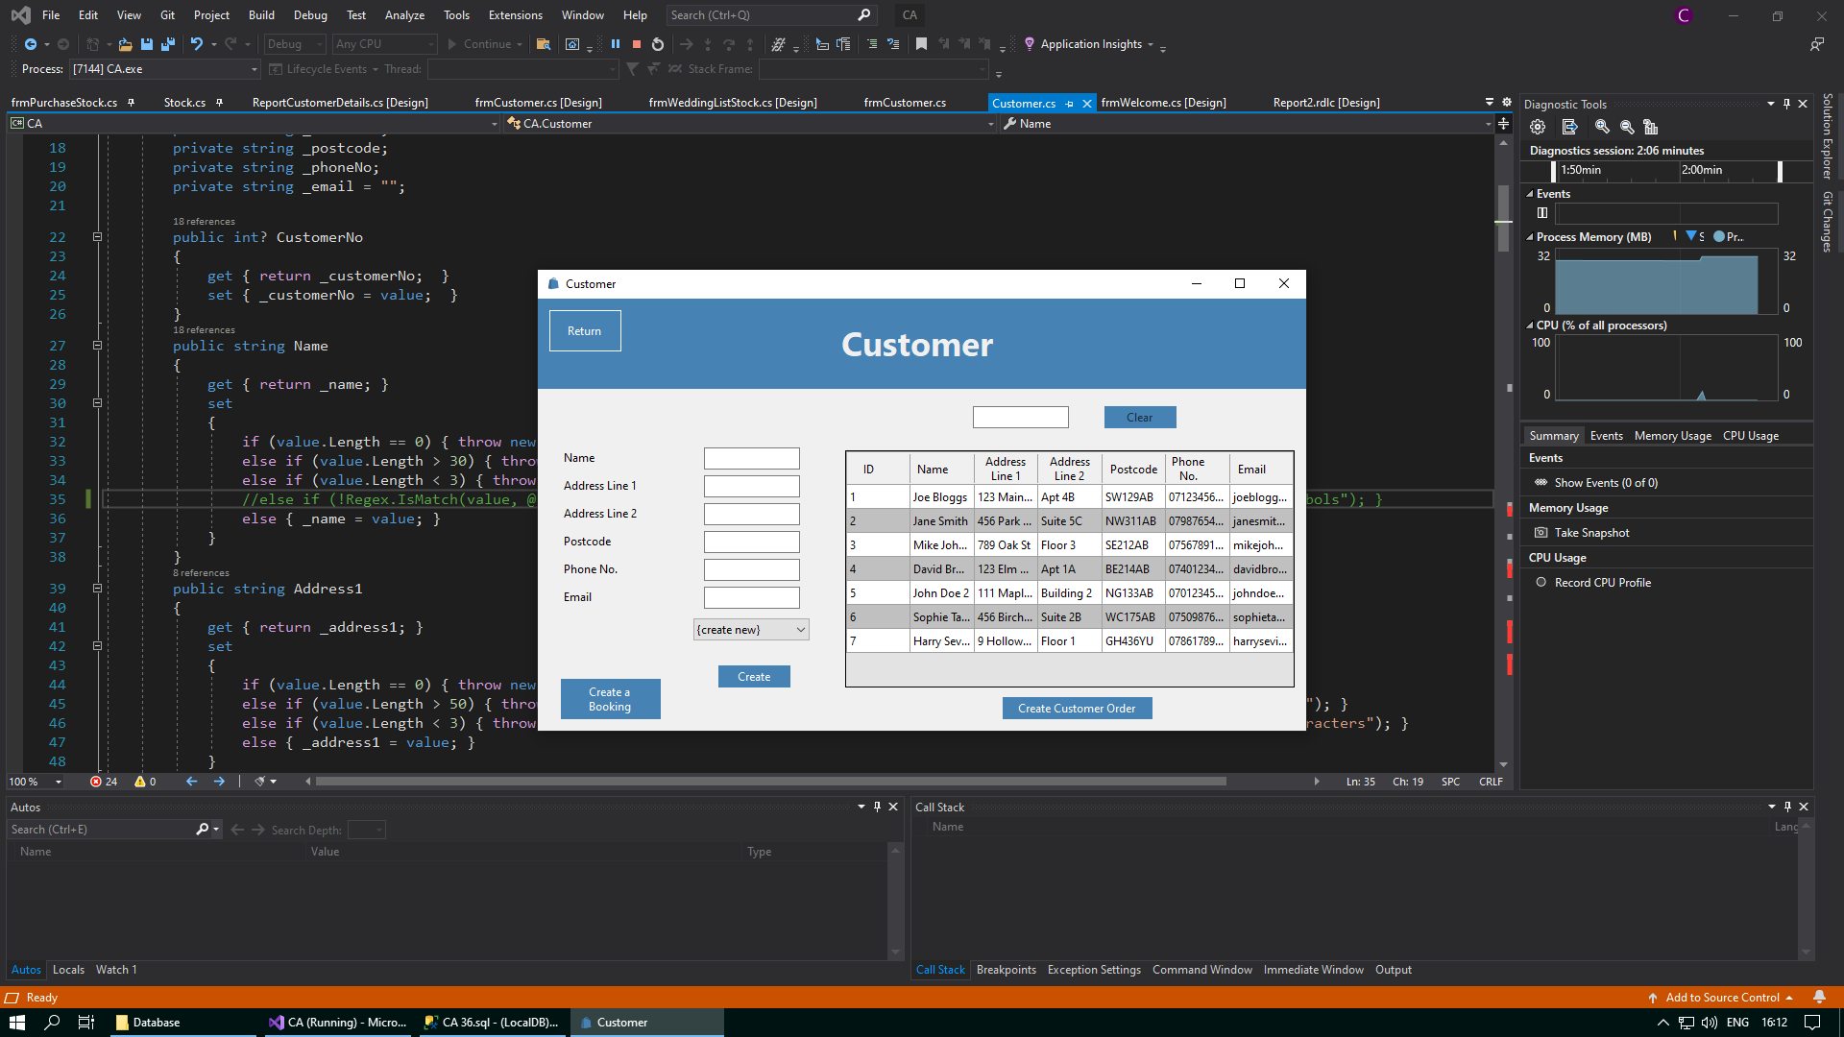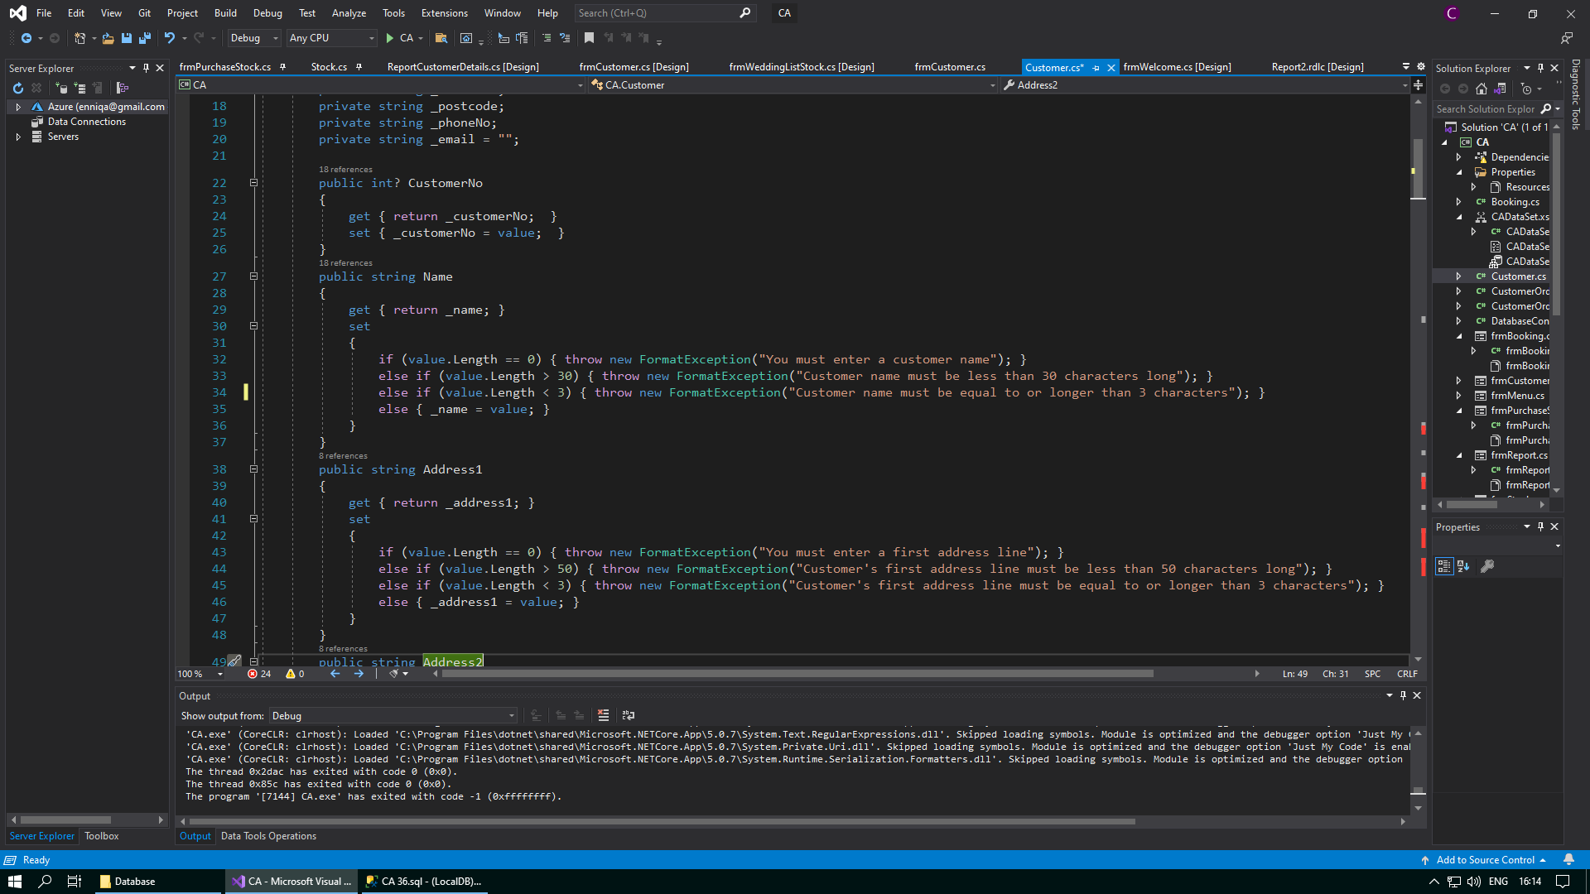

Code to validate that only letters are allowed is missing

A name containing a number has been allowed to be entered into the system

*After:*

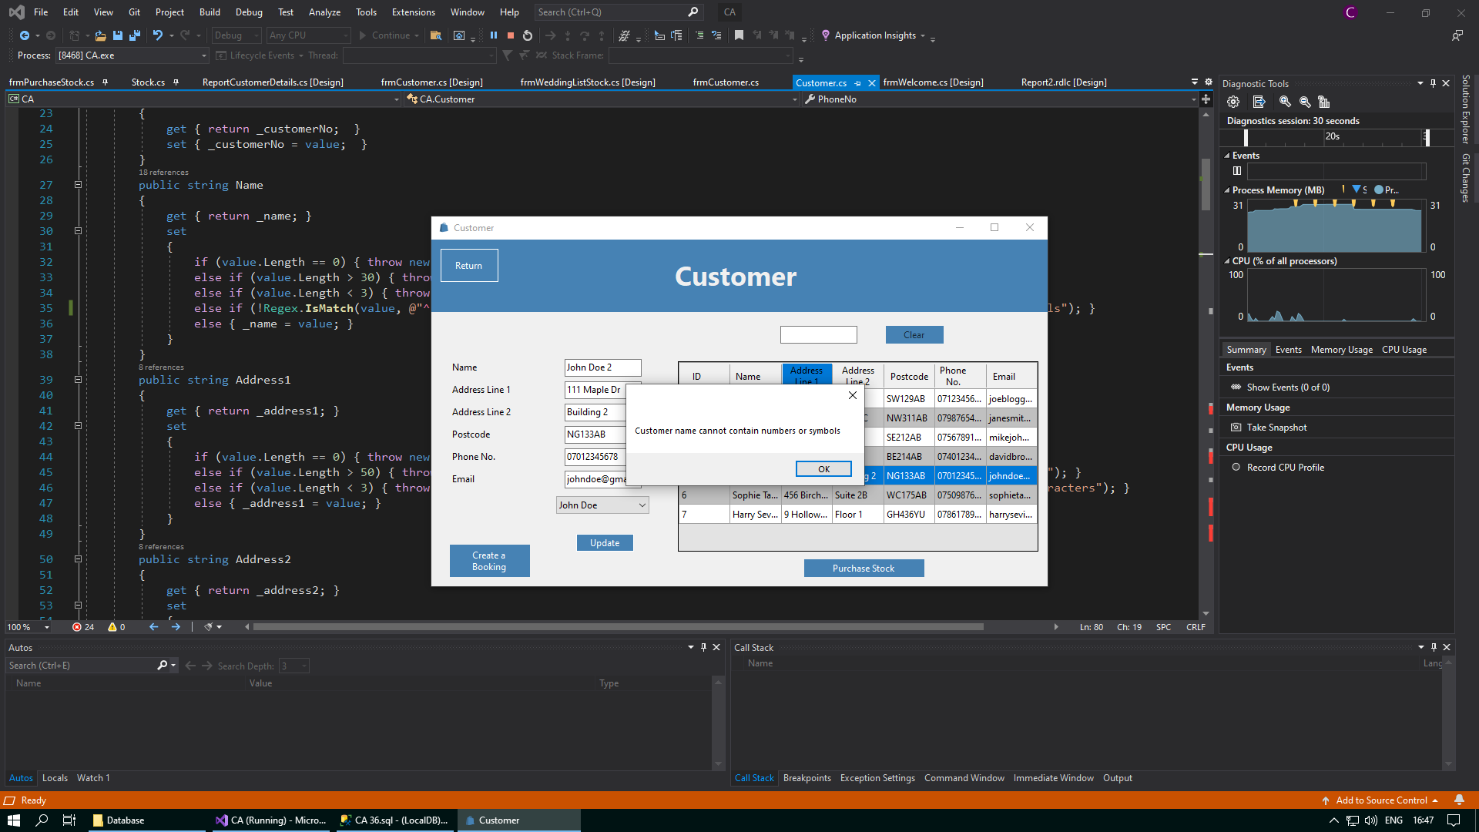

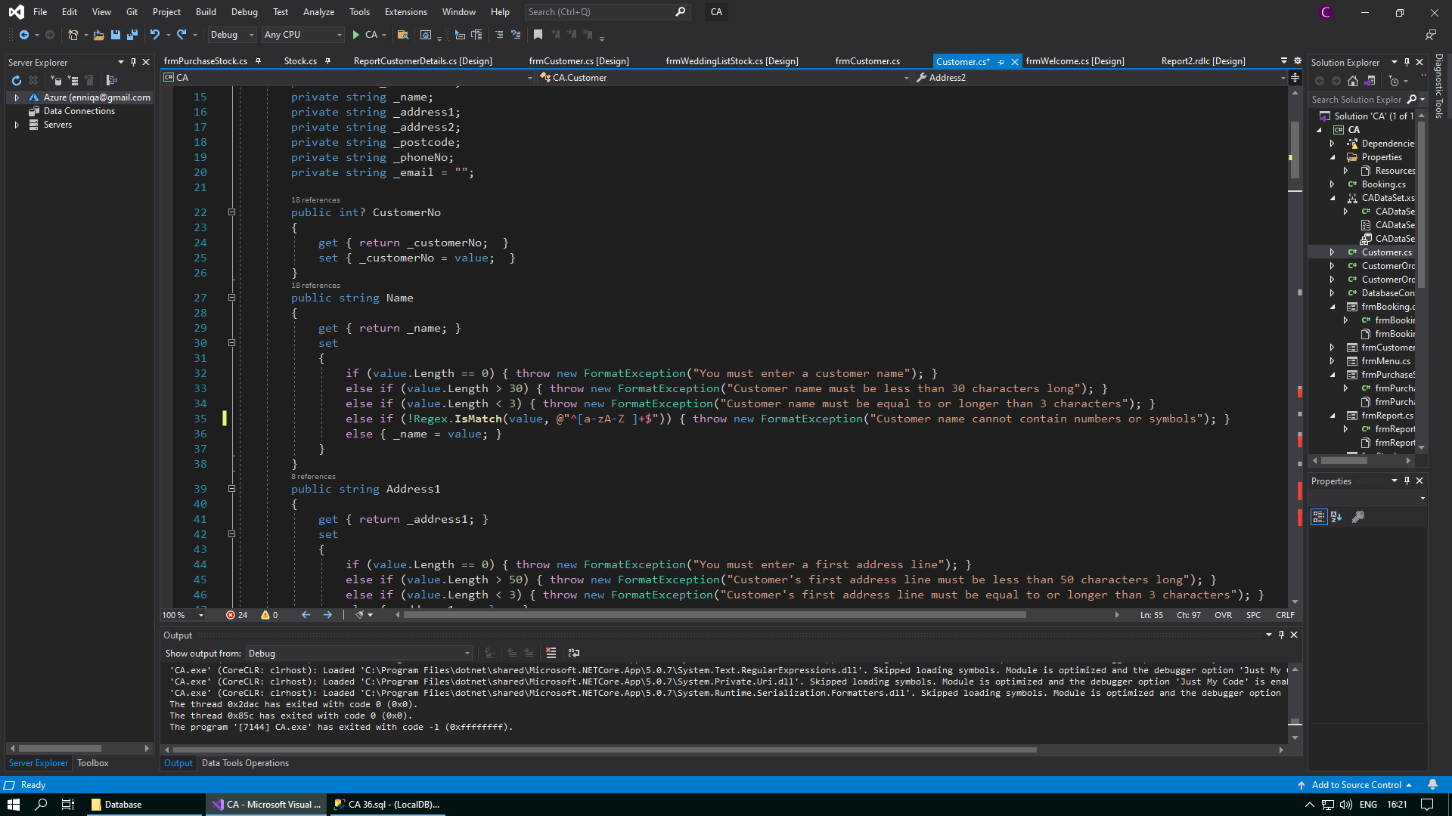

I have added the code to validate that the name entered does not contain numbers or symbols

A message box will now appear when an invalid name is entered

**Corrective Action 2**

Test number:

Issue: Phone numbers that contain letters or symbols are being allowed to be entered into the database

Solution: Add the line else if (!Regex.IsMatch(value, @"^\d+$")) { throw new FormatException("Customer phone number cannot contain letters or symbols"); }

*Before:*

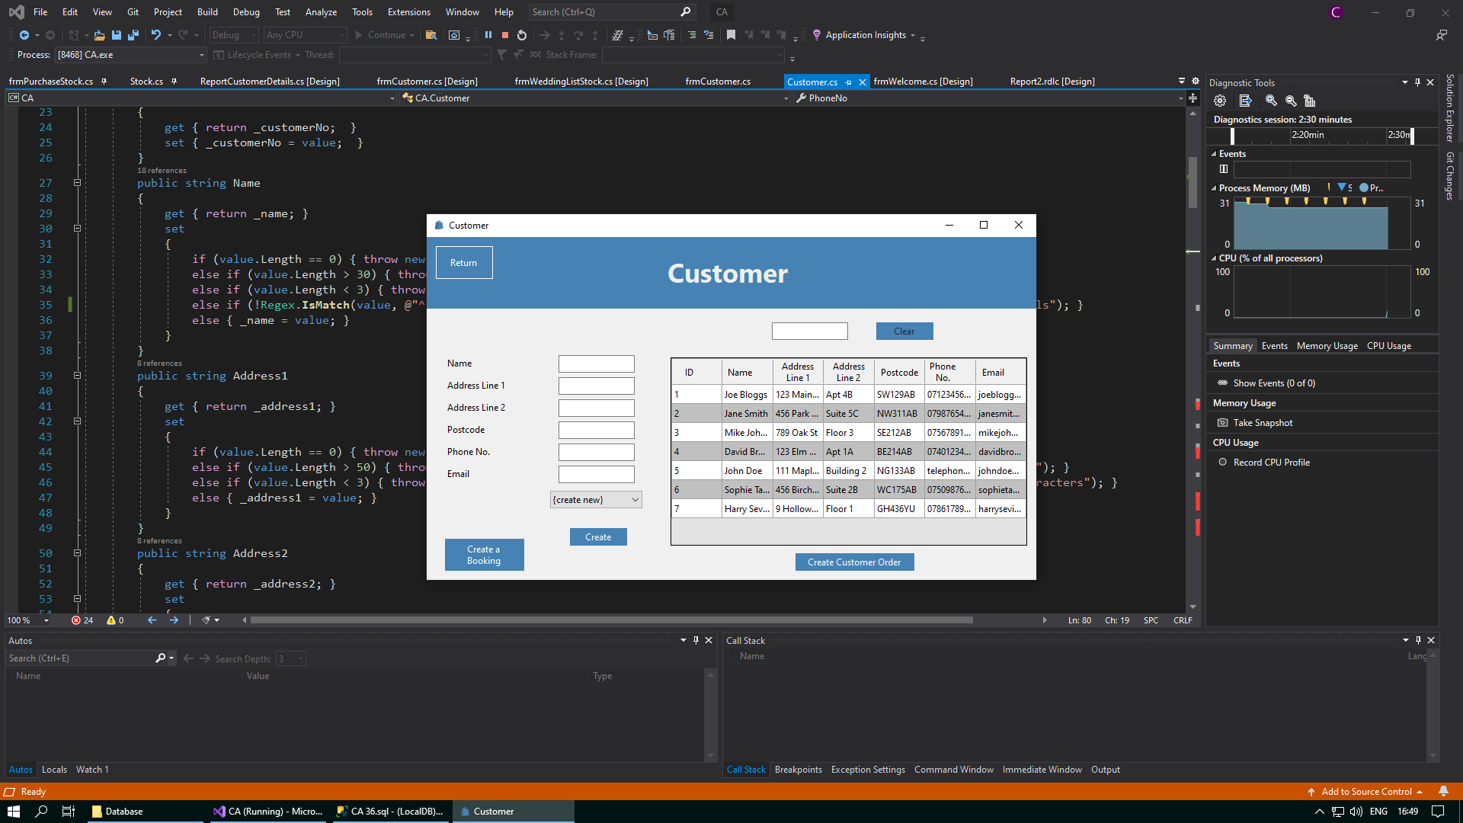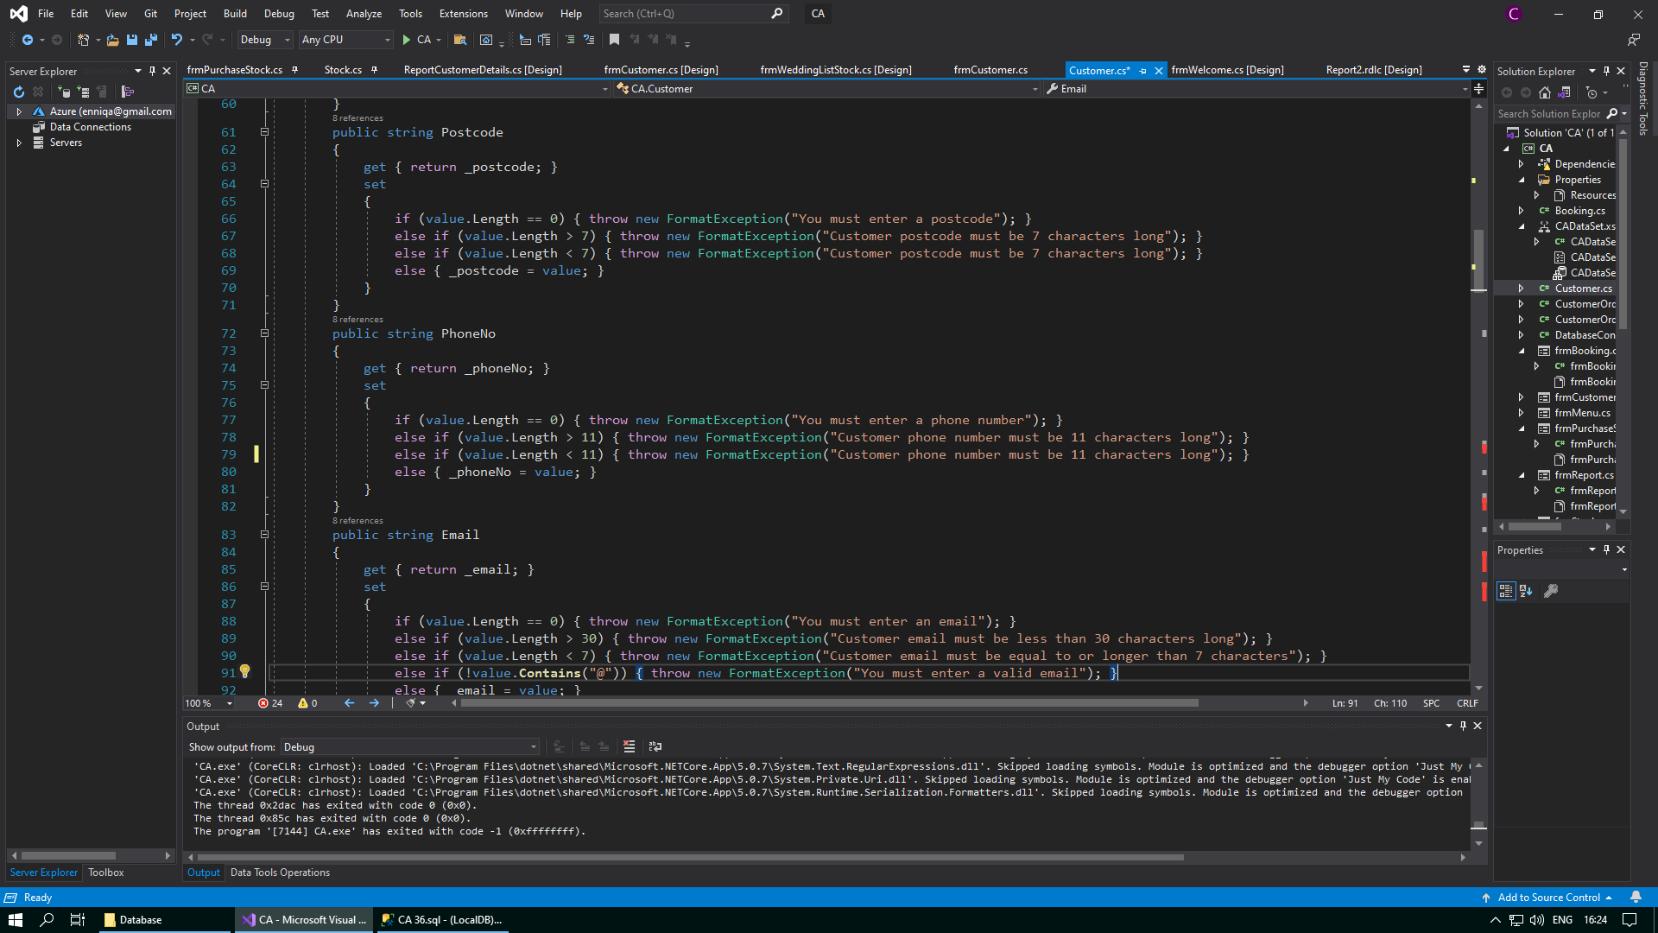

A phone number containing letters has been allowed to be entered into the system

Code to validate that only numbers are allowed is missing

*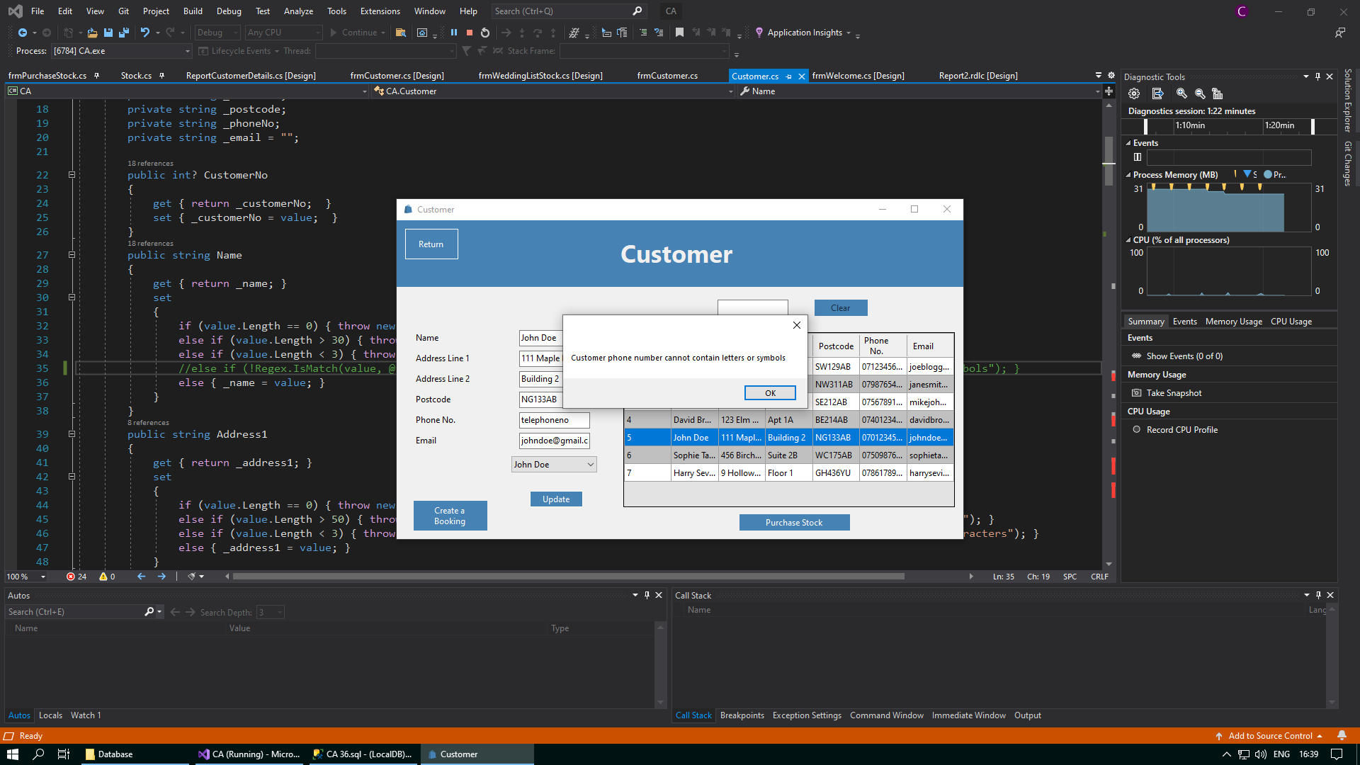After*:

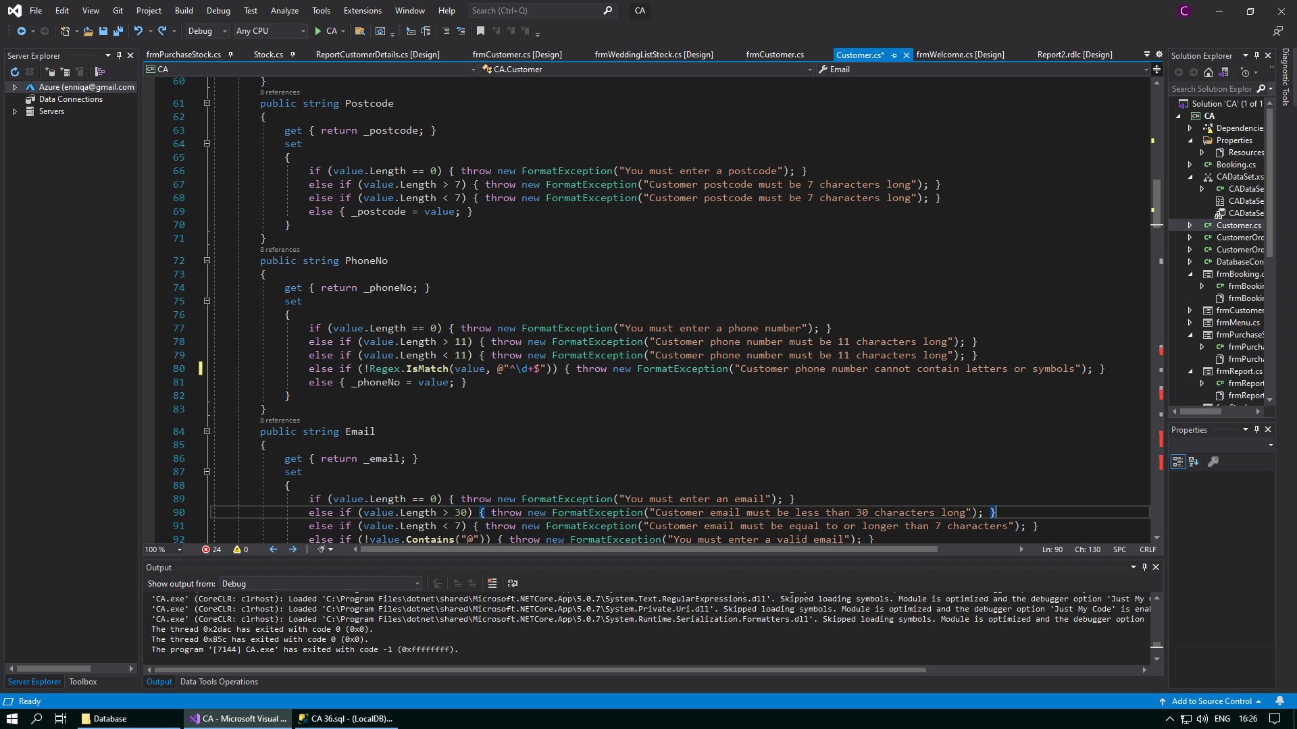

I have added the code to validate that the phone number entered does not contain letters or symbols

A message box will now appear when an invalid phone number is entered

**Corrective Action 3**

Test number:

Issue: Categories that contain numbers or symbols are being allowed to be entered into the database

Solution: Add the line else if (!Regex.IsMatch(value, @"^[a-zA-Z ]+$")) { throw new FormatException("Stock category cannot contain numbers or symbols"); }

*Before:*

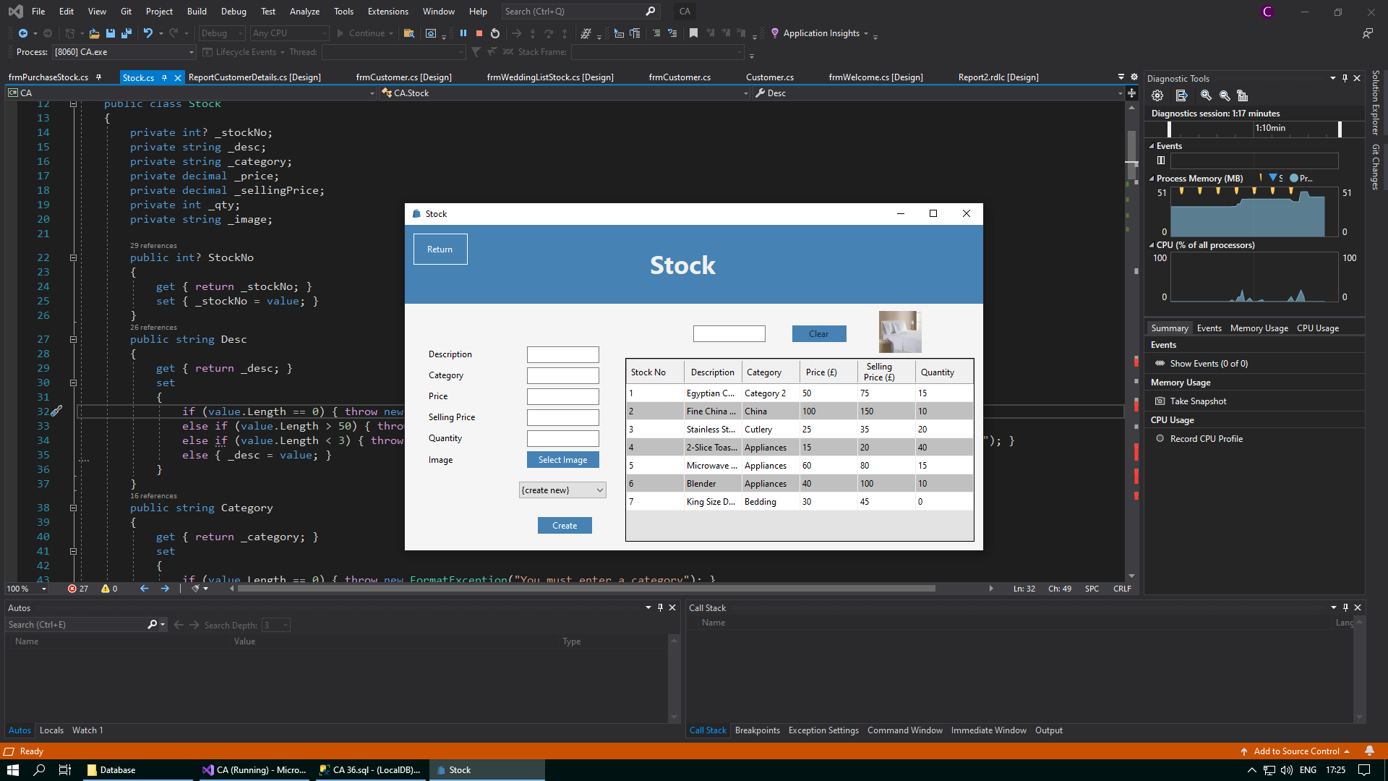

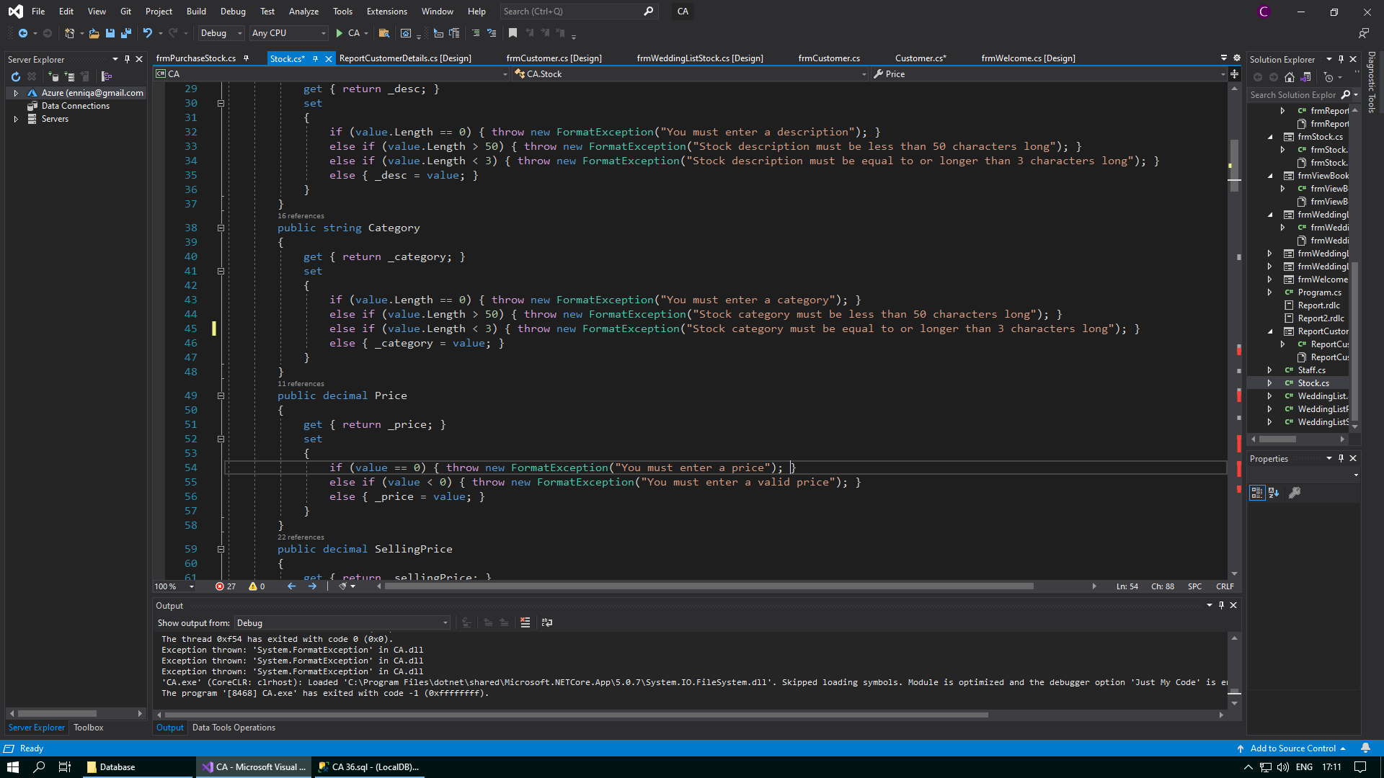

Code to validate that only letters are allowed is missing

A category containing a number has been allowed to be entered into the system

*After:*

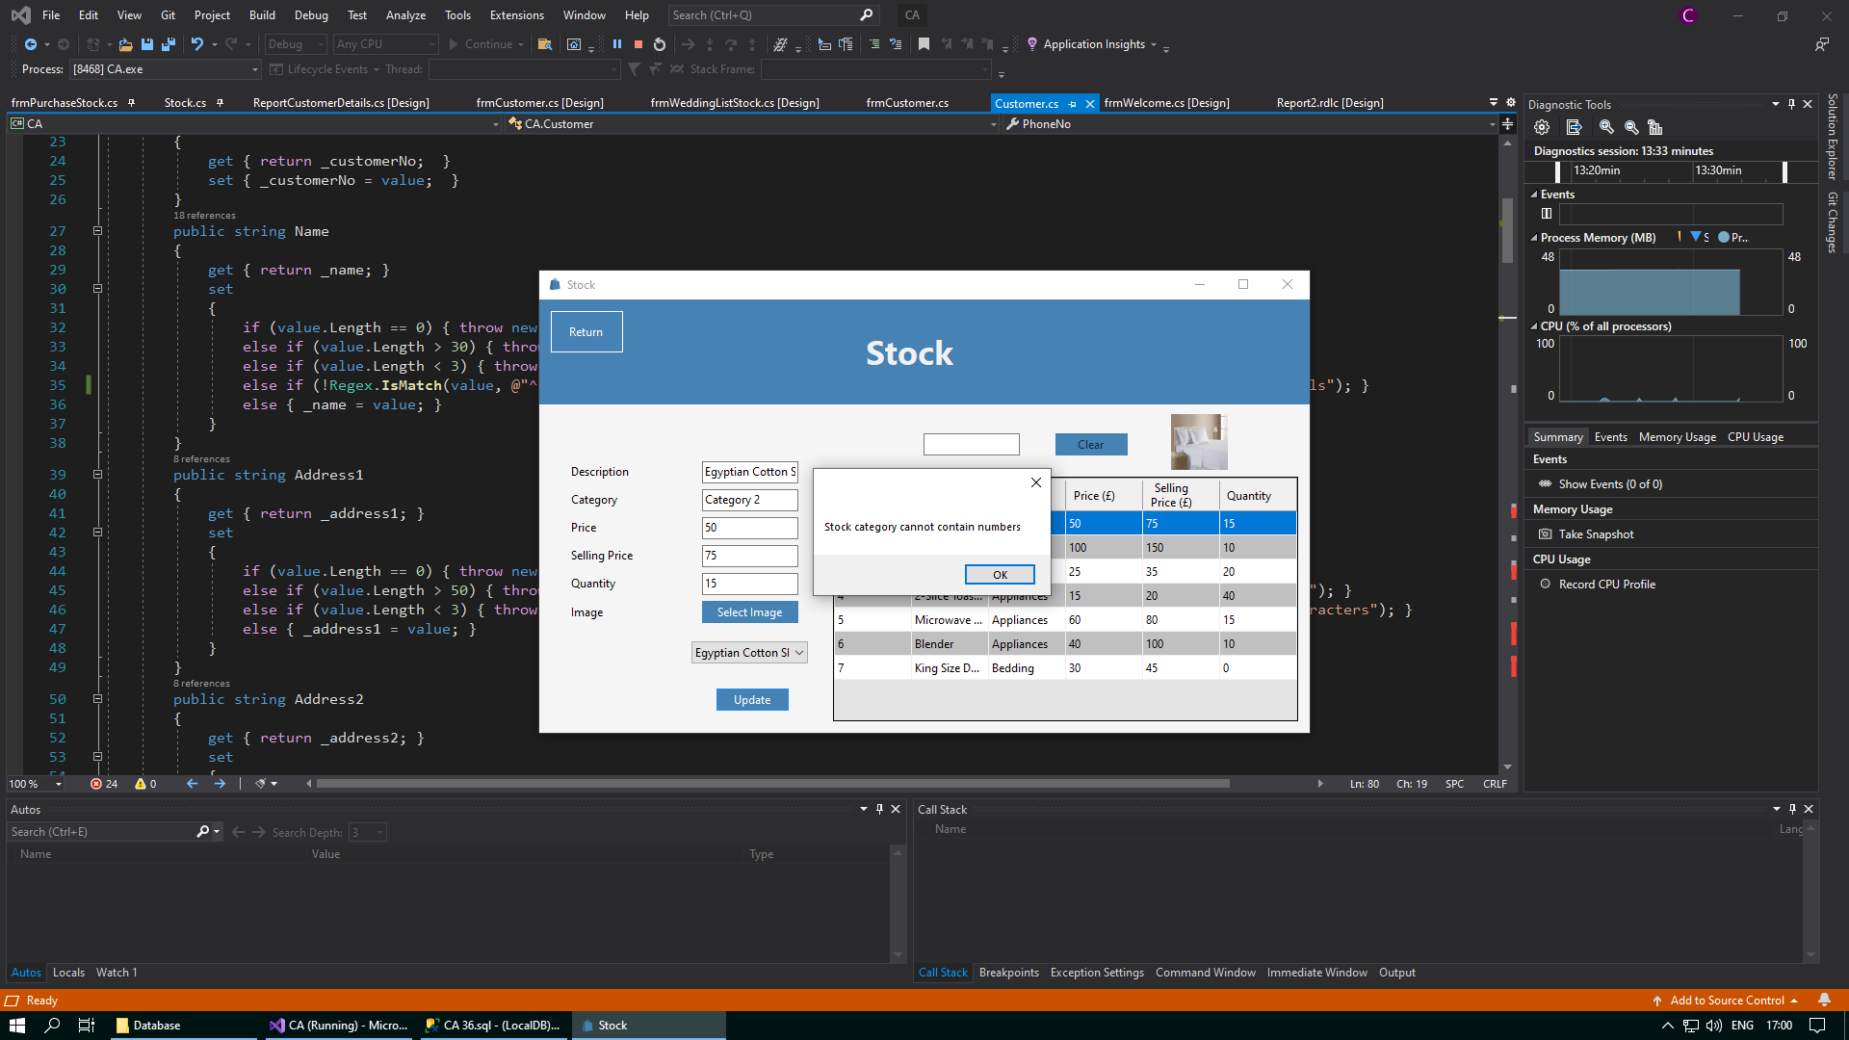

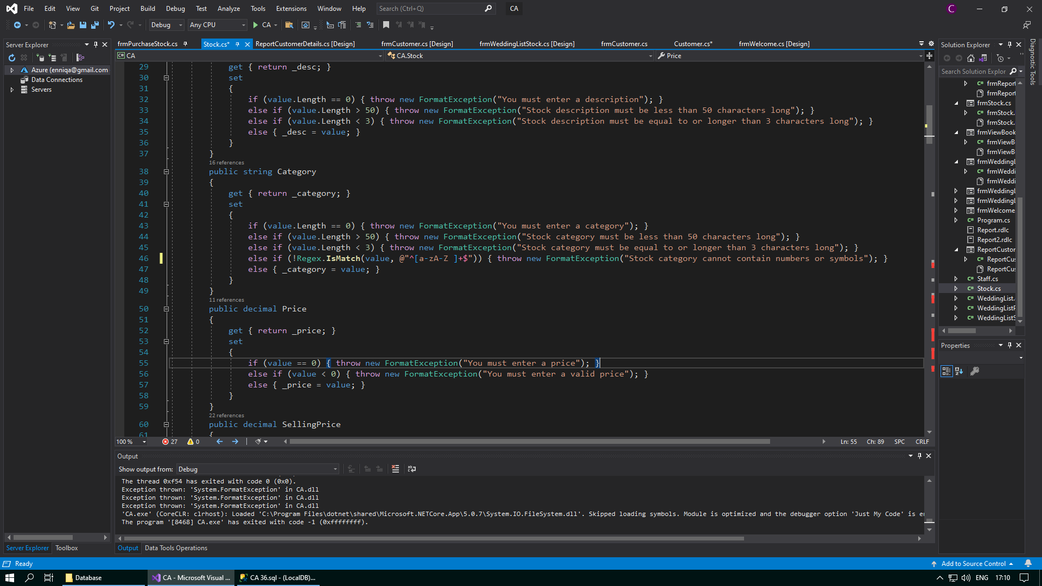

I have added the code to validate that the category entered does not contain numbers or symbols

A message box will now appear when an invalid category is entered

**Corrective Action 4**

Test number:

Issue: Prices that contain negative numbers are being allowed to be entered into the database

Solution: Add the line else if (value < 0) { throw new FormatException("You must enter a valid price"); }

*Before:*

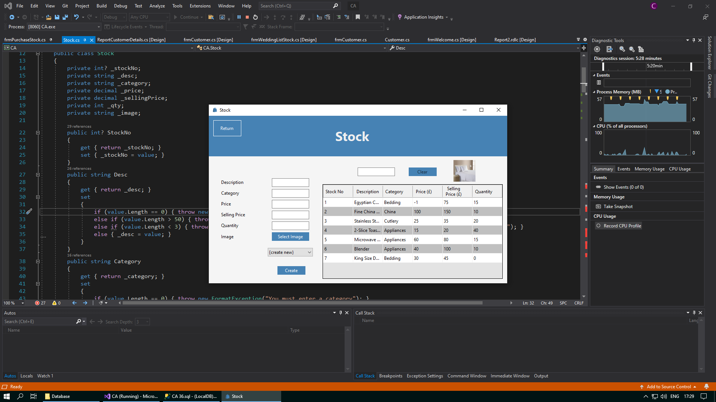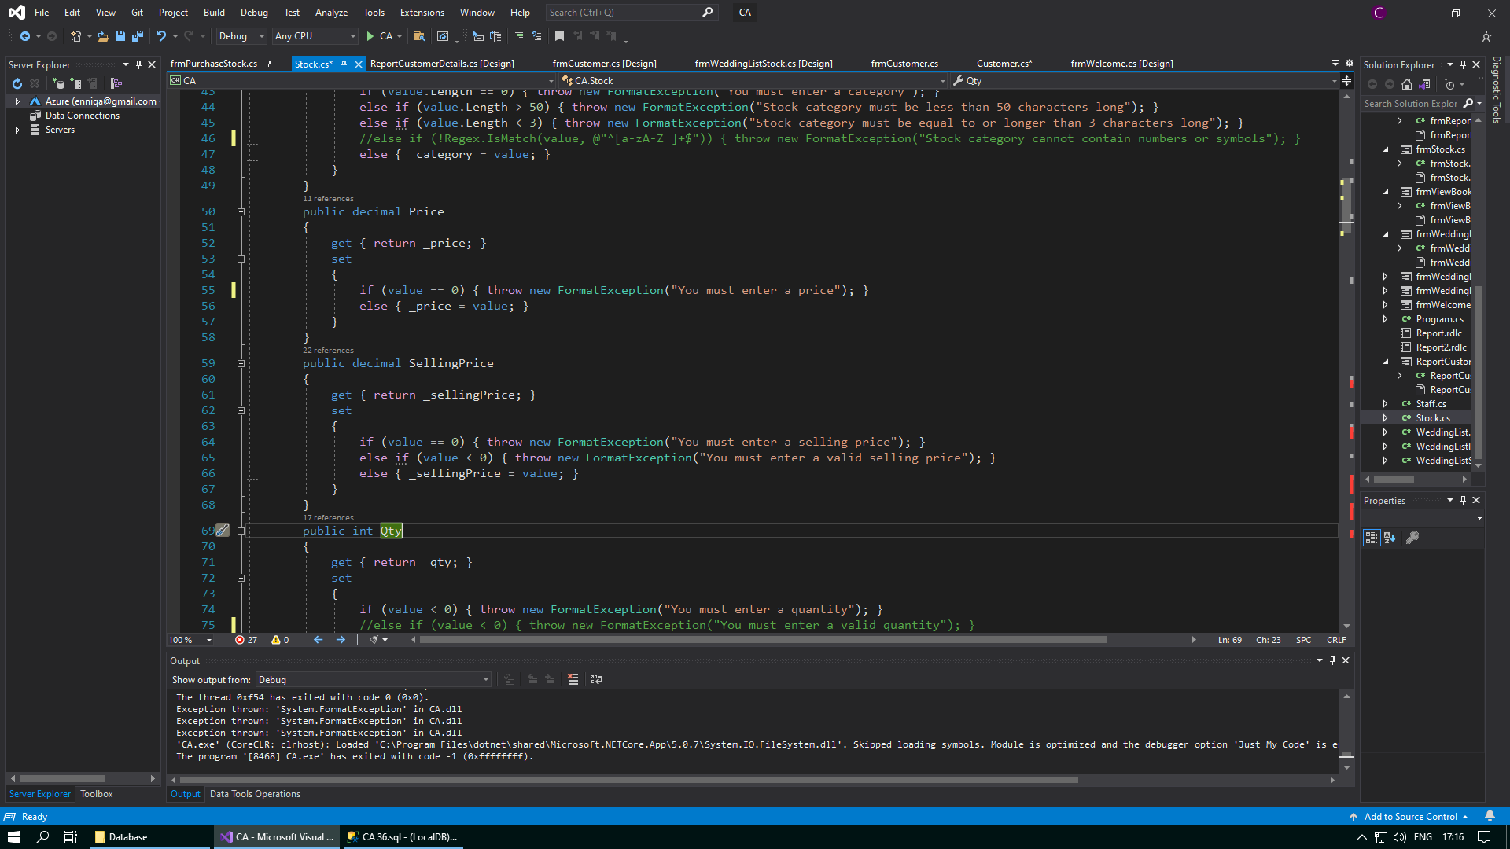

Code to validate that only positive numbers are allowed is missing

A price containing a negative number has been allowed to be entered into the system

*After:*

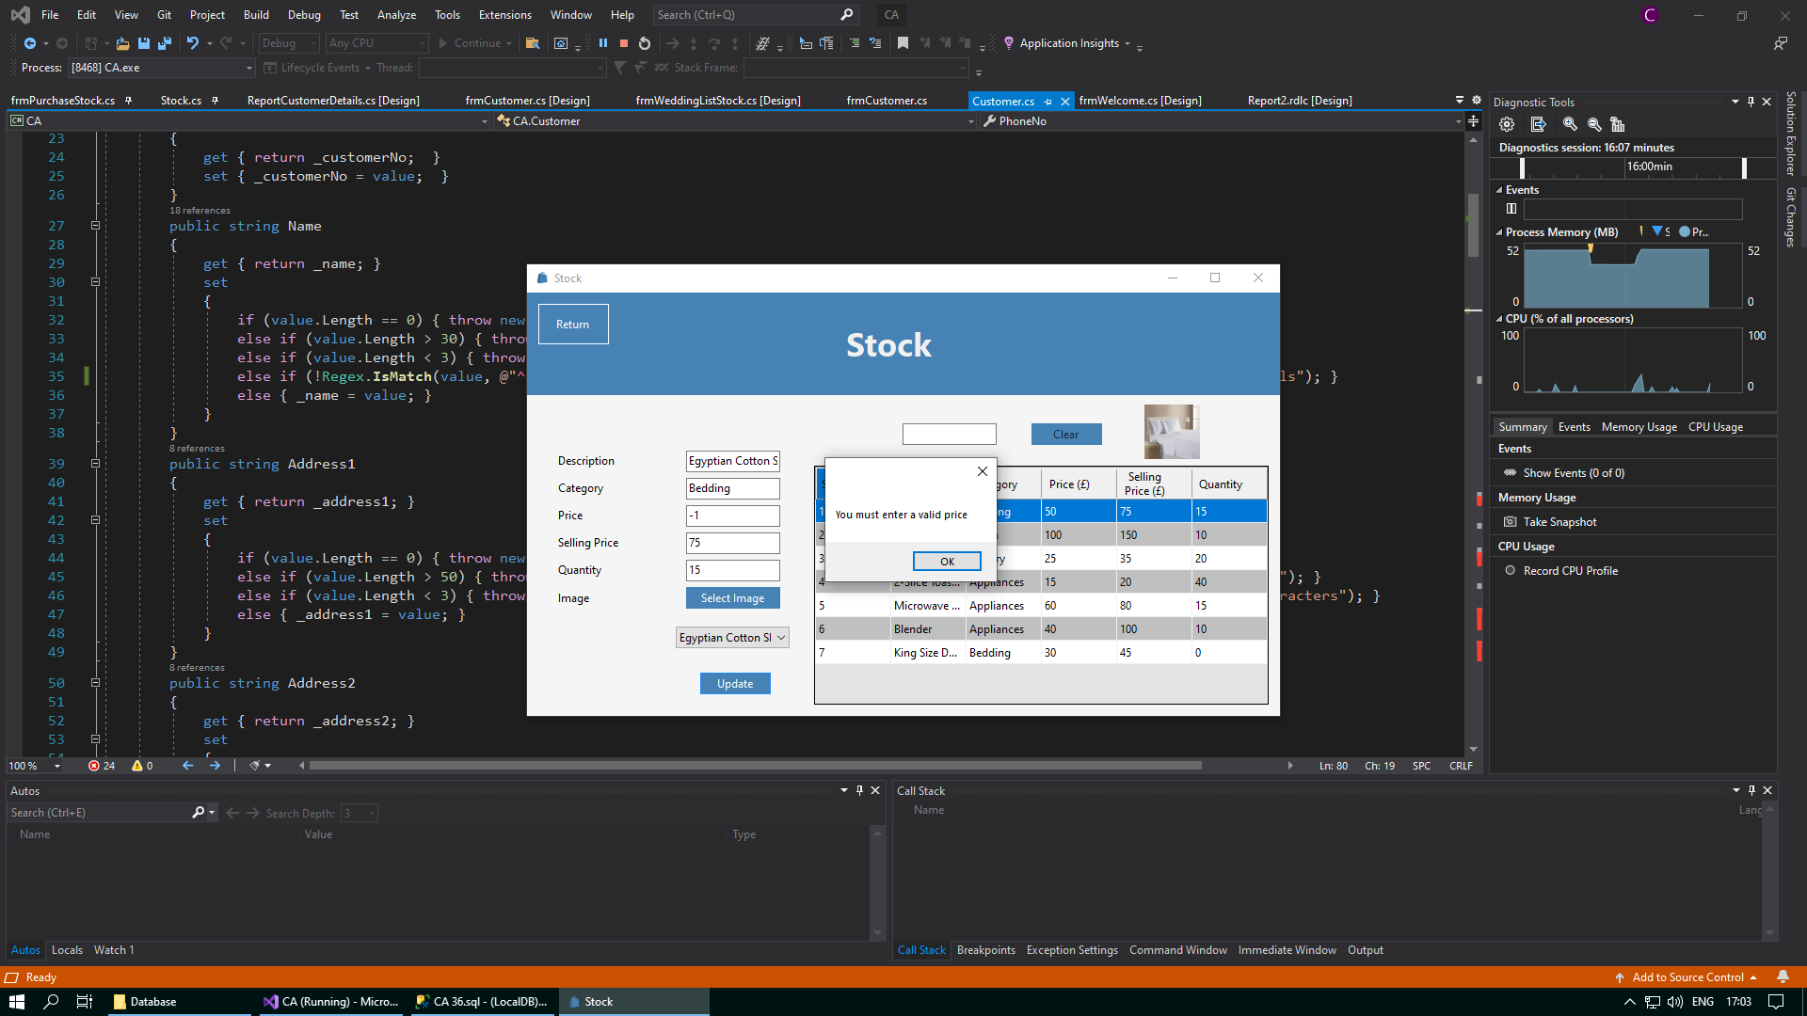

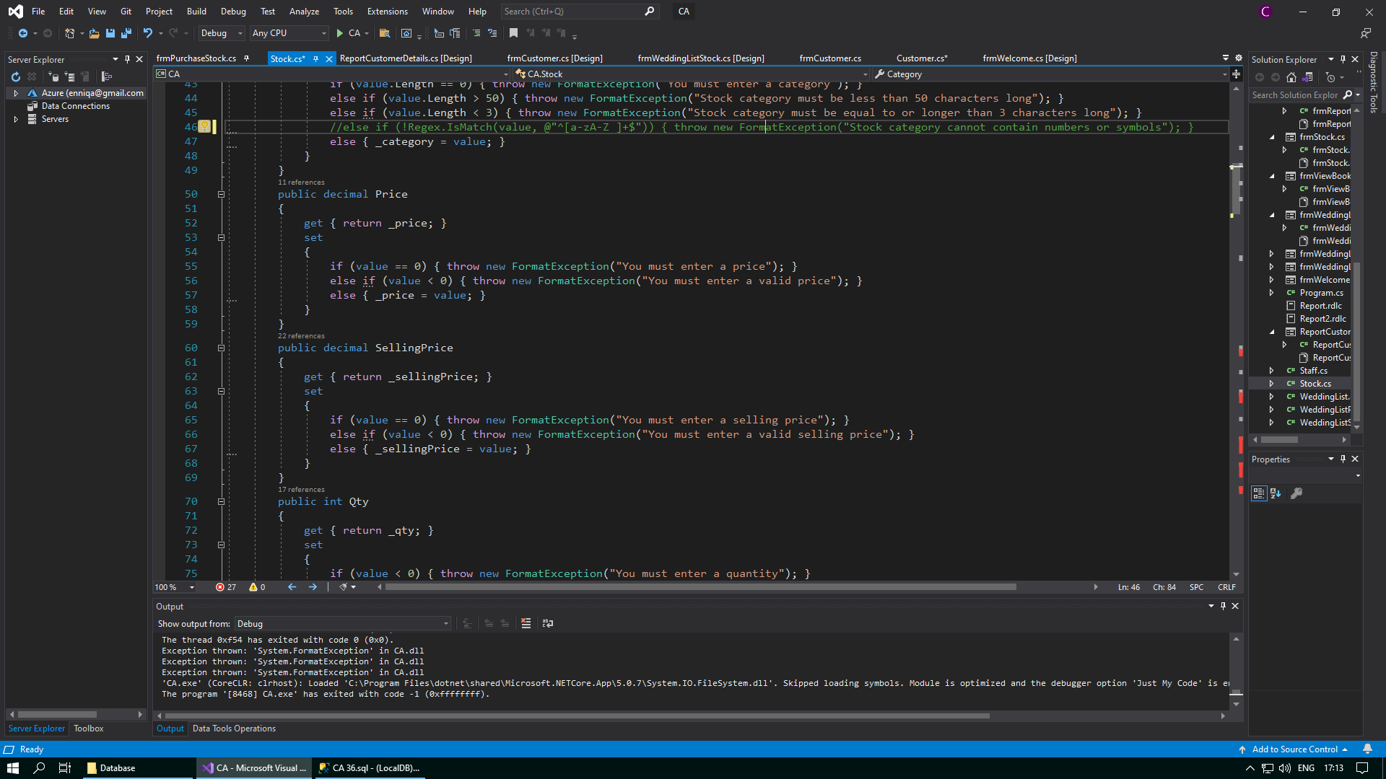

A message box will now appear when an invalid price is entered

I have added the code to validate that the price entered does not contain negative numbers

**Corrective Action 5**

Test number:

Issue: Selling prices that contain negative numbers are being allowed to be entered into the database

Solution: Add the line else if (value < 0) { throw new FormatException("You must enter a valid selling price"); }

*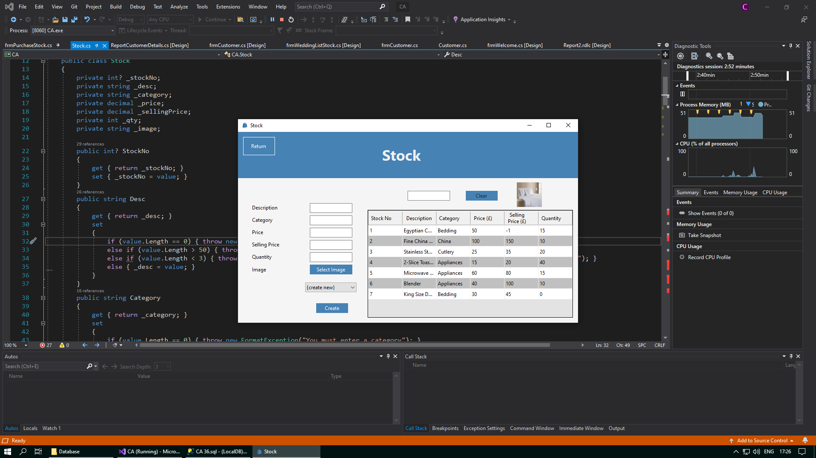Before*:

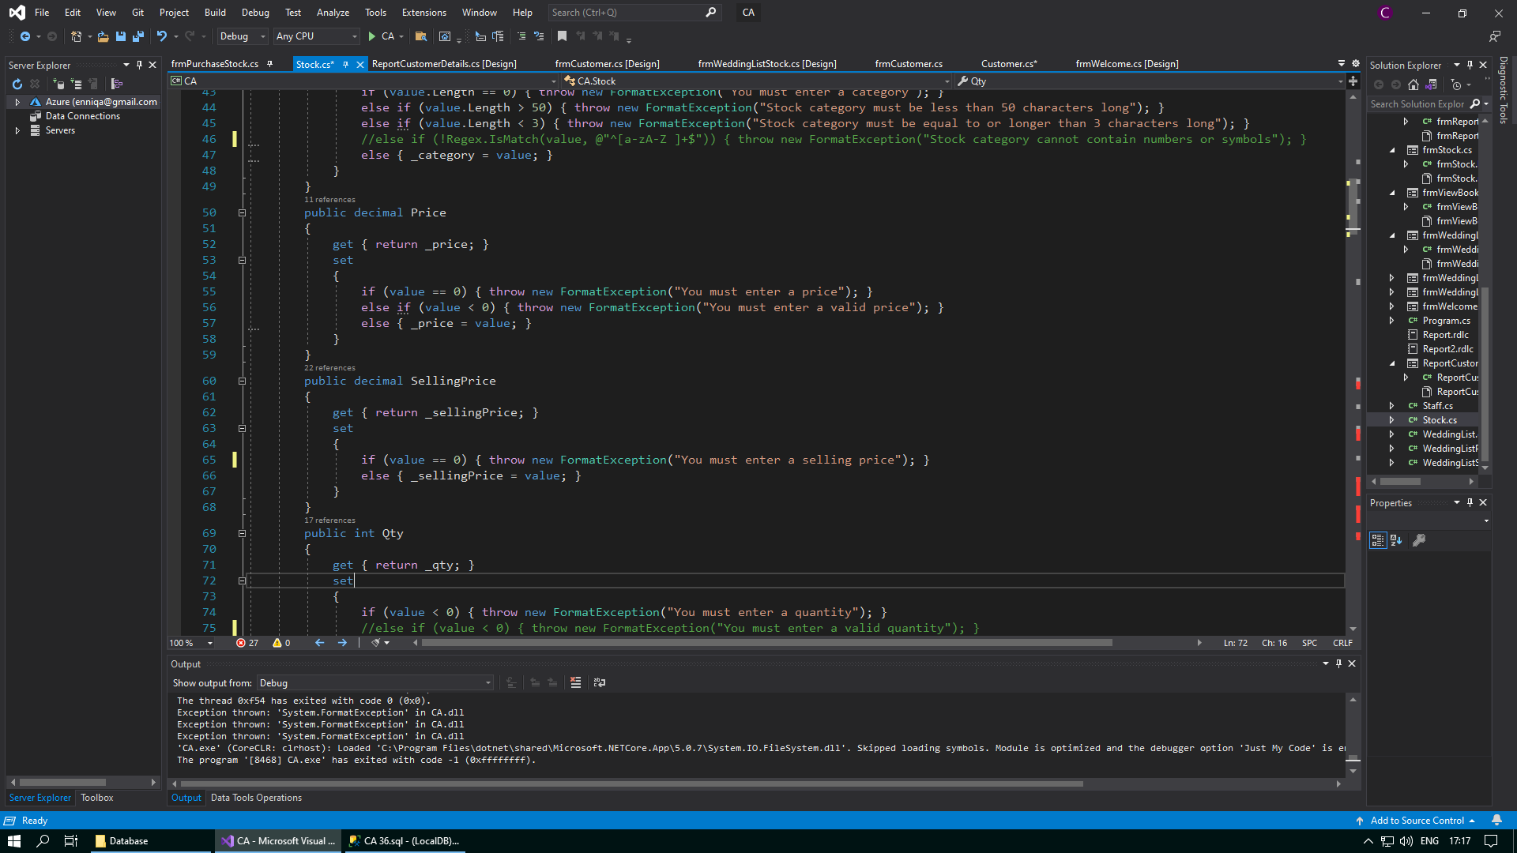

A selling price containing a negative number has been allowed to be entered into the system

Code to validate that only positive numbers are allowed is missing

*After:*

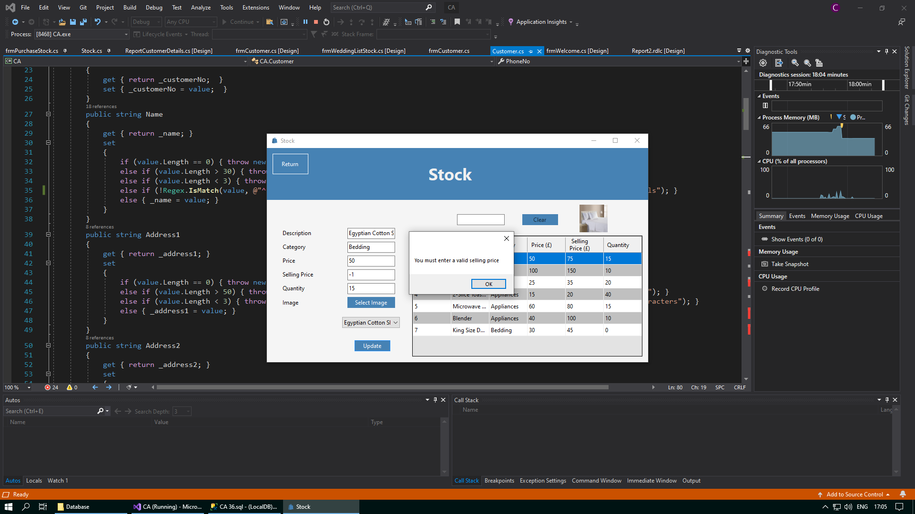



I have added the code to validate that the selling price entered does not contain negative numbers

A message box will now appear when an invalid selling price is entered

**Corrective Action 6**

Test number:

Issue: In the event that a database connection cannot be established, the application directs the user back to the Welcome form, instead of the Customer form

Solution: Change the lines Form frmWelcome = new frmWelcome(); frmWelcome.Show(); to Form frmCustomer = new frmCustomer(); frmCustomer.Show();

*Before:*

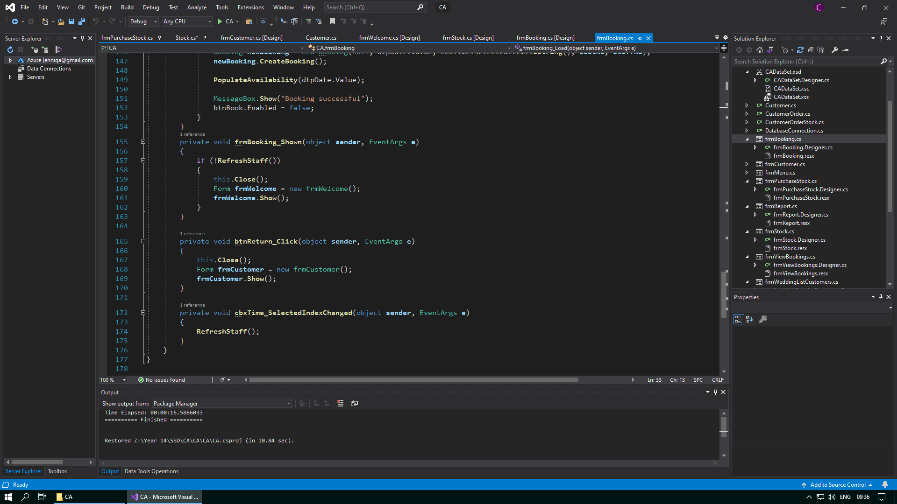

The user is being directed back to frmWelcome instead of frmCustomer

*After:*

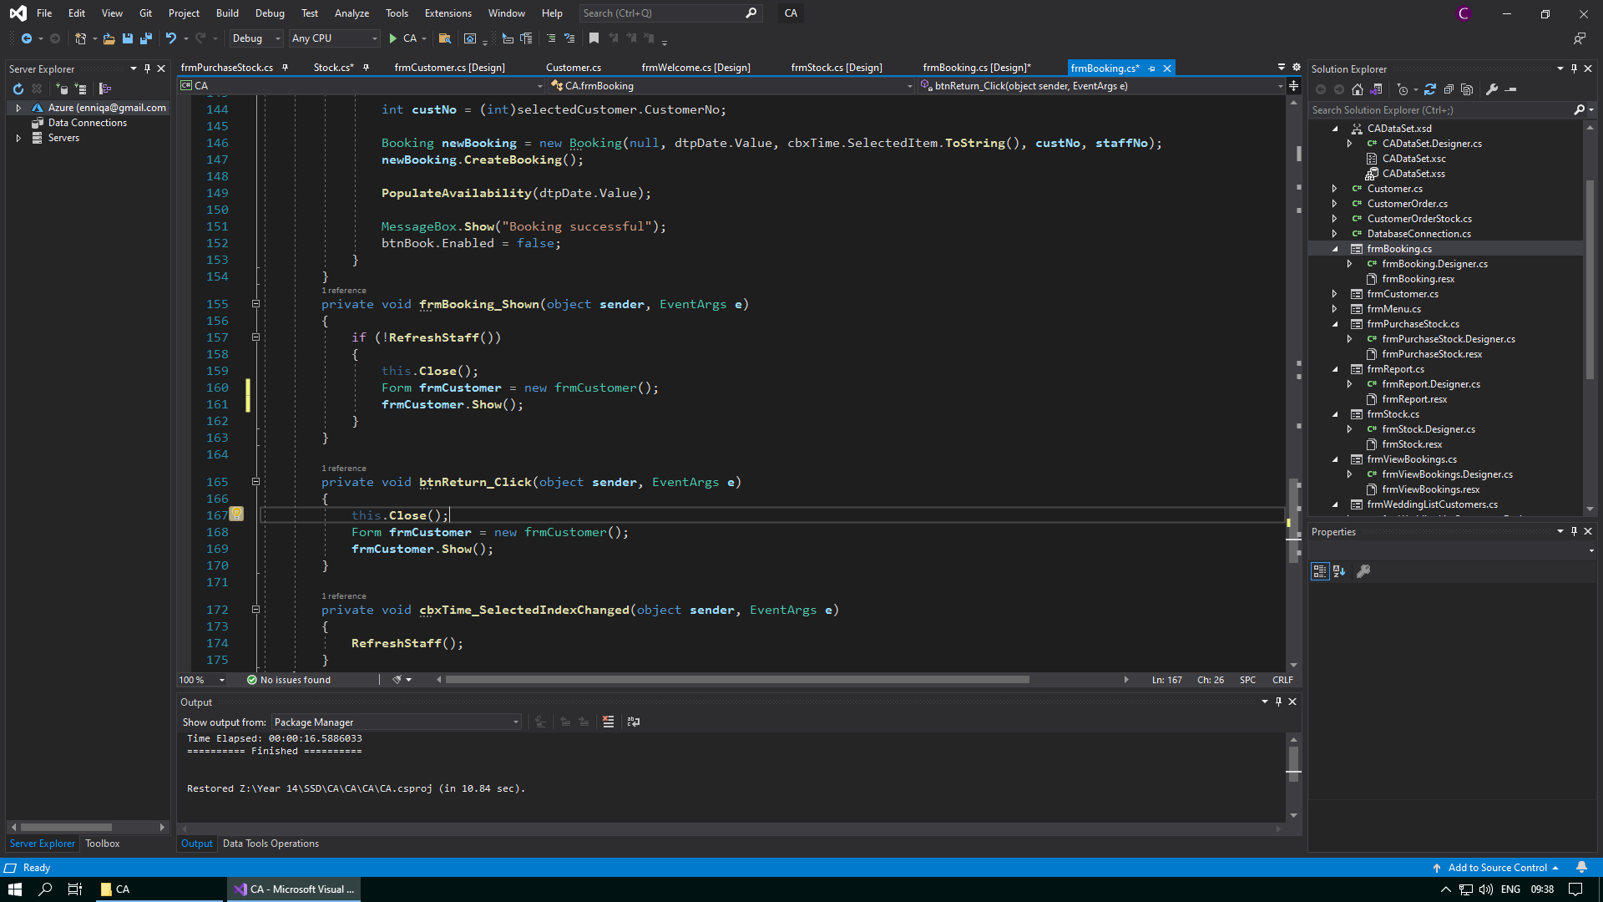

The user is now directed back to frmCustomer

**Corrective Action 7**

Test number:

Issue: When purchasing stock, a user can choose to buy an invalid quantity of 0

Solution: Change the line if (qty <= Convert.ToInt32(stock.Qty) && success == true) to if (qty <= Convert.ToInt32(stock.Qty) && success == true && qty > 0)

*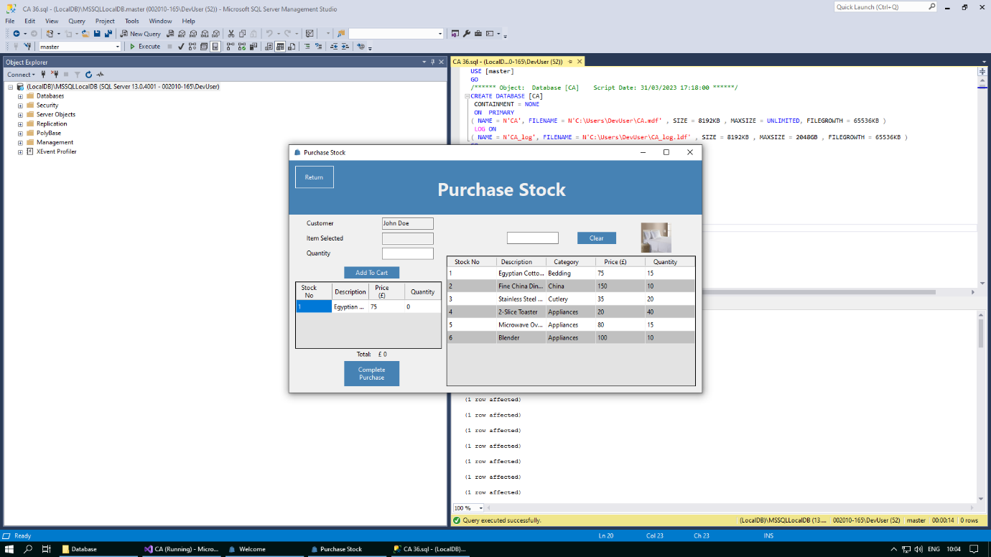Before*:

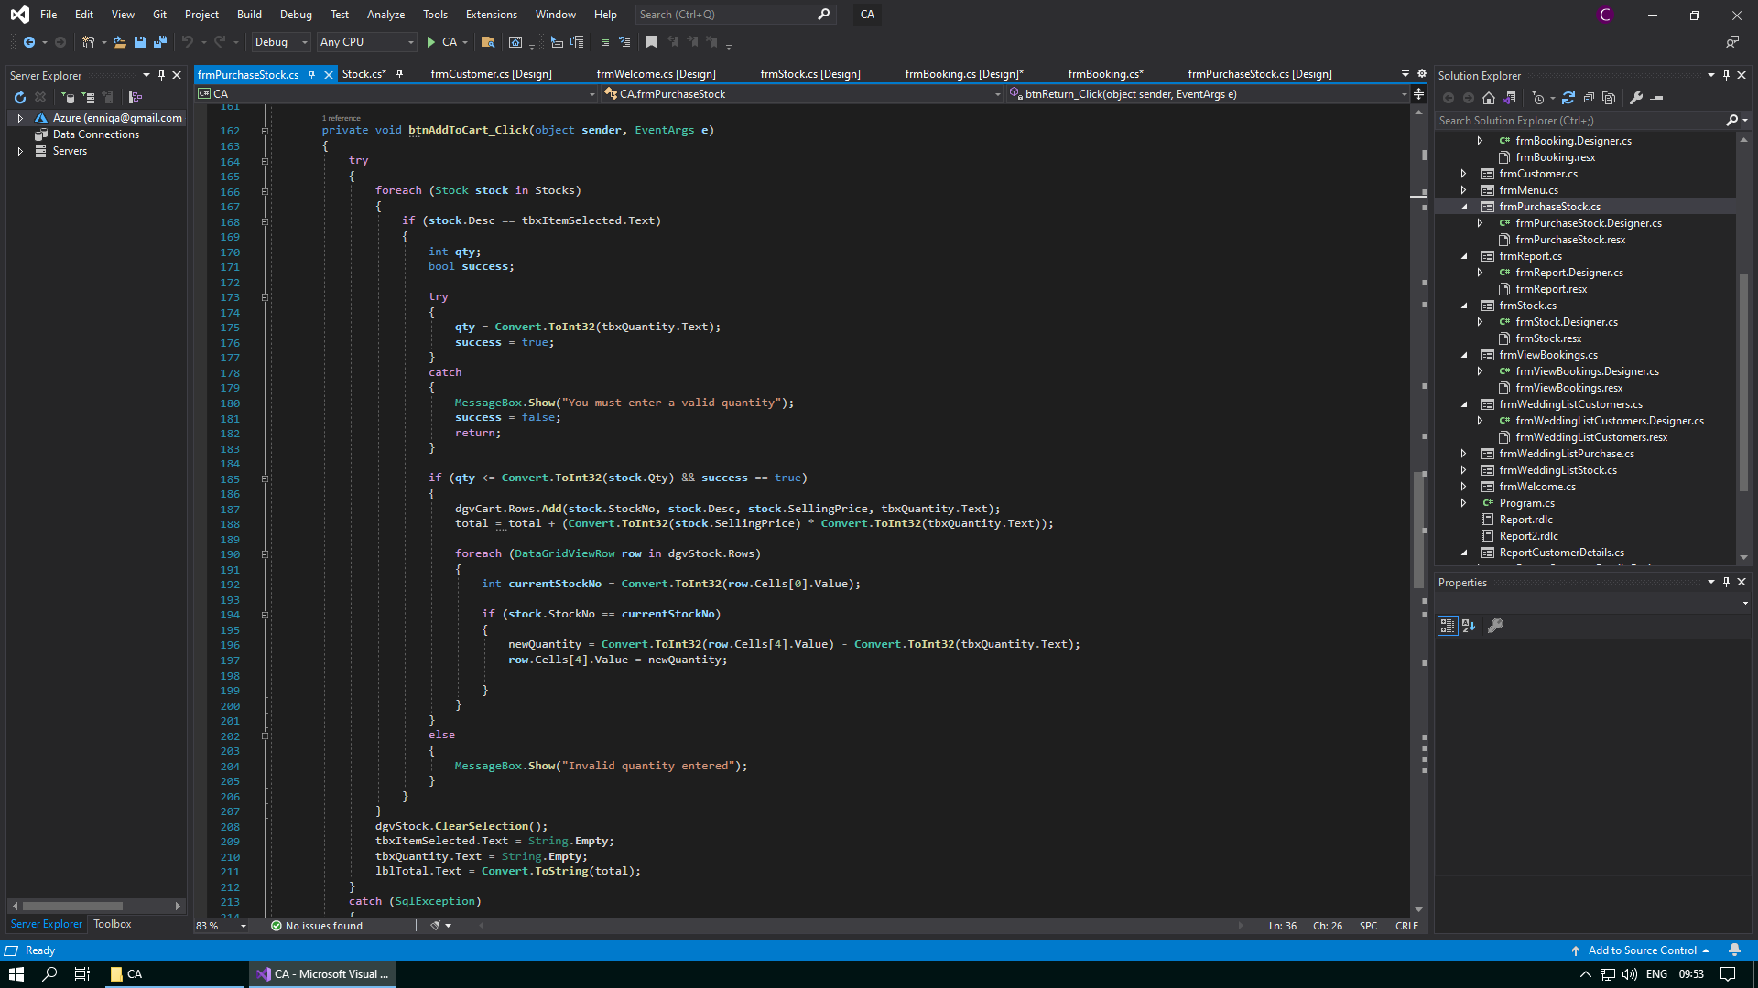

Code to validate that only quantities greater than 0 are allowed is missing

A quantity of 0 has been allowed to be entered into the system

*After:*

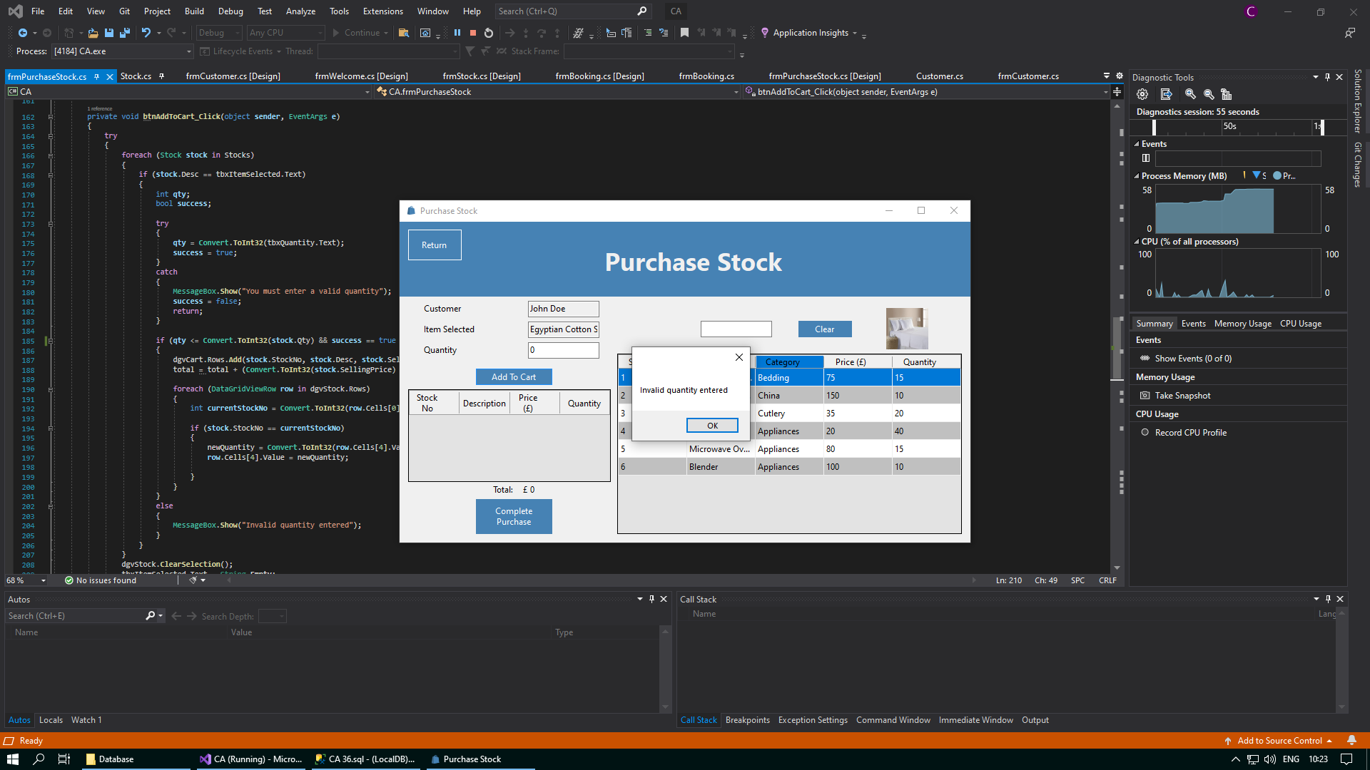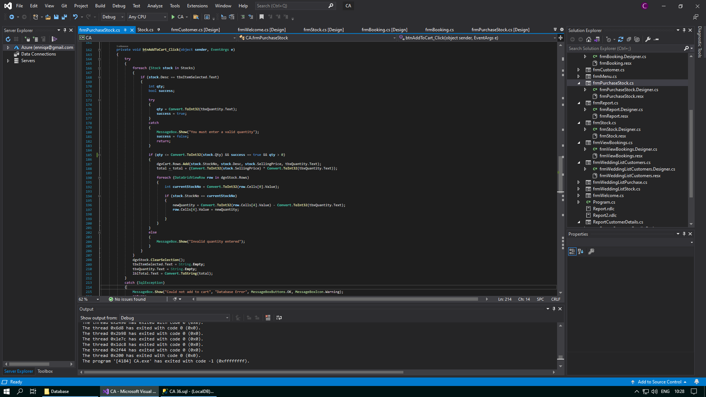

I have added the code to validate that the quantity entered is not 0

A message box will now appear when an invalid quantity is entered

**Corrective Action 8**

Test number:

Issue: When purchasing stock, negative numbers are being allowed to be entered as a quantity

Solution: Change the line if (qty <= Convert.ToInt32(stock.Qty) && success == true) to if (qty <= Convert.ToInt32(stock.Qty) && success == true && qty > 0)

*Before:*

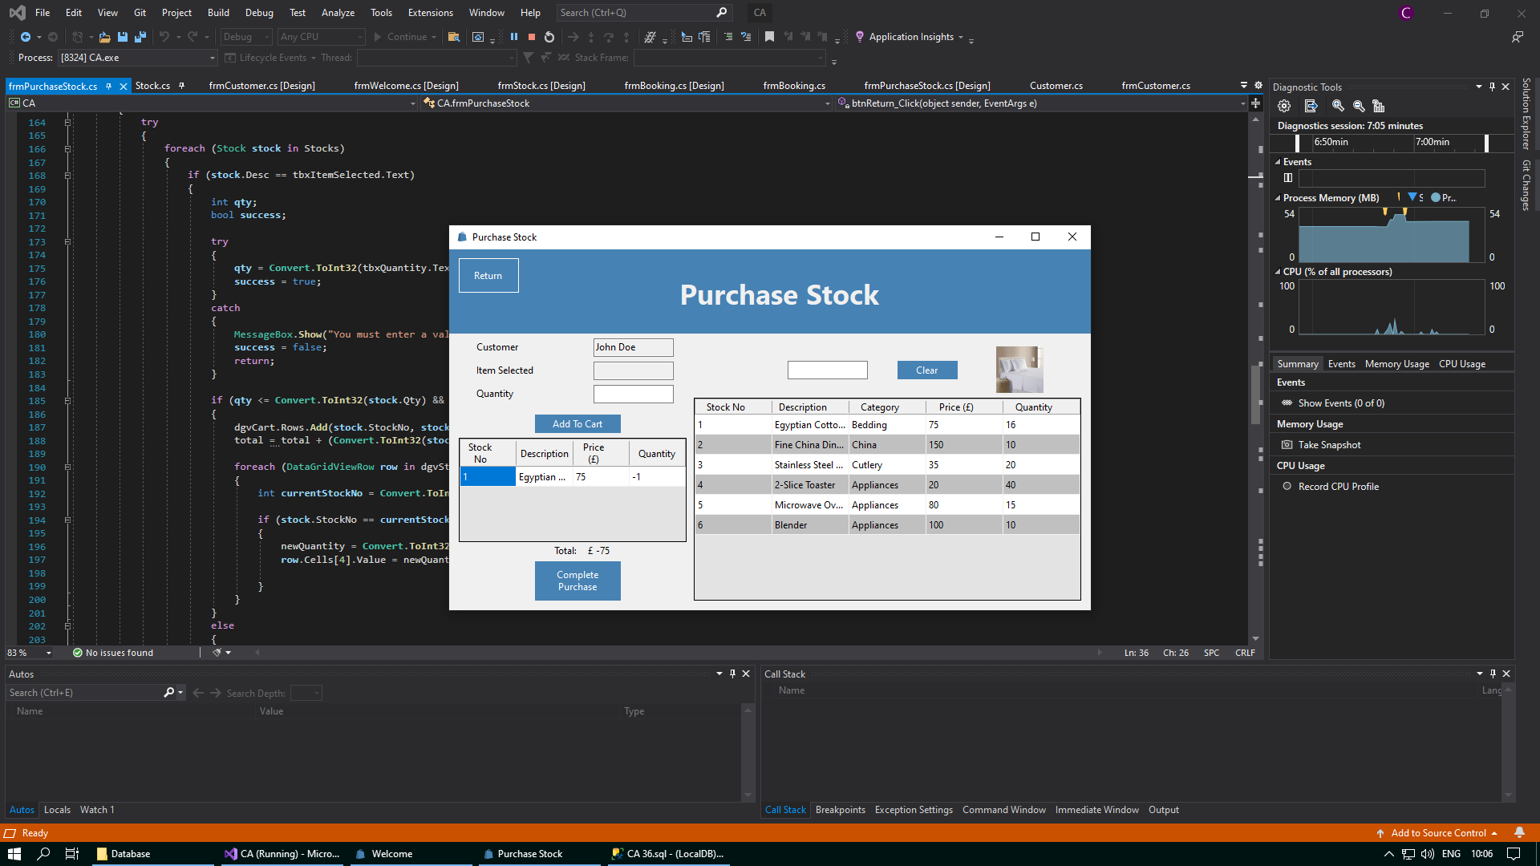

Code to validate that only quantities greater than 0 are allowed is missing

A quantity of less than 0 has been allowed to be entered into the system

*After:*

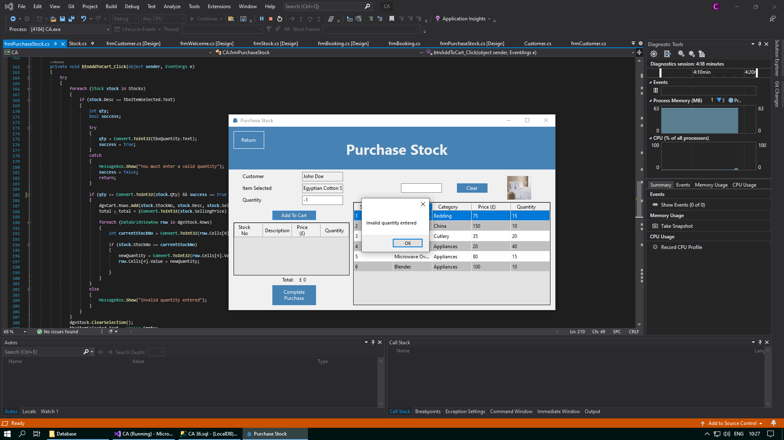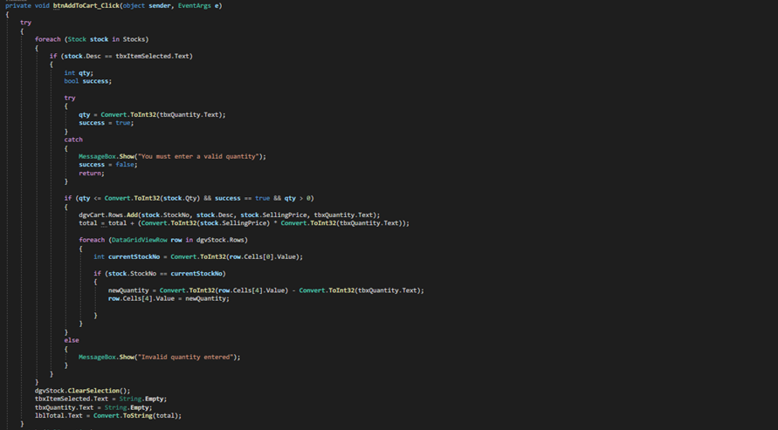

I have added the code to validate that the quantity entered is not less than 0

A message box will now appear when an invalid quantity is entered

**Corrective Action 9**

Test number:

Issue: There is no message box displayed to tell the user they must add stock to the cart before completing a purchase

Solution: Add the statement before the code if (dgvCart.Rows.Count == 0) { MessageBox.Show("You must add stock to the cart"); }

*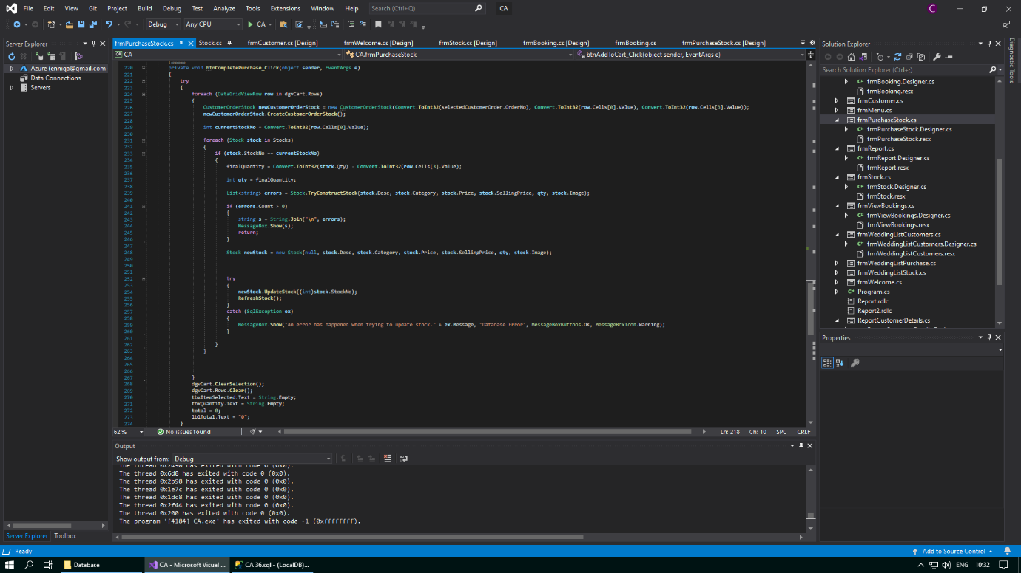Before:*

Code to ensure that the cart must have stock added to it before a purchase can be completed is missing

*After:*

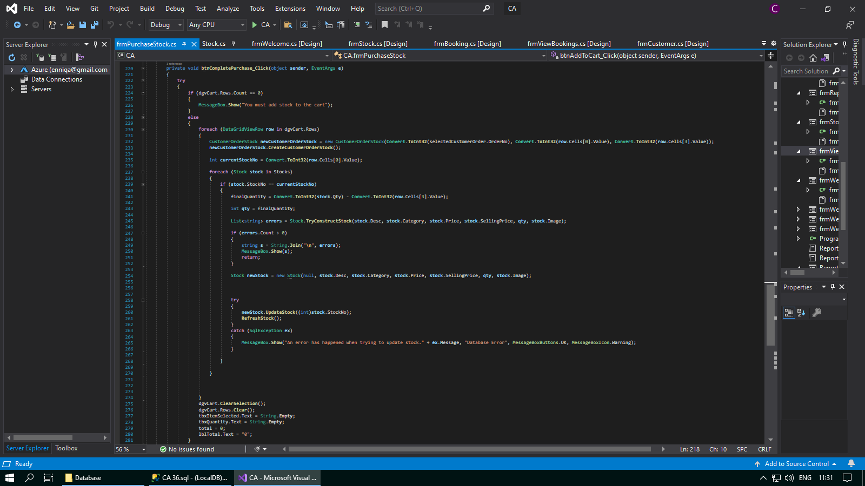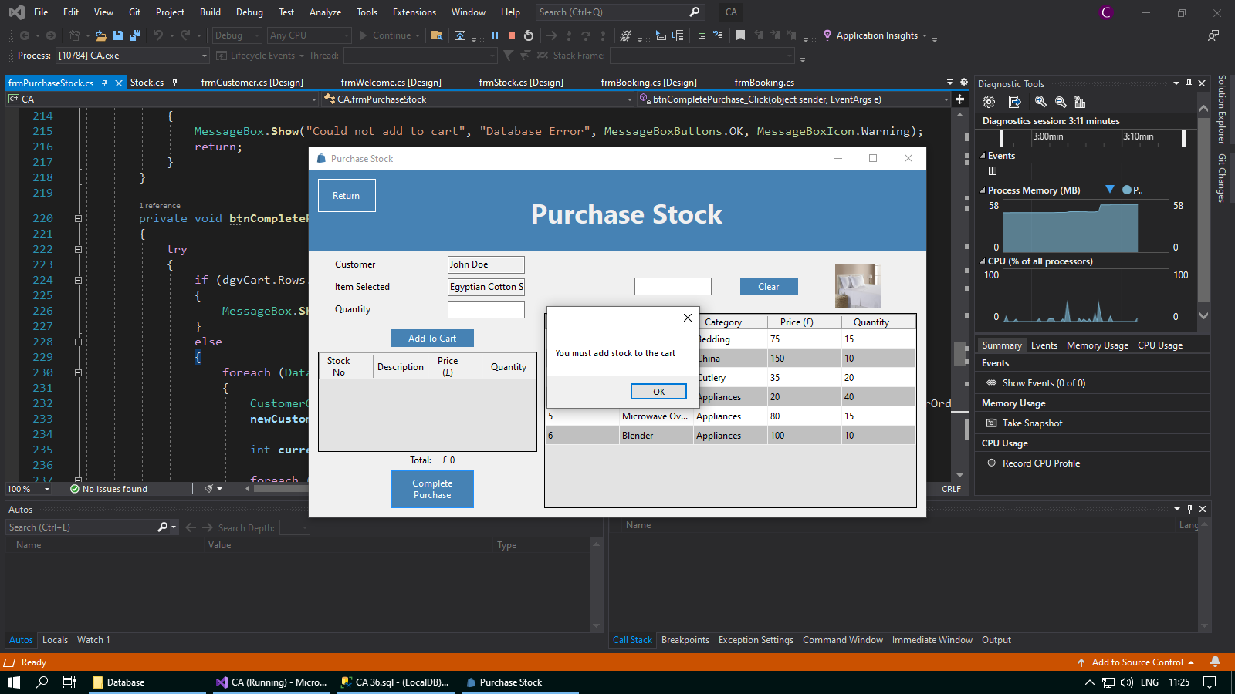

A message box will now appear when no stock has been added to the cart and btnCompletePurchase has been clicked on

I have added the code to ensure that there must be stock added to the cart before a purchase can be completed

**Corrective Action 10**

Test number:

Issue: When trying to view bookings, the code for the join throws an exception error

Solution: Add the line b.DateOfBooking to the SQL

*Before:*

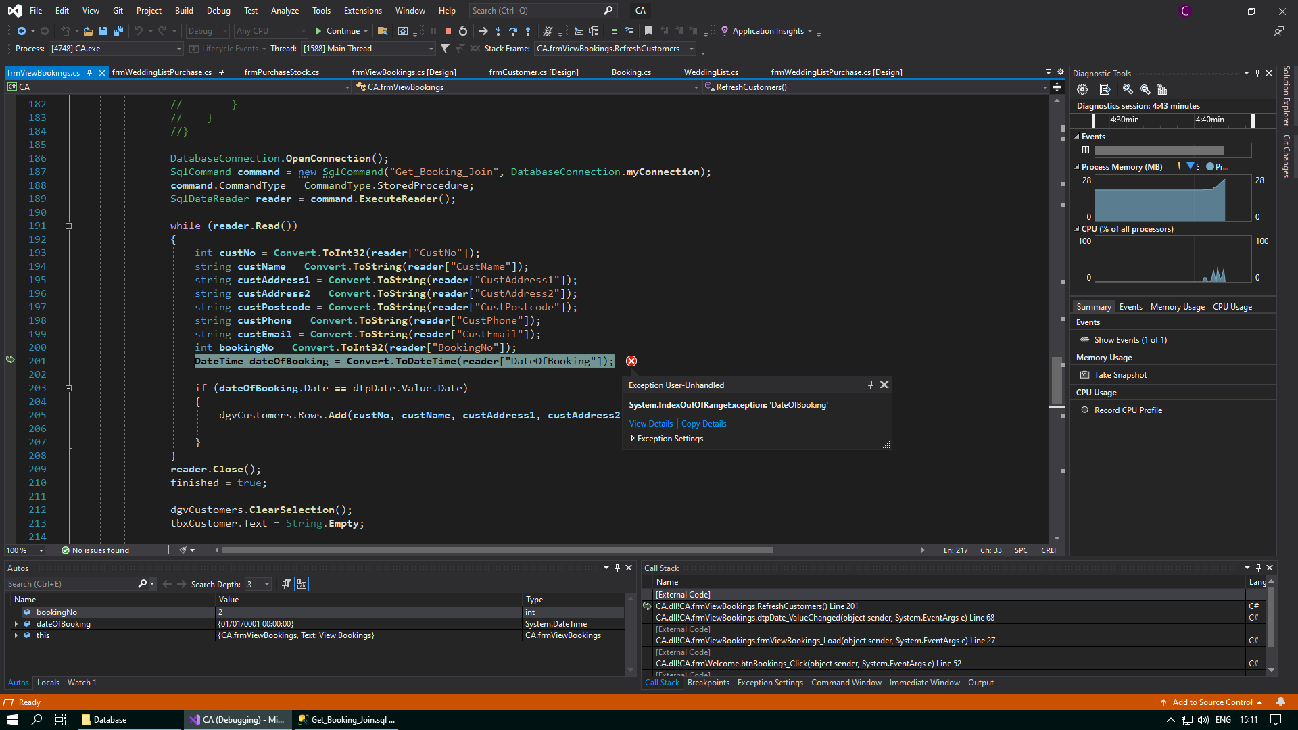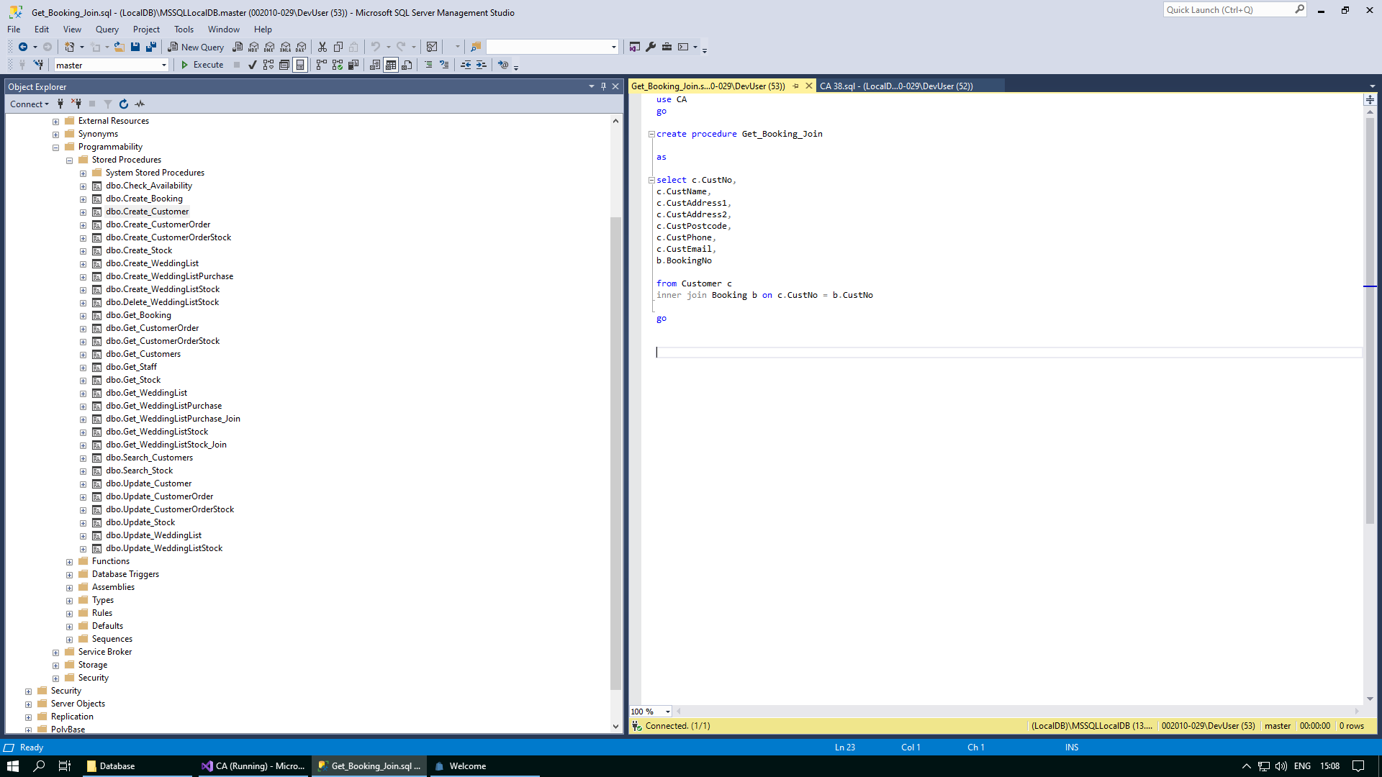

Code to select the date of booking from the Booking table is missing

An exception has been thrown when trying to read in the date of booking from the stored procedure Get_Booking_Join when the date in dtpDate is changed

*After:*

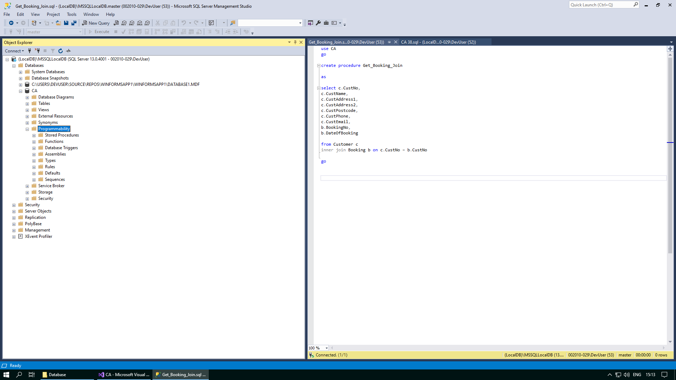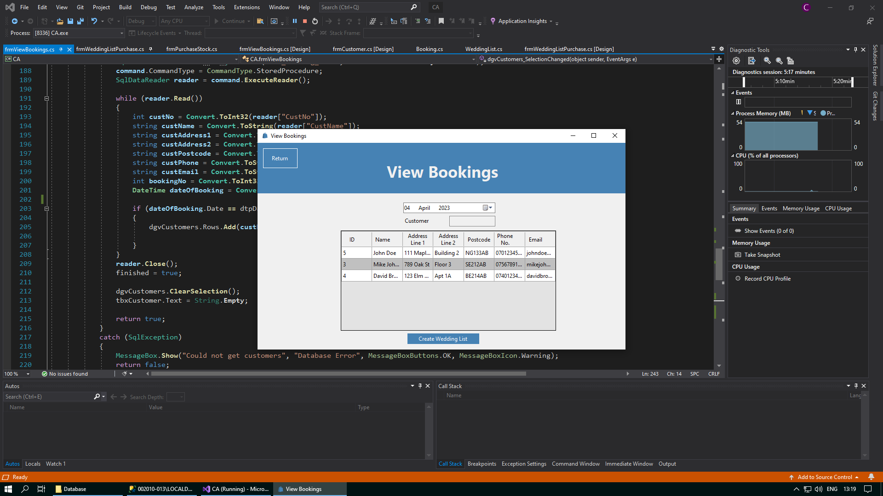+

The bookings made for a selected date will be displayed when the date in dtpDate is changed

I have added the code to select the date of booking from the Booking table

**Corrective Action 11**

Test number:

Issue: In the event that a database connection cannot be established, the application directs the user back to the Customer form, instead of the View Bookings form

Solution: Change the lines Form frmCustomer = new frmCustomer(); frmCustomer.Show(); to Form frmViewBookings = new frmViewBookings(); frmViewBookings.Show();

*Before:*

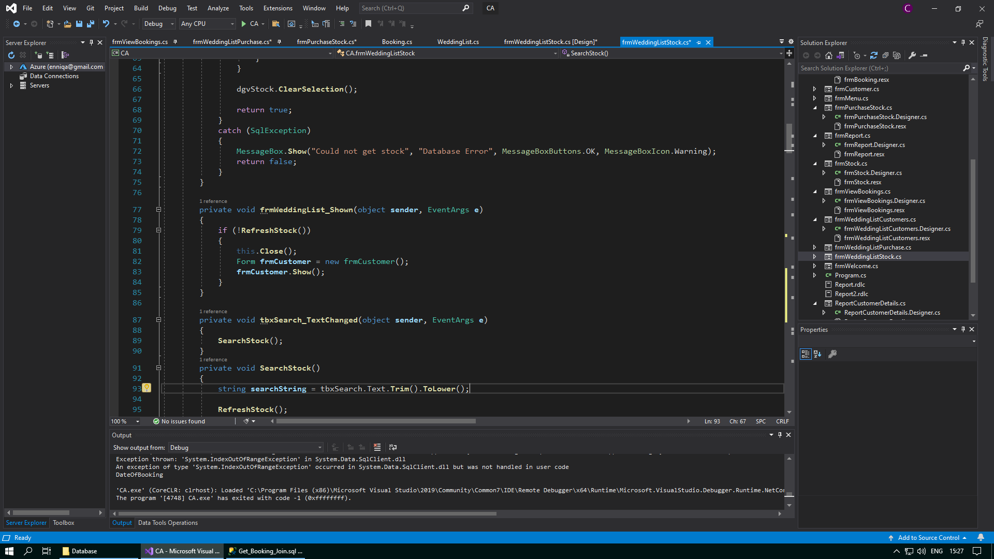

The user is being directed back to frmCustomer instead of frmViewBookings

*After:*

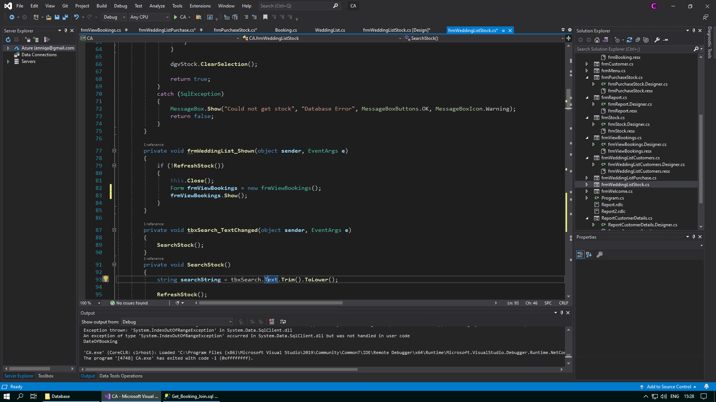

The user is now directed back to frmViewBookings

**Corrective Action 12**

Test number:

Issue: The Wedding List Customers form opens even when the user has not selected a wedding list

Solution: Add the statement before the code if (cbxBuyingFor.SelectedIndex == -1) { MessageBox.Show("You must select a customer to buy for first"); }

*Before:*

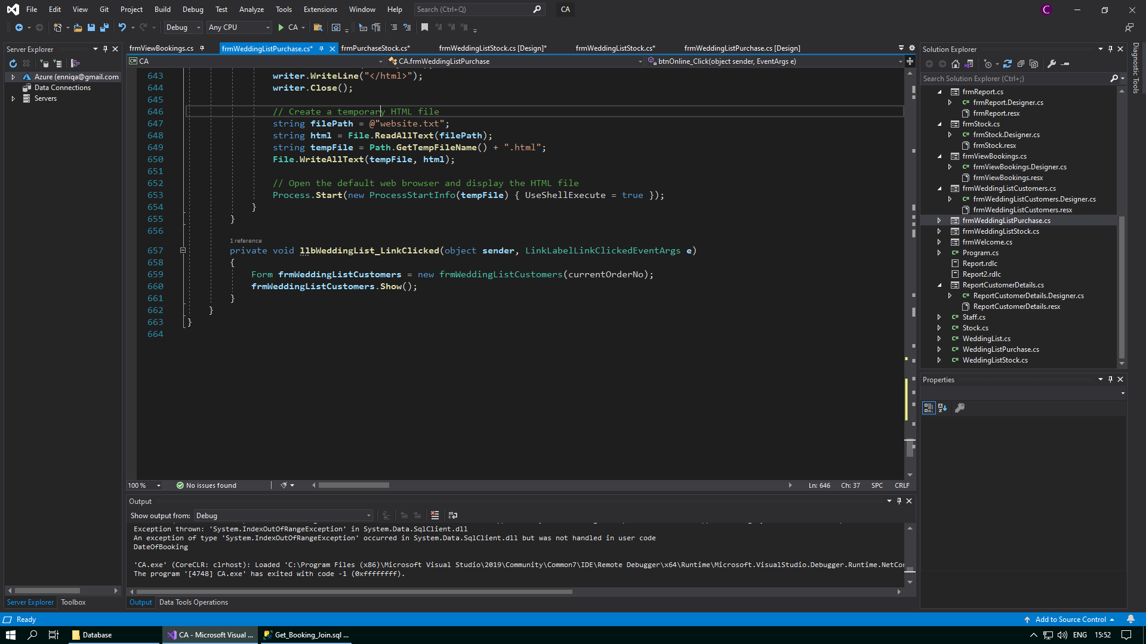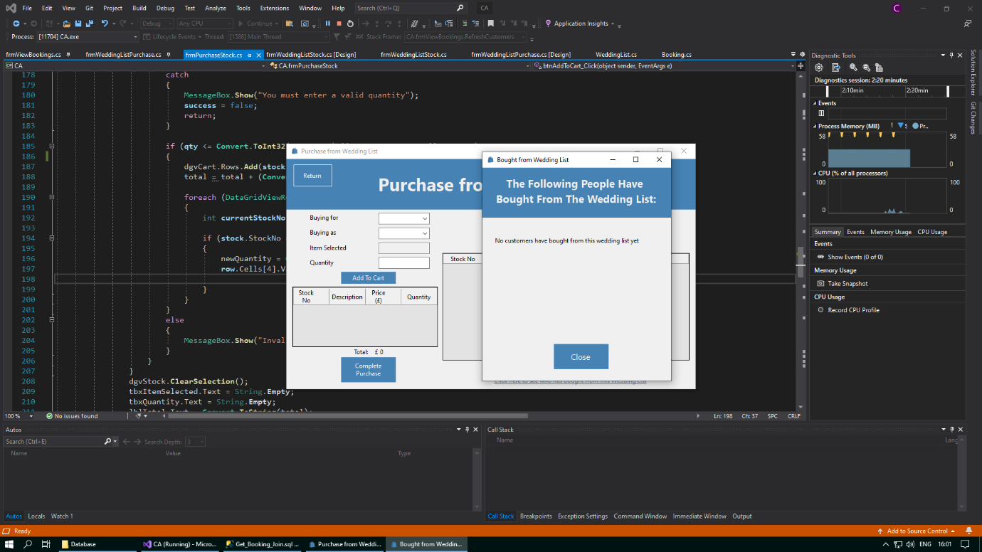

frmWeddingListCustomers has opened even though no customer to buy for has been selected and llbWeddingList has been clicked on

Code to validate that a customer must be selected in cbxBuyingFor is missing

*After:*

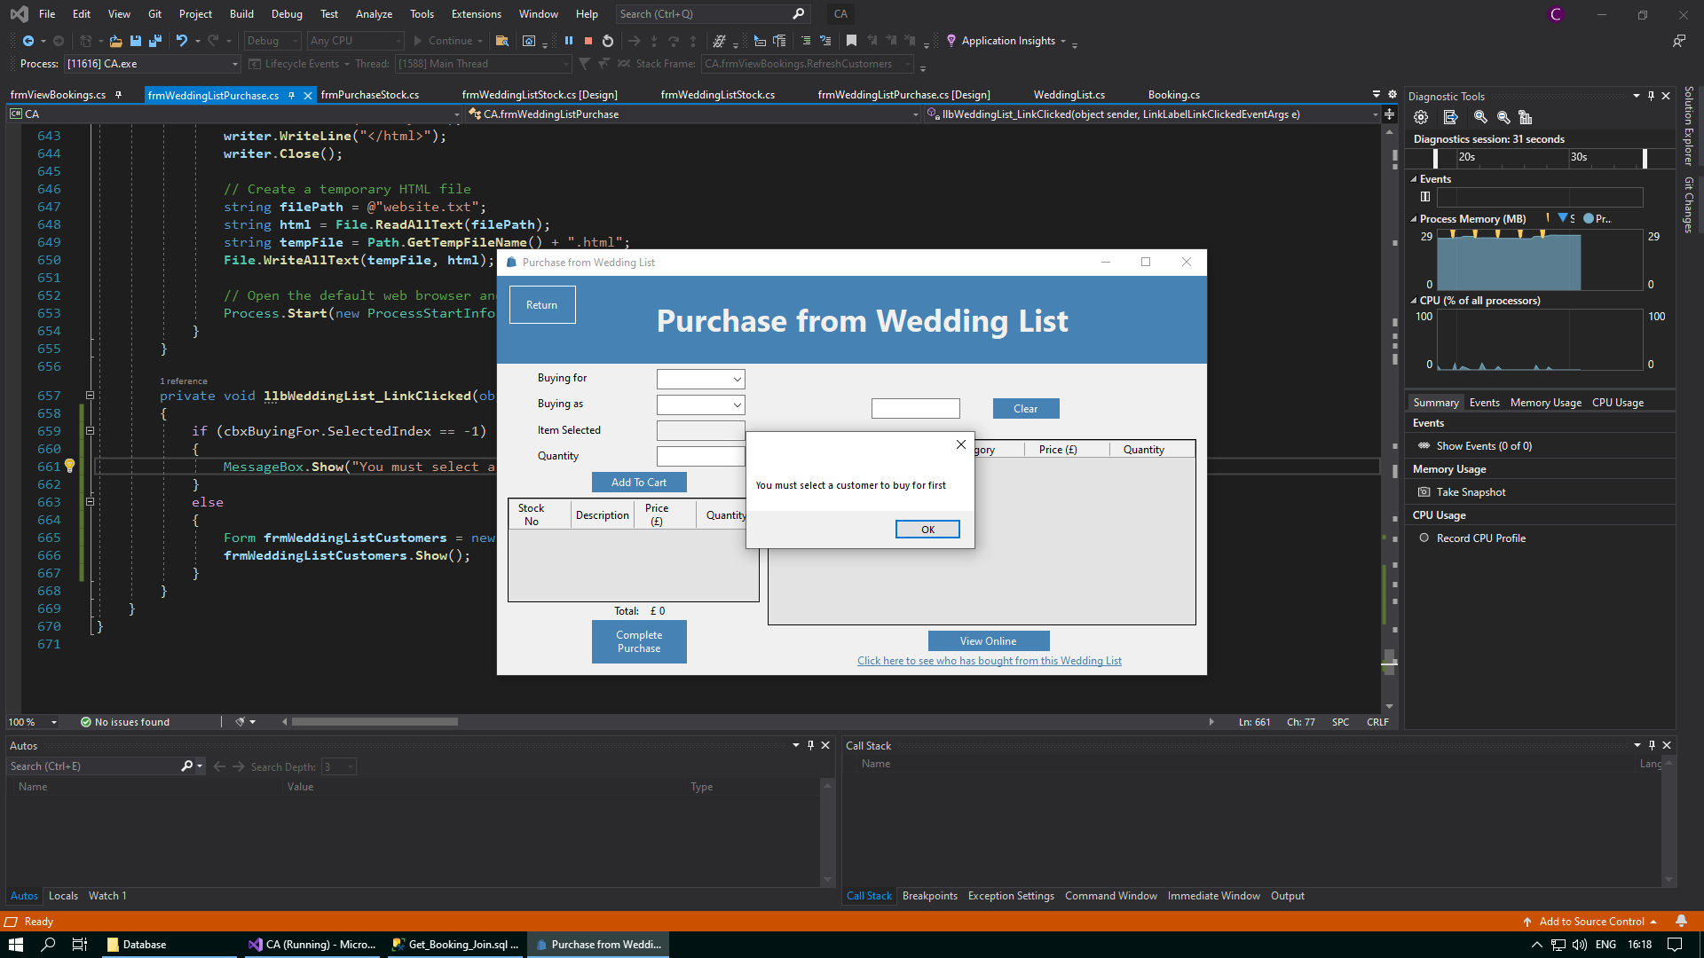

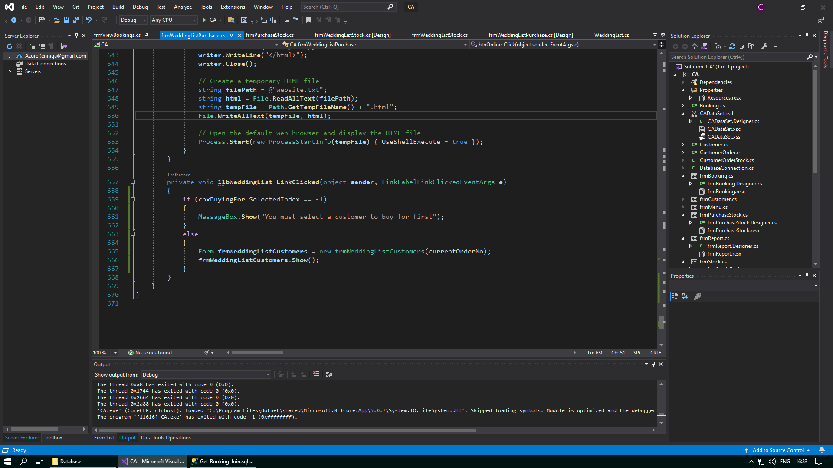

I have added the code to ensure that a customer must be selected in cbxCustomers before frmWeddingListCustomers can open

A message box will now appear when no customer to buy for has been selected and llbWeddingList has been clicked on

# Evaluation of Time Management/Project Plan

Looking back on my project plan, I can confidently say that I was able to follow the plan that I had made and was able to manage my time efficiently. Due to not owning a windows machine, I was unable to run SQL server at home, which meant that I had to complete all testing at school. This became increasingly difficult as the run up to exams resulted in an increase in class tests and mocks, meaning that I had to use my supervised study periods efferently.

In the time frame I had, I was able to successfully build a working solution that matched the proposed development. Since my methodology of choice was waterfall, it was very important to make sure that all tasks were completed in order without any overlap. This is because in waterfall one task cannot start until the current one is complete. However, this is hard to achieve in the real world and therefore the overlapping of tasks was inevitable. This goes against the structure of the waterfall methodology, but it was crucial to ensuring that all tasks were completed on time.

I had a wide range of tasks for me to complete to ensure that the project was a success. These tasks spanned the course of roughly 6 months. At the start of the project, there was a high degree of overlapping. This was because the tasks at hand were very small and all related, so I was able to work on them in unison with one another to increase my efficiency and to stay on track with the project plan. Many of these tasks were initial tasks, such as researching and understanding Simpson’s. For this, many of the resources used were the CCEA Case Study. However, for researching and choosing a methodology to use, I mostly used my Methodology notes in my textbook, and the internet. All these tasks had a small timescale.

This general trend of overlapping of smaller tasks continued up until the Christmas break, but after when I came back to work on the project, the tasks that I was required to complete were longer and required more focus so there was not much overlapping of tasks at all for the month of January. Whenever I was creating the Purchase from Wedding List form, I was able to do this while doing the Purchase Stock/Customer Order form as this proved to be very similar to the Create Customer form. Overlapping these two tasks required no real extra effort but was crucial in helping the project stay on track as it was nearing the due date.

After the mid-term break in February, it was time for testing. For this, the main resource I used was the Test Plan I wrote for the project. Testing had a large timescale in the project plan, and this process took a very long time due to the sheer number of tests that are required to be completed. Testing started to take longer than I expected, and so I then had to start overlapping my testing with my corrective actions. However, these two worked well together and helped to take the stress off as the project due date came near. However, this was not a perfect system and it meant that I started to overlap the final stages of corrective action with my user guide. When my user guide was nearing an end, I was able to start my evaluation and I was able to have it finished for the project due date. For my evaluation, the main resource I used was the User Requirements wrote at the start of the project.

In my Gannt chart, I feel I overestimated the amount of time required for each individual task, due to the amount of overlapping that occurred during the actual implementation. However, I stand by the overlapping as without it I would not have got my project finished on time. Overlapping was the main impact of change on the project plan.

# Evaluation of User Requirements

**System Requirements**

1. **All forms should have return buttons to their previous forms**

I have fully met this requirement as I have added a Return button on every form, apart from the Menu form, because there are no forms that come before it. This functionality was necessary to ensure that the user had a nice flow between different parts of the software. It was important that the Return button was clearly labelled and in a prominent position on each form, so on every form it is located in the top left corner, and it is a blue button with a white font and a white outline. This helps to create a sense of familiarity in the user when it is the same in every form.

1. **All forms should have a title**

I have fully met this requirement as I have added a title to every form in the application. For every form, the title is in bold and large font to help it stand out. As well as this, in most forms the title is at the top backed by a panel that is a different colour to the main colour of the form. The only form where this is not the case is the Welcome form. This helps the user to know what form they are on and prevents any confusion for the user.

1. **Invalid data should be handled in a way that prevents the program from producing errors**

I have fully met this requirement as I have added validation and conditional statements to any textboxes that take in data from the user. For some textboxes, validation occurs within the set property of whatever variable is being assigned. However, for some other textboxes, the validation occurs within the click event of the button that they are linked to. This will usually include the use of an “if - else” statement.

1. **All forms must have an icon of the Simpson’s logo and follow the same set colour scheme for Simpson’s – blue, black and white**

I have fully met this requirement as I have made sure that every form in the application follows the same colour scheme. The black is represented by the colour ControlText, the white is represented by the colour ControlLightLight, and the blue is represented by a shade of blue called SteelBlue. This clean, repetitive colour scheme helps to give the user interface a more professional look and also makes every form feel familiar to the user making it more user friendly.

**Menu**

1. **All strands of Simpson’s should be accessible from this form**

I have fully met this requirement as I have added 5 buttons which are able to take the user to any strand of Simpson’s that they want. These strands include the office and conference facility rental, wedding dresses/bridge/bridesmaids/wedding suits/mother of the bride outfits, dressmaking and alterations, cosmetics and beauty services, and household goods. These 5 buttons have a corresponding image above them which represents the department they are linked to. However, only the household goods strand of Simpson’s has been developed, and therefore the others do not allow the user to visit their respective strands.

This requirement is tested in test numbers: 1, 2, 3, 4 & 5

1. **Strands that have not yet been implemented are to display a “currently under construction” message when clicked on**

I have fully met this requirement as I have added click events on the buttons for the office and conference facility rental, wedding dresses/bridge/bridesmaids/wedding suits/mother of the bride outfits, dressmaking and alterations, and cosmetics and beauty services strands that display a message box when clicked on. As well, these buttons are displayed on the form with their text saying “Currently Under Construction”. However, the message boxes give extra information to the user as to which particular strand they click on is currently not available. This helps to enhance the user experience by giving the user feedback. This requirement was very easy to implement and only required one line of code for each different button.

This requirement is tested in test numbers: 1, 2, 3 & 4

1. **The user should be able to access the Welcome form in this menu**

I have fully met this requirement as I have added a button with the text “Household Goods” that, on click, directs the user to frmWelcome. This Welcome form is the menu for the Household Goods department of Simpson’s. This works by hiding the Menu form, then showing the Welcome form to the user. The Menu form must be hidden, not closed, as it is the first form to be shown in the application. If it is closed, then the entire application will close. Any forms after this however can be closed without closing the application as well. This requirement was also very easy to implement.

This requirement is tested in test number: 5

**Welcome Menu**

1. **All parts of the Household Goods department should be accessible from this screen**

I have fully met this requirement as I have added 4 buttons which are able to take the user to any strand of the Household Goods department that they want. These strands include a form to create, view and update customers, a form to create, view and update stock, a form to view bookings made by customers on different dates, and a form to purchase stock from a selected wedding list by a chosen customer in the system. These 4 buttons will also have a corresponding image above them which represents the form they are linked to. All 4 of these buttons are fully developed and this was not difficult to program as it only required 4 click events.

This requirement is tested in test numbers: 6, 7, 8 & 9

1. **The user should be able to return to the Menu form**

I have fully met this requirement as I have added a “Return” button to the top left corner of the Welcome form. It was important to ensure that the button is clearly labelled and located in a prominent position so that the user can easily find it and return to the Menu form whenever needed. I implemented the necessary functionality in the click event for the "Return" button so that when the user clicks on it, the application navigates them back to the Menu form. This functionality was straightforward to implement, and only involves closing the Welcome form and showing the user the Menu form again.

This requirement is tested in test number: 10

**Customers**

1. **The application should attempt to establish a successful connection to the Customer table in the database upon opening of the Customer form**

I have fully met this requirement as I have added a load event to the Customer form that will try to establish a connection to the Customer table in the database. It does this by trying to call the RefreshCustomers() method, which is a method with a Boolean return type. This is called inside a conditional statement which executes a series of commands if the value returned is false. A try-catch statement within the method is responsible for either returning true or false. This functionality was easy to implement, but at the same time is extremely crucial for preventing the application from crashing.

This requirement is tested in test number: 11

1. **In the event that a database connection cannot be established, the application should direct the user back to the Welcome form**

I have fully met this requirement as I have added a load event to the Customer form that contains a conditional statement which executes a series of commands when a connection to the Customer table in the database cannot be established. This series of commands will close the Customer form and return the user back to the Welcome form. This will only happen if the RefreshCustomers() method returns a Boolean value of false. This functionality was fairly straightforward to incorporate into the application. However, in the event that a database connection to the Customer table is unsuccessful, the program would crash on the user without this code, so it was extremely important to ensure that it worked as needed, and as expected.

This requirement is tested in test number: 12

1. **The user should be prevented from entering invalid customer details into the database**

I have fully met this requirement as I have added an extensive amount of validation to the set properties of all the details of a customer that are assigned with user input. Validation covers a wide range of checks, such as presence check, format check and length check. It is crucial to prevent the user from entering invalid data into the database as this could cause serious errors in other areas of the software where this data is used and processed in different ways. If a user tries to enter invalid data into the system, they will be met with an error message. This works by using conditional statements in the code for the set property for any given customer detail. This required an extensive amount of testing to ensure that all the validation for all the customer details was working as expected.

This requirement is tested in test numbers: 13, 14, 15, 16, 17, 18, 19, 20, 21, 22, 23, 24, 25, 26, 27, 28, 29, 30, 31, 32, 33, 34, 35, 36, 37, 38, 39, 40, 41, 42 & 43

1. **The user should be able to use either a combo box or a data grid view to create a new customer or view the details of existing customers**

I have fully met this requirement as I have implemented a selected index changed method for the combo box cbxCustomer, and a selection changed method for the data grid view dgvCustomers. Both of these methods allow the user to select an existing customer in the Customer table in the database and view their details, but cbxCustomer in particular allows the user to select an option, “{create new}”, which allows them to enter the details for a new customer. I have coded and tested both of these options to make sure that they work for the user and everything works as expected. This functionality was slightly tricky to figure out how to achieve the desired effect, but it is working successfully.

This requirement is tested in test numbers: 44, 45 & 46

1. **The user should be able to create a new customer with valid details**

I have fully met this requirement as I have coded the functionality that takes the details entered for a new customer, validates them against a set of individual rules for each detail, and if successful, will add the new customer to the Customer table in the database. Both cbxCustomer and dgvCustomers will refresh to show the new customer in the database to confirm to the user that the new customer was successfully created. I have tested this functionality with both valid and invalid details to ensure that only new customers with valid details are allowed to be entered into the system. This functionality works by using both validation for the details, and a try-catch statement when using the CreateCustomer() method to add the new customer to the Customer table in the database.

This requirement is tested in test numbers: 47 & 48

1. **The user should be able to update an existing customer with new details**

I have fully met this requirement as I have added functionality that takes the new details entered for an existing customer, validates them again against a set of individual rules for each detail, and if successful, will update the details of the existing customer in the Customer table in the database. Just like when creating a new customer, both cbxCustomer and dgvCustomers will refresh to show the updated customer in the database to confirm to the user that the existing customer was successfully updated with new details. I have tested this functionality with both valid and invalid details to ensure that only valid details are allowed to be entered into the system. This functionality works by using both validation for the updated details, and a try-catch statement when using the UpdateCustomer() method to update the customer details in the Customer table in the database.

This requirement is tested in test numbers: 49 & 50

1. **The user should be able to search for existing customers using customer details such as name, address, and email**

I have fully met this requirement as I have incorporated a text box called tbxSearch into the Customer form that, when typed in, will select any customers in the Customer table in the database that have details similar to the user input. These results are then displayed in dgvCustomers which can then be selected by the user for updating customer details. As well as this, I have also added the necessary code to a button called btnClear that allows the user to clear any text that they may have typed in tbxSearch. I found this functionality hard to include as it uses an SQL clause “like” which I was unfamiliar with prior to the development of this application.

This requirement is tested in test numbers: 51 & 52

1. **The user should be able to create a booking for the currently selected customer**

I have fully met this requirement as I have implemented a button, called btnCreateBooking, that when clicked on, checks if the currently selected customer, in either dgvCustomers or cbxCustomer, has already made a booking. If they have, then a message box appears that says “You cannot create another booking for this customer”. Otherwise, the Customer form closes, and the user is directed to the Booking form. From here, they are now able to create a booking for this selected customer. If no customer was selected in the first place, a message box appears to tell the user that they must “Select a customer first”.

This requirement is tested in test numbers: 53, 54 & 55

1. **The user should be able to create a new customer order allowing them to purchase stock for the currently selected customer**

I have fully met this requirement as I have coded a button, called btnCustomerOrder, checks if the currently selected customer, in either dgvCustomers or cbxCustomer, has already made a customer order. If they have, the text of btnCustomerOrder will say “Update”, and on click, the Customer form closes, and the user is directed to the Purchase Stock form. Otherwise, the text of btnCustomerOrder will say “Create”, and on click, a message box appears that says “Customer Order successfully created”. From here, whenever this customer is selected again, the text of btnCustomerOrder will say “Update”, and the user is now able to purchase stock for this selected customer. If no customer was selected in the first place, a message box appears to tell the user that they must “Select a customer first”. This functionality works successfully and as expected.

This requirement is tested in test numbers: 56, 57 & 58

1. **The user should be able to return to the Welcome form**

I have fully met this requirement as I have added a “Return” button to the top left corner of the Customer form. It was important to ensure that this button is clearly labelled and located in a prominent position so that the user can easily find it and return to the Welcome form whenever needed. I implemented the necessary functionality in the click event for the "Return" button so that when the user clicks on it, the application navigates them back to the Welcome form. This functionality was straightforward to implement, and only involves closing the Customer form and showing the user the Welcome form again.

This requirement is tested in test number: 59

**Stock**

1. **The application should attempt to establish a successful connection to the Stock table in the database upon opening of the Stock form**

I have fully met this requirement as I have added a load event to the Stock form that will try to establish a connection to the Stock table in the database. It does this by trying to call the RefreshStock() method, which is a method with a Boolean return type. This is called inside a conditional statement which executes a series of commands if the value returned is false. A try-catch statement within the method is responsible for either returning true or false. This functionality was easy to implement, but at the same time is extremely crucial for preventing the application from crashing.

This requirement is tested in test number: 60

1. **In the event that a database connection cannot be established, the application should direct the user back to the Welcome form**

I have fully met this requirement as I have added a load event to the Stock form that contains a conditional statement which executes a series of commands when a connection to the Stock table in the database cannot be established. This series of commands will close the Stock form and return the user back to the Welcome form. This will only happen if the RefreshStock() method returns a Boolean value of false. This functionality was fairly straightforward to incorporate into the application. However, in the event that a database connection to the Stock table is unsuccessful, the program would crash on the user without this code, so it was extremely important to ensure that it worked as needed, and as expected.

This requirement is tested in test number: 61

1. **The user should be prevented from entering invalid stock details into the database**

I have fully met this requirement as I have added an extensive amount of validation to the set properties of all the details of an item of stock that are assigned with user input. Validation covers a wide range of checks, such as presence check, format check and length check. It is crucial to prevent the user from entering invalid data into the database as this could cause serious errors in other areas of the software where this data is used and processed in different ways. If a user tries to enter invalid data into the system, they will be met with an error message. This works by using conditional statements in the code for the set property for any given item of stock detail. This required an extensive amount of testing to ensure that all the validation for all the customer details was working as expected.

This requirement is tested in test numbers: 62, 63, 64, 65, 66, 67, 68, 69, 70, 71, 72, 73, 74, 75, 76, 77, 78, 79, 80, 81, 82, 83, 84, 85, 86, 87, 88, 89, 90

1. **The user should be warned when an item is out of stock**

I have full me this requirement as I have added a label to the Stock form, called lblOutOfStock, that will display “OUT OF STOCK” in bold, red text when the currently selected item of stock has a quantity of 0. This has been implemented to tell the user that they must order more of this item in, and then this can be updated once a new quantity of this item is available. I was able to do this by adding a conditional statement that checks the quantity available for the elected item of stock, and then lblOutOfStock will be made visible or invisible accordingly. This was very easy to implement and helps to provide more feedback to the user.

This requirement is tested in test number: 86

1. **The user should be able to supply an image for the new item of stock**

I have fully met this requirement as I have added a button to the Stock form called btnOnline, that when clicked on, displays the file browser for the user’s computer and allows them to navigate to and select an appropriate picture for the item of stock they are currently creating or updating. This image will then be displayed in the picture box pbxPreview. If no image is selected when creating a new item of stock, the image that was in pbxPreviewat the time of creation serves as a default image until the user updates the item of stock with a new image.

This requirement is tested in test numbers: 91 & 92

1. **The user should be able to use either a combo box or a data grid view to create a new item of stock or view the details of existing stock**

I have fully met this requirement as I have implemented a selected index changed method for the combo box cbxStock, and a selection changed method for the data grid view dgvStock. Both of these methods allow the user to select an existing item of stock in the Stock table in the database and view its details, but cbxStock in particular allows the user to select an option, “{create new}”, which allows them to enter the details for a new item of stock. I have coded and tested both of these options to make sure that they work for the user and everything works as expected. This functionality was slightly tricky to figure out how to achieve the desired effect, but it is working successfully.

This requirement is tested in test numbers: 93, 94 & 95

1. **The user should be able to create a new item of stock with valid details**

I have fully met this requirement as I have coded the functionality that takes the details entered for a new item of stock, validates them against a set of individual rules for each detail, and if successful, will add the new item of stock to the Stock table in the database. Both cbxStock and dgvStock will refresh to show the new item of stock in the database to confirm to the user that the new item of stock was successfully created. I have tested this functionality with both valid and invalid details to ensure that only new stock items with valid details are allowed to be entered into the system. This functionality works by using both validation for the details, and a try-catch statement when using the CreateStock() method to add the new item of stock to the Stock table in the database.

This requirement is tested in test numbers: 96 & 97

1. **The user should be able to update existing items of stock with new details**

I have fully met this requirement as I have added functionality that takes the new details entered for an existing item of stock, validates them again against a set of individual rules for each detail, and if successful, will update the details of the existing item of stock in the Stock table in the database. Just like when creating a new item of stock, both cbxStock and dgvStock will refresh to show the updated item of stock in the database to confirm to the user that the existing item of stock was successfully updated with new details. I have tested this functionality with both valid and invalid details to ensure that only valid details are allowed to be entered into the system. This functionality works by using both validation for the updated details, and a try-catch statement when using the UpdateStock() method to update the stock details in the Stock table in the database.

This requirement is tested in test numbers: 98 & 99

1. **The user should be able to search for existing items of stock using stock details such as description, price, and quantity**

I have fully met this requirement as I have incorporated a text box called tbxSearch into the Stock form that, when typed in, will select any stock in the Stock table in the database that have details similar to the user input. These results are then displayed in dgvStock which can then be selected by the user for updating stock details. As well as this, I have also added the necessary code to a button called btnClear that allows the user to clear any text that they may have typed in tbxSearch. I found this functionality hard to include as it uses an SQL clause “like” which I was unfamiliar with prior to the development of this application.

This requirement is tested in test numbers: 100 & 101

1. **The user should be able to return to the Welcome form**

I have fully met this requirement as I have added a “Return” button to the top left corner of the Stock form. It was important to ensure that this button is clearly labelled and located in a prominent position so that the user can easily find it and return to the Welcome form whenever needed. I implemented the necessary functionality in the click event for the "Return" button so that when the user clicks on it, the application navigates them back to the Welcome form. This functionality was straightforward to implement, and only involves closing the Stock form and showing the user the Welcome form again.

This requirement is tested in test number: 102

**Bookings**

1. **The application should attempt to establish a successful connection to the Staff table in the database upon opening of the Bookings form**

I have fully met this requirement as I have added a load event to the Bookings form that will try to establish a connection to the Staff table in the database. It does this by trying to call the RefreshStaff() method, which is a method with a Boolean return type. This is called inside a conditional statement which executes a series of commands if the value returned is false. A try-catch statement within the method is responsible for either returning true or false. This functionality was easy to implement, but at the same time is extremely crucial for preventing the application from crashing.

This requirement is tested in test number: 103

1. **In the event that a database connection cannot be established, the application should direct the user back to the Customer form**

I have fully met this requirement as I have added a load event to the Bookings form that contains a conditional statement which executes a series of commands when a connection to the Staff table in the database cannot be established. This series of commands will close the Bookings form and return the user back to the Customer form. This will only happen if the RefreshStaff() method returns a Boolean value of false. This functionality was fairly straightforward to incorporate into the application. However, in the event that a database connection to the Staff table is unsuccessful, the program would crash on the user without this code, so it was extremely important to ensure that it worked as needed, and as expected.

This requirement is tested in test number: 104

1. **The name of the customer who is making the booking should be displayed to avoid confusion and ensure that the user is making a booking for the correct customer**

I have fully met this requirement as I have made a constructor for the Booking form that takes in one parameter, this being a customer object. This customer passed in will then be used to display the name of the customer currently making a booking in tbxCustomer. This helps to provide feedback to the user, ensuring that they are making a booking for the correct customer. As well, this will be used to record the details of a new booking to be added to the Booking table in the database, so for this it was extremely crucial that the customer is successfully passed over from the Customer form, or else an exception will be thrown when a new booking is attempted to be made.

This requirement is tested in test number: 105

1. **The user should be able to choose a date from a list of dates, with a minimum date of one day after the current date**

I have fully met this requirement as I have added a date time picker, called dtpDate, that the user can use to select a date for the currently selected customer. On the load event of the Booking form, the minimum date a user can pick for a booking will be assigned to one day after the current date. This is an essential part of the system as it is too short notice to make a booking on the current date for the employees at Simpson’s Household Goods department, as they will have already been assigned their responsibilities for that day and will not be able to assist.

This requirement is tested in test number: 106

1. **The user should be able to choose a time slot for their chosen date**

I have fully met this requirement as I have added a combo box, named cbxTime, that allows a user to select a time slot from a list of available time slots for their booking on the date that they have chosen. This combo box serves to purposes, the first being to assign a user a time slot, but the second to also assign the user a member of staff of the Simpson’s Household Goods department who will assist the customer with their appointment. This is based off time slot that the user has selected for the customer’s booking.

This requirement is tested in test number: 107 & 108

1. **When the user selects a time slot for their chosen date a Sales Representatives team member will be automatically assigned to assist for that time slot**

I have fully met this requirement as I have added a switch statement to the code for the selected index changed method of cbxTime, that will assign a member of staff of the Simpson’s Household Goods department to the booking based on the time slot that is chosen. This functionality was very easy to implement. The member of staff assigned will be displayed to the user throught the text of the label lblStaffMember, which will change accordingly when the time slot selected in cbxTime is changed.

This requirement is tested in test number: 107

1. **When a time slot has been booked it is removed from the available time slots for that day to prevent double bookings**

I have fully met this requirement as I have coded a method called PopulateAvailability(), which is responsible for removing time slots that have already been booked on particular days. When the date selected in dtpDate is changed, the PopulateAvailability() method will use the Check_Availability stored procedure to remove available time slots from cbxTime. This functionality was essential to have working s it is necessary to prevent double bookings for the same time slot on the same date.

This requirement is tested in test number: 108

1. **The user should only be able to make a booking when all details are correct**

I have fully met this requirement as I have coded conditional statement that ensure no details are missing and all details are correct before trying to create a new booking in the Booking table in the database. If a time has been selected and all details are correct, a message box displays that says “Booking successful”. If there are details missing for the booking, a message box will display that says “Booking unsuccessful - please select a time"

This requirement is tested in test numbers: 109 & 110

1. **When a booking is made, booking details are recorded in the Booking table and the user is no longer able to make a booking for that customer**

I have fully met this requirement as I have added code that once a booking has been successfully made, the “Book” button, btnBook, becomes disabled, forcing the user to return to the Customer form using the “Return” button. This functionality was very easy to incorporate as it only required one line of code, however, it was very necessary to ensure that this line of code is included inside the click event of btnBook, as otherwise a customer could make a double booking and this is not allowed.

This requirement is tested in test number: 110

1. **The user should be able to return to the Customer form once they have made a booking, or if they decide to cancel making a booking**

I have fully met this requirement as I have added a “Return” button to the top left corner of the Bookings form. It was important to ensure that this button is clearly labelled and located in a prominent position so that the user can easily find it and return to the Customer form whenever needed. I implemented the necessary functionality in the click event for the "Return" button so that when the user clicks on it, the application navigates them back to the Customer form. This functionality was straightforward to implement, and only involves closing the Bookings form and showing the user the Customer form again.

This requirement is tested in test number: 111

**Purchase Stock**

1. **The application should attempt to establish a successful connection to the Stock table in the database upon opening of the Purchase Stock form**

I have fully met this requirement as I have added a load event to the Purchase Stock form that will try to establish a connection to the Stock table in the database. It does this by trying to call the RefreshStock() method, which is a method with a Boolean return type. This is called inside a conditional statement which executes a series of commands if the value returned is false. A try-catch statement within the method is responsible for either returning true or false. This functionality was easy to implement, but at the same time is extremely crucial for preventing the application from crashing.

This requirement is tested in test number: 112

1. **In the event that a database connection cannot be established, the application should direct the user back to the Customer form**

I have fully met this requirement as I have added a load event to the Purchase Stock form that contains a conditional statement which executes a series of commands when a connection to the Stock table in the database cannot be established. This series of commands will close the Purchase Stock form and return the user back to the Customer form. This will only happen if the RefreshStock() method returns a Boolean value of false. This functionality was fairly straightforward to incorporate into the application. However, in the event that a database connection to the Stock table is unsuccessful, the program would crash on the user without this code, so it was extremely important to ensure that it worked as needed, and as expected.

This requirement is tested in test number: 113

1. **The name of the customer who is purchasing stock should be displayed to avoid confusion and ensure that the user is making a customer order for the correct customer**

I have fully met this requirement as I have made a constructor for the Purchase Stock form that takes in two parameters, one of them being a customer object. This customer passed in will then be used to display the name of the customer currently making an order in tbxCustomer. This helps to provide feedback to the user, ensuring that they are making purchasing stock for the correct customer. As well, this will be used to record the details of a new purchase to be added to the Customer Order Stock table in the database, so for this it was extremely crucial that the customer is successfully passed over from the Customer form, or else an exception will be thrown when a new purchase is attempted to be made.

This requirement is tested in test number: 114

1. **The customer order details of the customer who is purchasing stock should be passed into the form as well**

I have fully met this requirement as I have made a constructor for the Purchase Stock form that takes in two parameter, the other being a customer order object. This customer order passed will not be displayed anywhere in the Purchase Stock form. However, this will be used to record the details of a new purchase to be added to the Customer Order Stock table in the database, so for this it was extremely crucial that the customer order is successfully passed over from the Customer form, or else an exception will be thrown when a new purchase is attempted to be made.

This requirement is tested in test number: 115

1. **The user should be able to select stock, enter a valid quantity and add the stock to their cart for purchase**

I have fully met this requirement as I have added the ability for the user to select an item from dgvStock. From here, the stock description will be displayed in tbxItemSelected, and now the user can enter the quantity they want to add to the cart in tbxQuantity. If a valid quantity is entered, then the item of stock and its quantity will be added to dgvCart when the user clicks on btnAddToCart. The user is then able to add multiple items of stock to the cart before they then decide to complete their purchase.

This requirement is tested in test numbers: 116, 117, 118, 119, 120, 121, 122, 123

1. **The maximum quantity of stock a user can buy cannot be greater than the quantity that is currently in stock**

I have fully met this requirement as I have coded validation for the input entered into tbxQuantity. When btnAddToCart is clicked, the quantity entered into tbxQuantity will be checked to see that the quantity entered is not greater than the quantity of the item that is currently in stock. Otherwise, the item would be updated with a new, negative quantity in the Stock table in the database when the item of stock is purchased. This functionality was very easy to code but is so crucial to ensuring the application works successfully.

This requirement is tested in test number: 121

1. **The total price for the order is to be displayed and updated as the user adds more stock to their cart**

I have fully met this requirement as I have added a label, called lblTotal, which will display the total of all items in the cart. Whenever a user clicks on btnAddToCart, the new total will be calculated and lblTotal will be updated to display this new total. This will continue to update as the user adds more stock to the cart. Whenever a purchase is completed, the total will reset to 0 and lblTotal will also show 0.

This requirement is tested in test numbers: 122 & 123

1. **The user should be able to complete their purchase after selecting stock and have their order recorded in the CustomerOrderStock table in the database, with stock quantities available being adjusted accordingly**

I have fully met this requirement as I have added a click event to btnCompletePurchase, that when clicked on, records the details of all items of stock in the cart in the CustomerOrderStock table in the database. The method CreateCustomerOrderStock() passes through the customer’s order number, the stock number for each item of stock and their respective quantities from dgvCart to the stored procedure Create_CustomerOrderStock. The stock quantities available in dgvStock are adjusted accordingly using the UpdateStock() method.

This requirement is tested in test numbers: 124, 125 & 126

1. **The user should be able to search for existing items of stock using stock details such as description, price, and quantity**

I have fully met this requirement as I have incorporated a text box called tbxSearch into the Purchase Stock form that, when typed in, will select any stock in the Stock table in the database that have details similar to the user input. These results are then displayed in dgvStock which can then be selected by the user for adding to the cart. As well as this, I have also added the necessary code to a button called btnClear that allows the user to clear any text that they may have typed in tbxSearch. I found this functionality hard to include as it uses an SQL clause “like” which I was unfamiliar with prior to the development of this application.

This requirement is tested in test numbers: 127 & 128

1. **The user should be able to return to the Customer form**

I have fully met this requirement as I have added a “Return” button to the top left corner of the Purchase Stock form. It was important to ensure that this button is clearly labelled and located in a prominent position so that the user can easily find it and return to the Customer form whenever needed. I implemented the necessary functionality in the click event for the "Return" button so that when the user clicks on it, the application navigates them back to the Customer form. This functionality was straightforward to implement, and only involves closing the Purchase Stock form and showing the user the Customer form again.

This requirement is tested in test number: 129

**View Bookings**

1. **The application should attempt to establish a successful connection to the Customer table in the database upon opening of the View Bookings form**

I have fully met this requirement as I have added a load event to the View Bookings form that will try to establish a connection to the Customer table in the database. It does this by trying to call the RefreshCustomers() method, which is a method with a Boolean return type. This is called inside a conditional statement which executes a series of commands if the value returned is false. A try-catch statement within the method is responsible for either returning true or false. This functionality was easy to implement, but at the same time is extremely crucial for preventing the application from crashing.

This requirement is tested in test number: 130

1. **In the event that a database connection cannot be established, the application should direct the user back to the Welcome form**

I have fully met this requirement as I have added a load event to the View Bookings form that contains a conditional statement which executes a series of commands when a connection to the Customer table in the database cannot be established. This series of commands will close the View Bookings form and return the user back to the Welcome form. This will only happen if the RefreshCustomers() method returns a Boolean value of false. This functionality was fairly straightforward to incorporate into the application. However, in the event that a database connection to the Customer table is unsuccessful, the program would crash on the user without this code, so it was extremely important to ensure that it worked as needed, and as expected.

This requirement is tested in test number: 131

1. **The user should be able to select a date from a date-time picker and view the details of any customers who have made a booking for that selected date**

I have fully met this requirement as I have added a date time picker, called dtpDate, that the user can use to select a date to view bookings on. This date time picker does not have a mimimum date, unlike the one in the Bookings form. When the date in dtpDate is changed, a method of the name RefreshCustomers() is called, which retrieves the details of all customers in the Customer table whose customer number is also in the Booking table, using the stored procedure Get_Booking_Join. These customers will then be displayed in dgvCustomers, if the date of the customer’s booking is the same date selected in dtpDate.

This requirement is tested in test numbers: 132 & 133

1. **The user should only be able to create a wedding list if the date is today and at least one customer has made a booking for today and is selected**

I have fully met this requirement as I have coded a conditional statement into the dtpDate that checks for two conditions to be true – that the selected date is today, and that at least one customer has made a booking. If both of this conditions are true, then btnWeddingList will be made visible. From here, the user can make a booking for the customer that they have selected. Otherwise, if either of these conditions are not met, then btnWeddingList will not be visible. When btnWeddingList is clicked, if a customer has been selected and said customer has not marked their wedding list as complete, then a wedding list will be made for this customer. From here, btnWeddingList will now change from saying “Create Wedding List” to “Update Wedding List” whenever this customer is selected. When btnWeddingList says “Update Wedding List”, and it is clicked on, the user will be brough to the Wedding List Stock form, frmWeddingListStock.

This requirement is tested in test numbers: 133, 134, 135, 136, 137, 138 & 139

1. **The user should not be allowed to update a wedding list once that wedding list has been marked as complete**

I have fully met this requirement as I have coded a conditional statement into btnWeddingList that, on click, checks if the currently selected user has marked their wedding list as complete or not. If they have, then they will not be allowed to proceed to frmWeddingListStock and instead will be greeted with a message box that says “This wedding list has been marked as complete”. Otherwise, the user is directed to frmWeddingListStock where they can continue to update their wedding list with new items.

This requirement is tested in test number: 140

1. **The user should be able to return to the Welcome form**

I have fully met this requirement as I have added a “Return” button to the top left corner of the View Bookings form. It was important to ensure that this button is clearly labelled and located in a prominent position so that the user can easily find it and return to the Welcome form whenever needed. I implemented the necessary functionality in the click event for the "Return" button so that when the user clicks on it, the application navigates them back to the Welcome form. This functionality was straightforward to implement, and only involves closing the View Bookings form and showing the user the Welcome form again.

This requirement is tested in test number: 141

**Wedding List Stock**

1. **The application should attempt to establish a successful connection to the Stock table in the database upon opening of the Wedding List Stock form**

I have fully met this requirement as I have added a load event to the Wedding List Stock form that will try to establish a connection to the Stock table in the database. It does this by trying to call the RefreshStock() method, which is a method with a Boolean return type. This is called inside a conditional statement which executes a series of commands if the value returned is false. A try-catch statement within the method is responsible for either returning true or false. This functionality was easy to implement, but at the same time is extremely crucial for preventing the application from crashing.

This requirement is tested in test number: 142

1. **In the event that a database connection cannot be established, the application should direct the user back to the View Bookings form**

I have fully met this requirement as I have added a load event to the Wedding List Stock form that contains a conditional statement which executes a series of commands when a connection to the Stock table in the database cannot be established. This series of commands will close the Wedding List Stock form and return the user back to the View Bookings form. This will only happen if the RefreshStock() method returns a Boolean value of false. This functionality was fairly straightforward to incorporate into the application. However, in the event that a database connection to the Stock table is unsuccessful, the program would crash on the user without this code, so it was extremely important to ensure that it worked as needed, and as expected.

This requirement is tested in test number: 143

1. **The name of the customer who is making a wedding list should be displayed to avoid confusion and ensure that the user is making a wedding list for the correct customer**

I have fully met this requirement as I have made a constructor for the Wedding List Stock form that takes in two parameters, one of them being a customer object. This customer passed in will then be used to display the name of the customer currently making their wedding list in tbxCustomer. This helps to provide feedback to the user, ensuring that they are making a wedding list for the correct customer. As well, this will be used to record the details of stock to be added to the Wedding List Stock table in the database, so for this it was extremely crucial that the customer is successfully passed over from the View Bookings form, or else an exception will be thrown when trying to add stock to a wedding list.

This requirement is tested in test number: 144

1. **The wedding list details of the customer who is making a wedding list should be passed into the form as well**

I have fully met this requirement as I have made a constructor for the Wedding List Stock form that takes in two parameter, the other being a wedding list object. This wedding list passed will not be displayed anywhere in the Wedding List Stock form. However, this will be used to record the details of stock added to a wedding list in the Wedding List Stock table in the database, so for this it was extremely crucial that the wedding list is successfully passed over from the View Bookings form, or else an exception will be thrown when trying to add stock to a wedding list.

This requirement is tested in test number: 145

1. **The user should be able to select stock, enter a valid quantity and add the stock to their cart for purchase**

I have fully met this requirement as I have added the ability for the user to select an item from dgvStock. From here, the stock description will be displayed in tbxItemSelected, and now the user can enter the quantity they want to add to the cart in tbxQuantity. If a valid quantity is entered, then the item of stock and its quantity will be added to dgvCart when the user clicks on btnAddToCart. The user is then able to add multiple items of stock to the cart before they then decide to complete their purchase.

This requirement is tested in test numbers: 146, 147, 148, 149, 150, 151, 152, 153

1. **The maximum quantity of stock a user can buy cannot be greater than the quantity that is currently in stock**

I have fully met this requirement as I have coded validation for the input entered into tbxQuantity. When btnAddToCart is clicked, the quantity entered into tbxQuantity will be checked to see that the quantity entered is not greater than the quantity of the item that is currently in stock. Otherwise, the item would be updated with a new, negative quantity in the Stock table in the database when the item of stock is added to the wedding list. This functionality was very easy to code but is so crucial to ensuring the application works successfully.

This requirement is tested in test number: 151

1. **The total price of the items to be bought off the wedding list is to be displayed and updated as the user adds more stock to their cart**

I have fully met this requirement as I have added a label, called lblTotal, which will display the total of all items in the cart. Whenever a user clicks on btnAddToCart, the new total will be calculated and lblTotal will be updated to display this new total. This will continue to update as the user adds more stock to the cart. Whenever items are successfully added to the wedding list, the total will reset to 0 and lblTotal will also show 0.

This requirement is tested in test numbers: 152 & 153

1. **The user should be able to complete their purchase after selecting stock and have their items recorded in the WeddingListStock table in the database, with stock quantities available being adjusted accordingly**

I have fully met this requirement as I have added a click event to btnAddToWeddingList, that when clicked on, records the details of all items of stock in the cart in the WeddingListStock table in the database. The method CreateWeddingListStock() passes through the customer’s wedding list number, the stock number for each item of stock and their respective quantities from dgvCart to the stored procedure Create_WeddingListStock. The stock quantities available in dgvStock are adjusted accordingly using the UpdateStock() method.

This requirement is tested in test numbers: 154, 155 & 156

1. **The user should be able to search for existing items of stock using stock details such as description, price, and quantity**

I have fully met this requirement as I have incorporated a text box called tbxSearch into the Wedding List Stock form that, when typed in, will select any stock in the Stock table in the database that have details similar to the user input. These results are then displayed in dgvStock which can then be selected by the user for adding to the cart. As well as this, I have also added the necessary code to a button called btnClear that allows the user to clear any text that they may have typed in tbxSearch. I found this functionality hard to include as it uses an SQL clause “like” which I was unfamiliar with prior to the development of this application.

This requirement is tested in test numbers: 157 & 158

1. **When a customer is satisfied that their wedding list is complete, the user should be able to mark the wedding list as complete**

I have fully met this requirement as I have added a button to the form, called btnMarkAsComplete, that when clicked on, displays a message box that says "Wedding list successfully marked as complete". The Wedding List Stock form will close and the user will be directed back to the View Bookings form. A method of the name UpdateWeddingList() is called, which passes through the updated wedding list with a new MarkedYN value of “Y” to the stored procedure Update_WeddingList. This will update the details of the current wedding list in the WeddingList table in the database.

This requirement is tested in test numbers: 159 & 160

1. **The user should be able to return to the View Bookings form**

I have fully met this requirement as I have added a “Return” button to the top left corner of the Wedding List Stock form. It was important to ensure that this button is clearly labelled and located in a prominent position so that the user can easily find it and return to the View Bookings form whenever needed. I implemented the necessary functionality in the click event for the "Return" button so that when the user clicks on it, the application navigates them back to the View Bookings form. This functionality was straightforward to implement, and only involves closing the Wedding List Stock form and showing the user the View Bookings form again.

This requirement is tested in test number: 161

**Wedding List Purchase**

1. **The application should attempt to establish a successful connection to the WeddingList, WeddingListStock and Customer tables in the database upon opening of the Wedding List Purchase form**

I have fully met this requirement as I have added a load event to the Wedding List Purchase form that will try to establish a connection to the Wedding List, Wedding List Stock, and Customer tables in the database. It does this by trying to call the RefreshCustomers() and RefreshBuyingAs() methods, which are both methods with a Boolean return type. This is called inside two conditional statements which execute a series of commands if the value returned for their respective method is false. A try-catch statement within each method is responsible for either returning true or false. This functionality was easy to implement, but at the same time is extremely crucial for preventing the application from crashing.

This requirement is tested in test numbers: 162 & 164

1. **In the event that a database connection cannot be established, the application should direct the user back to the Welcome form**

I have fully met this requirement as I have added a load event to the Wedding List Purchase form that contains two conditional statements which execute a series of commands when a connection to the Wedding List, Wedding List Stock, or Customer tables in the database cannot be established. This series of commands will close the Wedding List Purchase form and return the user back to the Customer form. This will only happen if either the RefreshCustomers() or RefreshBuyingAs() methods return a Boolean value of false. This functionality was fairly straightforward to incorporate into the application. However, in the event that a database connection to the Wedding List, Wedding List Stock, or Customer tables is unsuccessful, the program would crash on the user without this code, so it was extremely important to ensure that it worked as needed, and as expected.

This requirement is tested in test numbers: 163 & 165

1. **Any items added more then once to the same wedding list will only be displayed as one item with an overall quantity**

I have fully met this requirement as I have coded a method called SortWeddingListStock(), that is called on load. This method adds together the quantities for any items of stock that are the same and appear in the same wedding list. It does this by keeping a running total of the quantity of that item of stock in the wedding list, deleting that item of stock from the WeddingListStock table in the database using a method DeleteWeddingListStock(). This method passes through the current item of stock to the stored procedure Delete_WeddingListStock, and then, if the total quantity was not 0, the method CreateWeddingListStock() will be called which works with the stored procedure Create_WeddingListStock to add that item of stock back into WeddingListStock with its new quantity.

This requirement is tested in test number: 166

1. **The user should be able to select the customer they are buying for, and the customer they are buying as**

I have fully met this requirement as I have added two combo boxes, cbxBuyingFor and cbxBuyingAs, which allow the user to select the customer they are buying for (they wedding list they are buying from), and the customer they are buying as. An essential part of this functionality was to ensure that the user cannot select a customer to buy for in cbxBuyingFor, and then select the same customer in cbxBuyingAs. However, this functionality was easy to incorporate and only required refreshing cbxBuyingAs whenever the selected index of cbxBuyingFor is changed. When a customer is selected in cbxBuyingFor, only items from their wedding list will be displayed in dgvStock.

This requirement is tested in test numbers: 167 & 168

1. **The user should be able to select stock, enter a valid quantity and add the stock to their cart for purchase**

I have fully met this requirement as I have added the ability for the user to select an item from dgvStock. From here, the stock description will be displayed in tbxItemSelected, and now the user can enter the quantity they want to add to the cart in tbxQuantity. If a valid quantity is entered, then the item of stock and its quantity will be added to dgvCart when the user clicks on btnAddToCart. The user is then able to add multiple items of stock from the wedding list to the cart, before they then decide to complete their purchase.

This requirement is tested in test numbers: 169, 170, 171, 172, 173, 174, 175, 176

1. **The maximum quantity of stock a user can buy cannot be greater than the quantity that is currently in stock**

I have fully met this requirement as I have coded validation for the input entered into tbxQuantity. When btnAddToCart is clicked, the quantity entered into tbxQuantity will be checked to see that the quantity entered is not greater than the quantity of the item that is currently available in the wedding list. Otherwise, the item would be updated with a new, negative quantity in the WeddingListStock table in the database when the item of stock is purchased from the wedding list. This functionality was very easy to code but is so crucial to ensuring the application works successfully.

This requirement is tested in test number: 174

1. **The total price of the items to be bought off the wedding list is to be displayed and updated as the user adds more stock to their cart**

I have fully met this requirement as I have added a label, called lblTotal, which will display the total of all items in the cart. Whenever a user clicks on btnAddToCart, the new total will be calculated and lblTotal will be updated to display this new total. This will continue to update as the user adds more stock to the cart. Whenever a purchase is completed, the total will reset to 0 and lblTotal will also show 0.

This requirement is tested in test numbers: 175 & 176

1. **The user should be able to complete their purchase after selecting stock and have their order recorded in the WeddingListPurchase table in the database, with stock quantities available in that wedding list being adjusted accordingly**

I have fully met this requirement as I have added a click event to btnCompletePurchase, that when clicked on, records the details of all items of stock in the cart in the WeddingListPurchase table in the database. The method CreateWeddingListPurchase() passes through the current wedding list number, the stock number for each item of stock and their respective quantities from dgvCart to the stored procedure Create_WeddingListPurchase. The stock quantities available in dgvStock are adjusted accordingly using the UpdateWeddingListStock() method. When a purchase is made, a message box will be displayed that says “Purchase complete” and the form will refresh.

This requirement is tested in test numbers: 177, 178, 179 & 180

1. **The user should be able to search for existing items of stock within that wedding list only using stock details such as description, price, and quantity**

I have fully met this requirement as I have incorporated a text box called tbxSearch into the Wedding List Purchase form that, when typed in, will select any stock in the WeddingListStock table in the database that have details similar to the user input and are also in the same wedding list as the wedding list currently selected. These results are then displayed in dgvStock which can then be selected by the user for adding to the cart. As well as this, I have also added the necessary code to a button called btnClear that allows the user to clear any text that they may have typed in tbxSearch. I found this functionality hard to include as it uses an SQL clause “like” which I was unfamiliar with prior to the development of this application, and as well I had to ensure that only items in the current wedding list are displayed as search results as well.

This requirement is tested in test numbers: 181 & 182

1. **The user should be able to view the currently selected wedding list online**

I have fully met this this requirement as I have added a button, called btnOnline, to the Wedding List Purchase Form, that when clicked on, will open up a website that displays the items available for purchase from the currently selected wedding list. This website will only open if a wedding list to buy from is currently selected in cbxBuyingFor, and if no wedding list has been selected, the user will be met with a message box that says "You must select a customer to buy for first". I was unfamiliar with how this could be achieved, but it proved to be very simple.

This requirement is tested in test numbers: 183 & 184

1. **The user should be able to view the customers who have purchased from the currently selected wedding list**

I have fully met this requirement as I have added a link label, called llbWeddingList, that when clicked on, will open up the Wedding List Customers form, frmWeddingListCustomers. This form will only open if a wedding list to buy from is currently selected in cbxBuyingFor, and if no wedding list has been selected, the user will be met with a message box that says "You must select a customer to buy for first". This was very simple to implement and only required two lines of code to open the pop-up form.

This requirement is tested in test numbers: 185 & 186

1. **The user should be able to return to the Welcome form**

I have fully met this requirement as I have added a “Return” button to the top left corner of the Wedding List Purchase form. It was important to ensure that this button is clearly labelled and located in a prominent position so that the user can easily find it and return to the Welcome form whenever needed. I implemented the necessary functionality in the click event for the "Return" button so that when the user clicks on it, the application navigates them back to the Welcome form. This functionality was straightforward to implement, and only involves closing the Wedding List Purchase form and showing the user the Welcome form again.

This requirement is tested in test numbers: 187

**Wedding List Customers**

1. **The user should be able to see all the customers who have bought from the wedding list that they selected in Wedding List Purchase form**

I have fully met this requirement as I have added a method called RefreshCustomers() will be called on load. This method retrieves the details of all customers in the Customer table whose customer number is also in the WeddingListPurchase table, using the stored procedure Get_WeddingListPurchase_Join. This stored procedure is an SQL Join clause. If the order number of a purchase in WeddingListPurchase for any customers is the same as the order number of the wedding list that was selected in cbxBuyingFor in frmWeddingListPurchase, then the name for these customers are listed in the text of a label on the Wedding List Customers form, called lblCustomers.

This requirement is tested in test numbers: 188 & 189

1. **The user should be able to close this pop-up form**

I have fully met this requirement as I have added a “Close” button to the bottom of the Wedding List Customers pop-up form. It was important to ensure that the button is clearly labelled and located in a prominent position so that the user can easily find it and close the pop-up form whenever needed. I implemented the necessary functionality in the click event for the "Close" button so that when the user clicks on it, the application will close the pop-up form. This functionality was straightforward to implement, and only involves one line of code, which closes the form.

This requirement is tested in test numbers: 190

# Solution Evaluation

## Strengths

Overall, my solution is a very strong and stable application that demonstrates my knowledge and engineering skills. The solution successfully achieves all the core functionality that it is required to do. It also includes features to help it stand out, such as preview images for stock and the ability to view a wedding list online. The software also has a very strong, clean user interface that is extremely user friendly and consistent. The solution makes a wide range of programming techniques, from the user of different types of loops, to SQL stored procedures and join clauses. The SQL relational database for this system is also very organised, with table names and column names following a consistent and easy to understand pattern. All stored procedures have a consistent format for their naming. The code for the solution is highly commented and easy to understand for an outside developer looking at it. These features will help to create an efficient and organised system for the Household Goods department of Simpson’s.

## Weaknesses

Overall, the solution does not show many weaknesses and is very robust. However, the solution lacks in the number of features and control it gives a user over manipulating data. For example, the user is unable to remove and change the quantity for an individual item in their cart. As well as this, the solution does not accommodate for international phone numbers or postcodes when making a customer or updating the details of an existing customer. One other weakness of the system is that it does not allow the user to either delete customers form the Customer table in the database or delete stock from the Stock table in the database.

## Improvements

If I had more time, I would have liked to code in functionality that allows user’s to select items in their cart, change the quantity or removed the item. At the moment, the only way for a user to remove an item from their cart is to avoid purchasing anything from the cart by leaving the current form using the Return button, then go back into the form and the cart will have been cleared and the items will not have been purchased. However, this is only really suitable if the user has only one or two items in their cart that they don’t want to purchase. If they had many items in their cart before clearing the cart, then they will have to re-add all those items again apart from the ones they don’t want/want less of. As well as all this, I would have liked to add the ability for the user to either delete customers form the Customer table in the database or delete stock from the Stock table in the database. This could be implemented by adding a button that would appear when you select a customer in the data grid view in the Customer form. This button would be a “Delete” button, that would delete the customer from the Customer table in the database when clicked on. However, this would be very hard to implement, as many other tables in the database may include this customer number, for example if this customer to be deleted had made a customer order. The database would not allow for this customer to be deleted. The same method to add a way to delete stock could also be implemented into the Stock form. However, just like with deleting customers, deleting stock could cause many problems in the database as other records in other tables may reference this item of stock.

# Evaluation of Selected Approach

At the start of the project, the approach to creating the solution was heavily researched. In the end, the waterfall methodology was decided on, and C# and SQL were chosen as the languages used for the front end. The waterfall methodology was chosen to help provide an easy-to-follow structure, and because the developers and customer did not work together for a large amount of the project, it meant that the customer was not able to provide a high level of involvement in the project. Waterfall was very helpful to me while I was developing the solution because I was working alone and not in a team and waterfall meant that I was able to complete each task to a higher quality as I was able to focus on just that task, with the occasional overlapping occurring into the next task as well, which wasn’t much of a problem.

In the beginning, other methodologies such as DSDM, Scrum, XP, and Agile were all considered to be used to help me approach and tackle the problems faced with a new solution. I am glad I chose the waterfall as it meant that I was confident in the work that I was doing, as some of these other methodologies would mean that the user requirements would change, and this would not have suited me well because it would have meant that I would have most likely not got the project finished on time. As well, since there is no involvement from the customer in this project, many of these other methodologies would not have worked as they require a high level of customer involvement. In addition, many of these methodologies also require a team, and this is not suitable for me because I am working as a lone developer.

As well as not having to worry about changes in the user requirements or involvement from the customer, Waterfall helped me to focus on the project by allowing me to have a set-in stone plan that I could follow to ensure that I was on track with all the tasks I planned to do. Many of these other methodologies may require changes to be made to their project plan as changes are made to the user requirements. This would have not suited me well as I do not have experience planning projects. If I had chosen one of these other methodologies, I could have seriously lost track of time and may have not been able to complete the system to the high standard that I have, in the time frame I was provided with.

The language I chose to develop the software in was C#. I have a high level of experience using C# due to other projects and solutions I have developed using this language. For the relational database, SQL was chosen. I had no experience in this language, however it proved to be easy enough as it is very much like plain English. The libraries available in C# for interacting with an SQL relational database are very easy to use and I was able to get a hand of them quickly. As a result of this, using C# and SQL for the front end provided a more flexible and customised approach to the solution.

Another part of my selected approach that was extremely important to the success of this project was the high level of design carried out before the system was made. The hand drawn wireframes provided a good initial basis for how the system would look, and after the customer provided their feedback, these designs were finalised and were not for changing. If I had chosen a methodology where the user was presented with the small prototypes of the system, then they may have requested changes in design, which may have resulted in the changing of code. If I had done this throughout the entire development of the system, then I may have not been able to complete the project on time. With the Waterfall methodology, this was not a worry to me, and I was able to code the system knowing that the system design was to the customer’s liking.

# Evaluation of Test Procedures

Since I was using the Waterfall methodology to develop my solution, testing had to be done at the end. Waterfall does not allow for testing to continuously happen throughout the development process, unlike other methodologies such as DSDM or Scrum. Only doing testing at the end was extremely difficult, and they were times I had to do testing throughout the development process.

Before I started my testing, I researched the many different types of testing, such as black box and white box testing. I was able to use both of these types of testing when carrying out my test plan. Whenever I met any difficulties, such as code not working as I had expected it to, I was able to use different testing strategies such as breakpoints to help me identify and amend errors in the corrective action. However, when testing the solution near the end, to ensure that everything was working as expected, I did not look into the code. I would also have friends of mine try out the solution, as they may have used it in a different way to how I did, and this may resulted in hidden errors being highlighted. However, I did not encounter any hidden errors when doing this.

I was also able to successfully carry out unit, system, and integration testing for the system. I was able to carry unit testing out for all the classes, such as the Customer, Stock and Booking classes. For this, I would test that all their major methods, such as the CreateStock() method in the Stock class, worked as expected. This was carried out by opening the form that these methods were executed in, and then individually testing the different ways to call these methods. For example, testing the Create button in the Stock form in one test, and then in another test I would test that the Update function for the same button worked. These both called different methods and it was important to make sure that these worked. Both black box and white box testing was used to test this.

I was able to carry out integration testing on many of the forms, with the Wedding List Purchase form being a key example of this. This form combined many different classes, such as the WeddingListStock, WeddingListPurchase, Stock and Customer classes. It was vital to ensure that all these classes worked together as this form is one of the four major strands of the household goods department. These classes worked together through the use of “For” loops and methods, such as in the text changed method for the Search text box, which called both the GetStockFromSearch() method, which is in the Stock class, and the GetWeddingListStock() method, which is in the WeddingListStock class.

System testing was carried out throughout testing to ensure that the system met all the user requirements. This was a form of black box testing, and it was carried out as testing neared completion. This is one of the most essential parts of testing as it assesses whether that the system works as a whole, with different components working seamlessly together.

However, even though I was using the Waterfall methodology, I did in fact test my solution throughout the development process - even though it goes against the structure of the waterfall methodology. This was to avoid writing code that I would use in other places and then having all the code not work at the end.

When looking back on this, it could be easy for someone to say that Waterfall was maybe not the best methodology to use for the solution due to this continual testing. However, Waterfall still had many advantages over the other methodologies, and suited me extremely well as a lone developer.

# Evaluation of My Performance

When evaluating my performance during the development of this solution, I believe that my key strength was the programming. I have a lot of experience programming, especially in C#, which I was able to carry forward from my AS Level in the subject. However, I had absolutely no experience programming in SQL before I started this project. I was able to pick it up very easily and now I thoroughly enjoy using SQL. It was quite tricky to integrate with the C# as well, especially when trying to use Joins in my C# code. However, I had learnt many problems solving skills from As Level when developing a solution last year, so I found it easier to figure out how to approach the problem. I was also able to learn a small amount of HTML and CSS for the feature that allows you to view a wedding list on a simple website.

I can also say that one of my strengths was in my designing of my system. I believe that my solution has a very user-friendly interface that is easy to navigate and helps to bring a professional look. I find that the design of a solution is one of is strong points, as if it looks well from a first glance it will be more enticing for a customer to use and try out. If there is a good flow between the different parts of the system, such as all the different forms, then the system will feel seamless and easy to use. I feel that the success of this design was due to the highly detailed wireframes I had designed for the system. I also believe that another strength of mine was testing. I feel as though I have built a very robust system that handles a wide range of types of data well, and in addition does not throw any errors that I could find after testing and corrective action had been completed. I felt that my test plan was well detailed, which helped me to make sure that when I was testing the system all the necessary code and functions were working as I had planned they would. This was much more detailed than the test plan I had produced last year for my AS Level coursework.

While a lack of expertise in SQL was one of my weaknesses, it did not massively affect me or the project, however it did cause me to take longer on some tasks in the project, for example, when creating the Purchase From Wedding List form, I found it took me very long to figure out the logic behind how I was going to display only stock from the wedding list currently selected. For this, I had to learn how to use SQL joins, not just in the stored procedures, but also how to implement them into the solution using C#. This made it easier however for other forms that also included Joins. I was very satisfied with the result that using joins in my code gave, and I felt that learning how to implement these into the C# code helped me to further improve on my coding skills, as well as my SQL skills,

In addition to having no experience with SQL, I also felt that another weakness of mine was the execution of my project plan. I felt that underestimated the timescales of many tasks, which resulted in a lot of overlapping. While this overlapping was not a serious problem and did not affect the completion or success of the project, it did go against the rigid structure of the waterfall methodology - the methodology I had chosen for this project. As I have already assessed, this rigid structure is very hard to follow without some degree of overlapping occurring. However, in saying this, the project plan was also crucial in ensuring that I was able to successfully complete the development of this solution by the end date. The execution of my project plan was one of my weaknesses, but the actual use of a project plan was a major success.

Throughout the development of the application, I ensured that I maintained a high level of organisation for all the necessary files for my solution. I kept both my solution and my database scripts in a folder called “CA”.

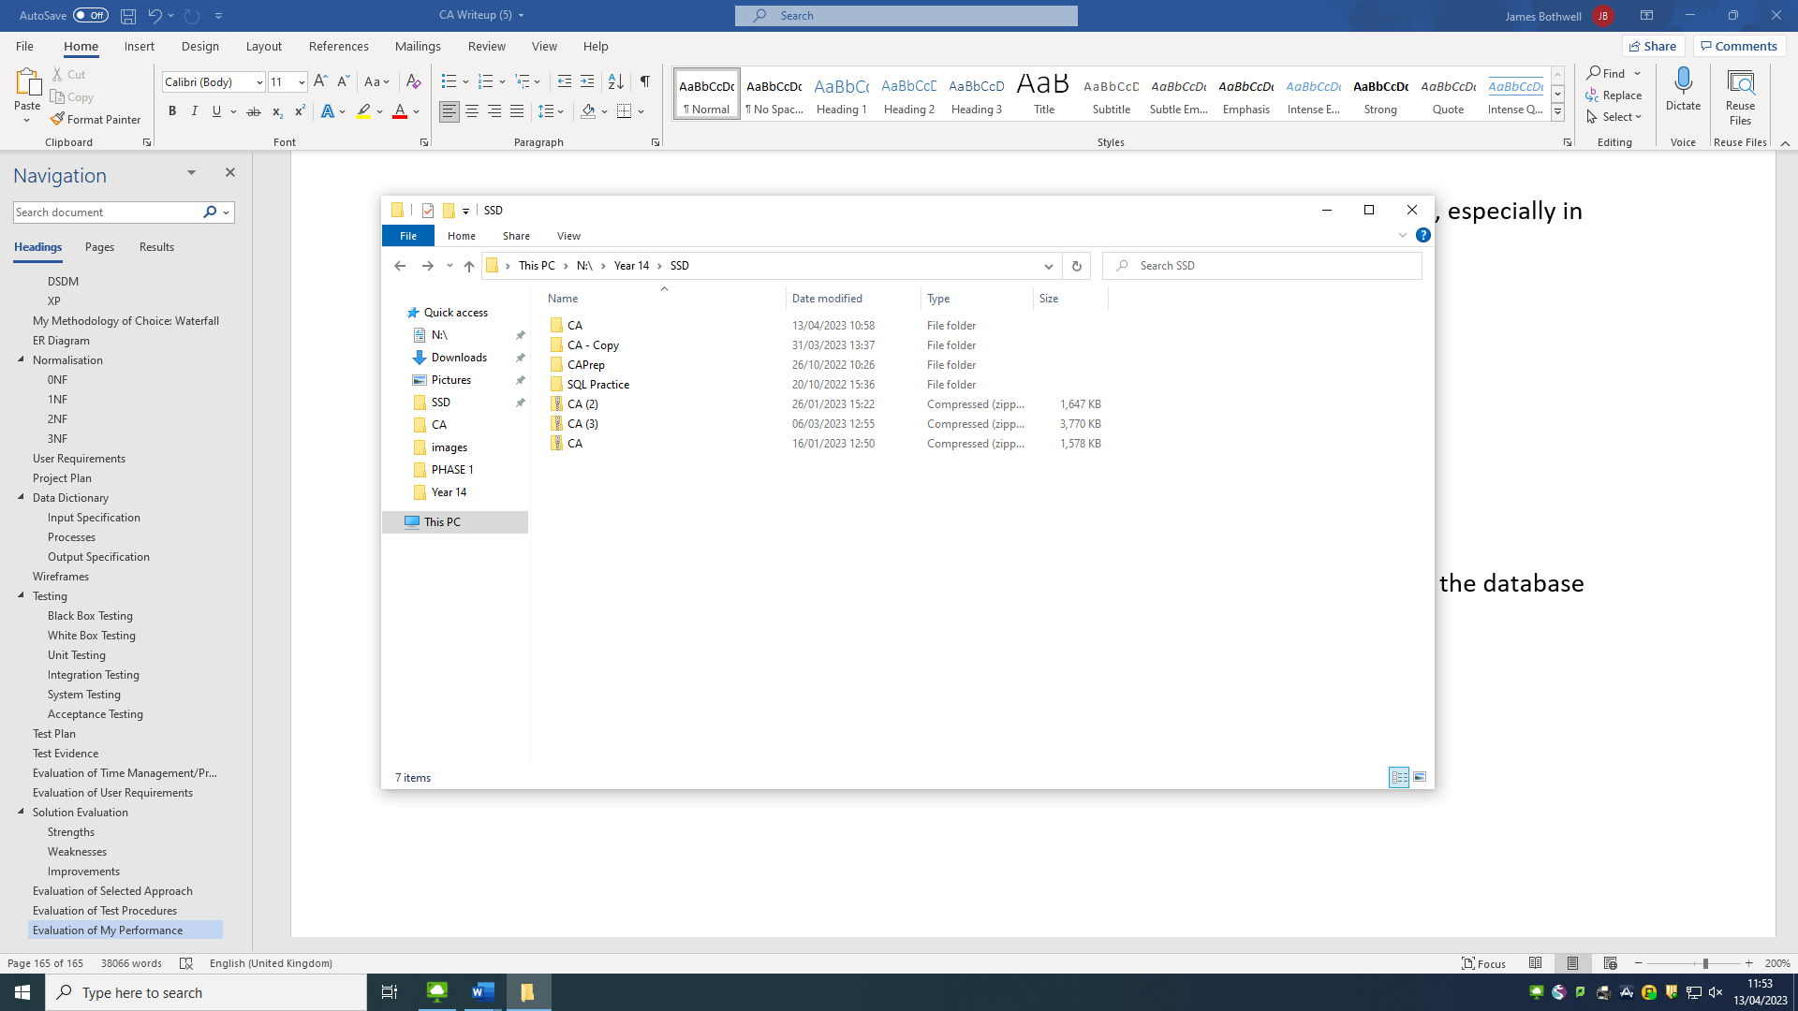

I made sure to keep regular backups of this folder, in case any files go missing, get deleted or become corrupted. It is crucial to maintain this high level of protection of my files when developing s software solution.

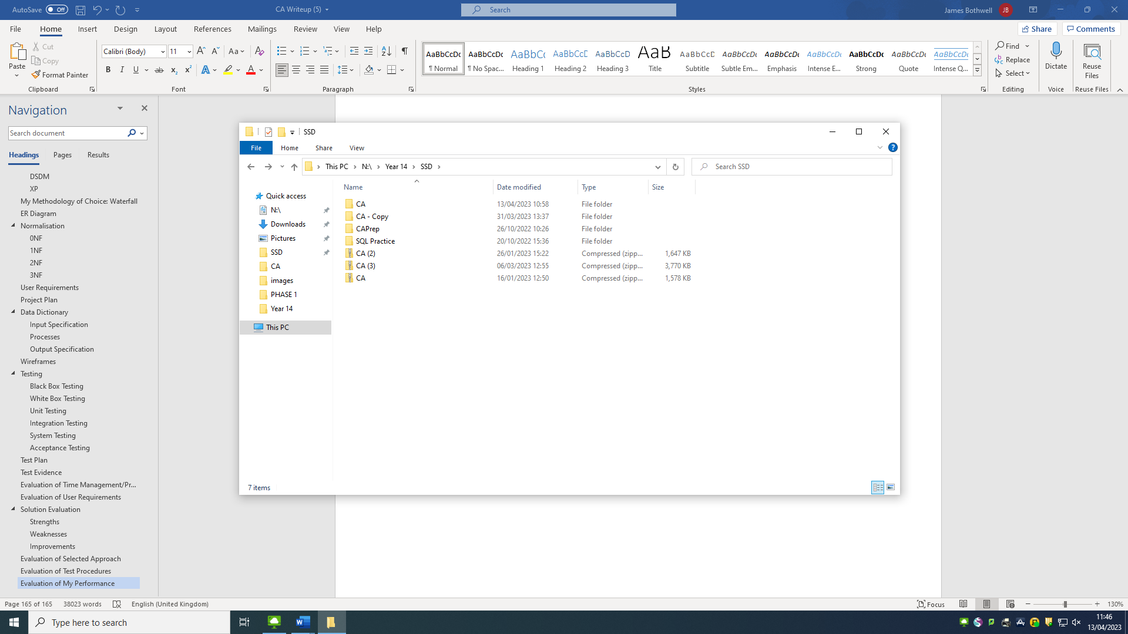

Inside this folder, there are two folders. The project folder for the solution – “CA”, and the database scripts folder – “Database”. This kept all the files for the actual solution in two separate folders in a minimalistic manner.

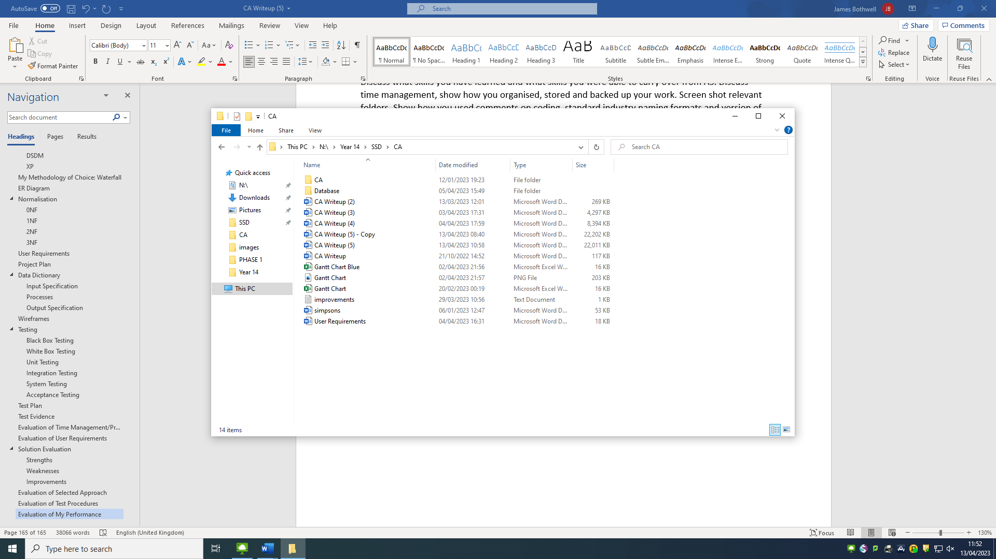

I made sure to give all my scripts suitable names and for stored procedures, I gave them all a standard naming convention of “TYPE_TABLE”. For example, the stored procedure for creating a new item of stock in the Stock table in the database is called “Create_Stock”. Any stored procedures that contained a join had the naming convention “Get_TABLE_Join”. For example the stored procedure to get the names of customers who had made a purchase from a wedding list, using their customer number, was called “Get_WeddingListPurchase_Join”.

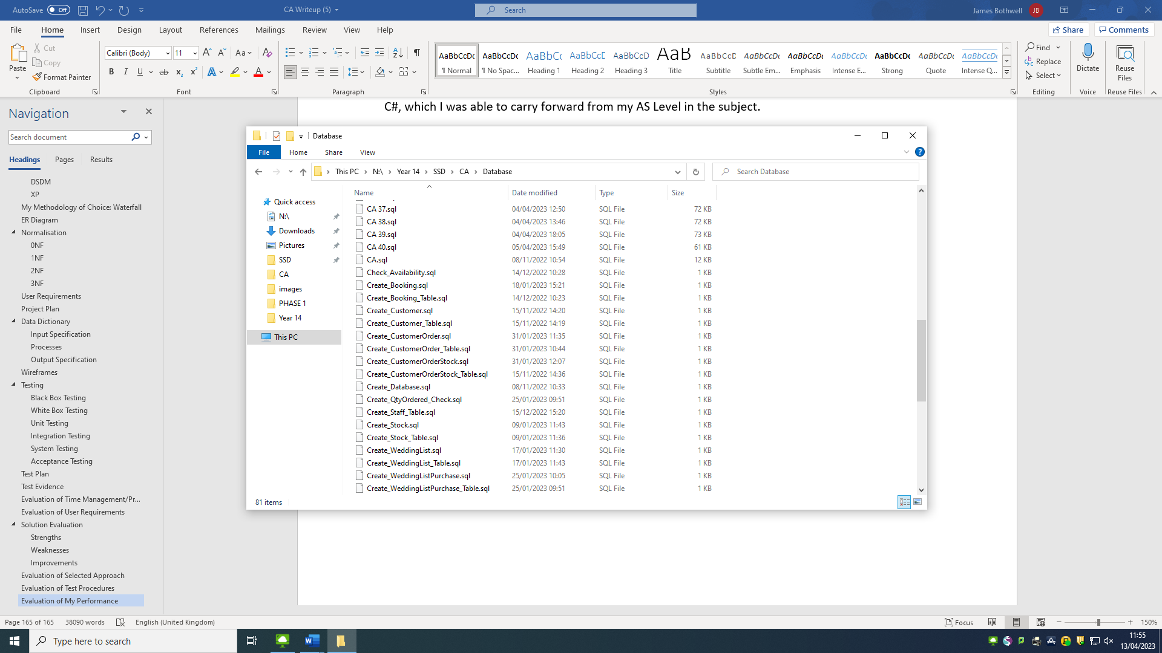

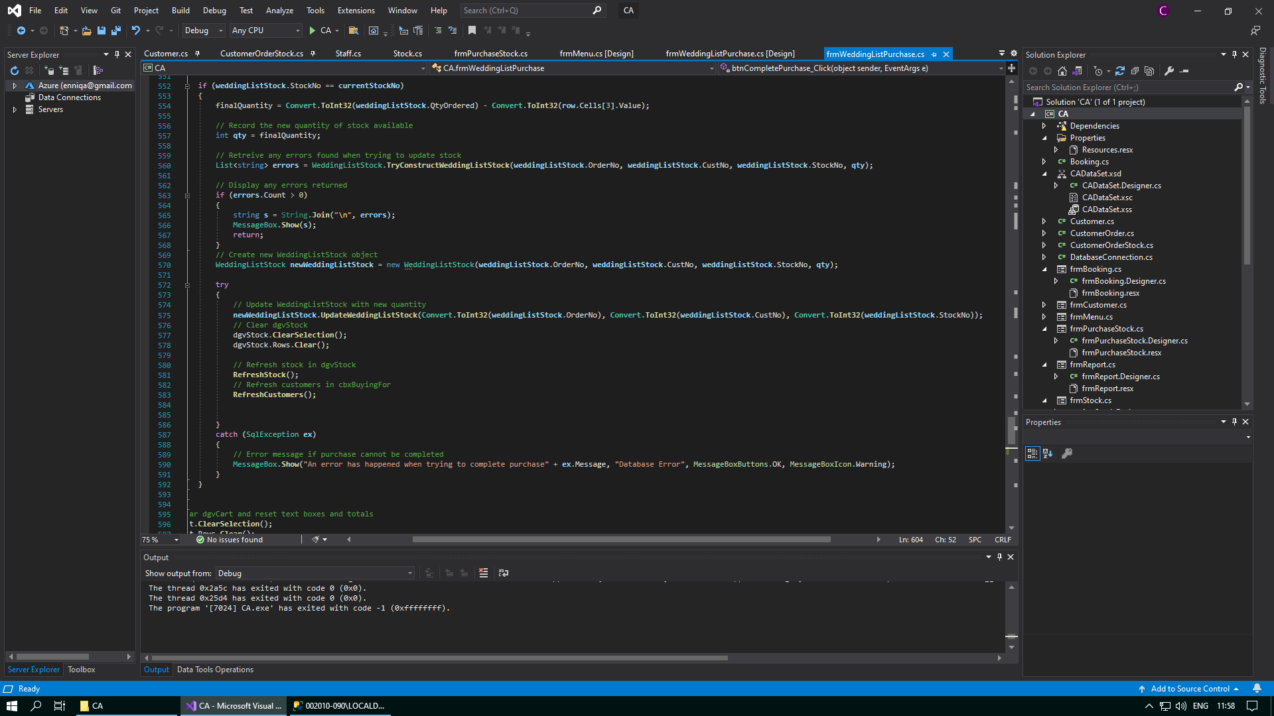I also provided comments all throughout my code to help any outside developers

By the end of the project, I felt as though had levelled up my programming skills by being able to use SQL and combine this with another programming language such as C#. I have also learnt to use new tools that I otherwise would not have used, such as Lucidchart to help me make the ER diagram. I also learnt how to use advanced features of Microsoft Excel, in order to help me create my Gantt chart. As well, I found that there was a lot more to do for this project than compared to AS Level, but I definitely enjoyed this year more. However, there was also a much higher level of work involved than compared last year, and so different areas of the project such as the project plan became crucial to ensuring the success and completion of the project by the due date. I also decided to try and improve upon the areas in which my project at AS Level was lacking, such as in the wireframes I had designed. The wireframes I had designed for my project last year were very bland and did not include any colour at all. In addition, this made it hard to identify the different parts of the annotations, such as the features of a button from its design. This year, I decided to take my wireframe designs to the next level, and I made sure to colour them in accordance to how the actual system would look, and I also made the annotations clearer, with the name, design, and features of any given component separated to make it easier to read. As well as this, I had to incorporate a lot more of the theory I have had to learn for a level into my coursework, such as all the theory on methodologies and testing.

In conclusion, I believe that the solution I have build is very stable and robust, and that it has a high-quality user interface with many useful features. I feel that designing and implementing this solution has helped me to improve as a developer, from planning and designing a new solution, to developing and testing a fully working system. Even though the solution this year was much more complex and harder to develop successfully, I found it to be much more enjoyable than the system I had to create for AS Level. The system I have developed will serve as a great solution to the problems experienced at Simpson’s Department Store.